The Queensland Care Army: how your organisation can get involved

What is the Care Army?
The Care Army is made up of everyday Queenslanders who want to help older people living in the community who may not have a wide circle of friends, family or neighbours who are able to support them.
The Queensland Government is enlisting people and organisations to help support seniors during the COVID-19 crisis.
The primary focus of the Care Army is social connection and essential services such as the delivery of groceries and medicines for Queensland’s seniors.
There may be other tasks volunteers can do, but in the first instance these are the priority.

How can organisations get involved?
Queensland’s community organisations are encouraged to think about how they could use volunteers to assist with meeting the needs of older people in their communities.
This could be achieved through phone calls or video chats to check on the wellbeing of seniors and help reduce the impacts of social isolation.
It could also involve the non-contact delivery of food, medication and essential items to older people in their local community.
The Queensland Government is currently in the process of finalising a process to link older Queenslanders who need a helping hand with the services they need.
Community organisations and Care Army volunteers will be a key part of this process.
If you need volunteers or want to find out more about how Care Army volunteers can work in your community with your teams, please contact Volunteering Queensland (VQ) directly at www.volunteeringqld.org.au

How does it work?
VQ will work with you to assess your volunteering needs. You will be sent information about suitable volunteers you may wish to engage to support your organisation.
All organisations which take volunteers on board will need to undertake the necessary checks and complete the necessary paperwork – depending upon the role of the volunteers and tasks they will perform.
In order to maintain social distancing requirements, volunteers should perform non- contact tasks.

How will volunteers be engaged?
People who are interested in volunteering can sign up to the Care Army by calling the

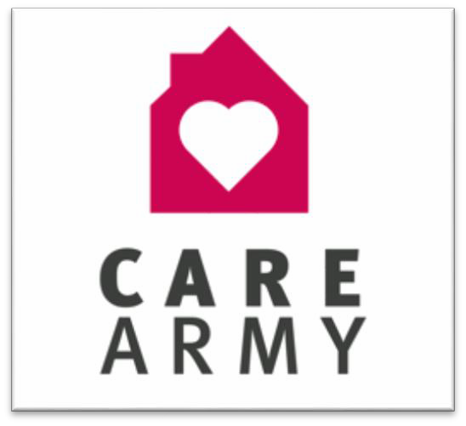

Page 1 of 2

Department of Communities, Disability Services and Seniors

Community Recovery Hotline on 1800 173 349 or visiting www.covid19.qld.gov.au/carearmy.
They will then be matched with tasks through local groups in partnership with non-government organisations.

How can seniors get support?
Seniors and anyone else in quarantine or self- isolation who don’t have other means of support can call the Community Recovery Hotline on Phone: 1800 173 349 to get assistance with:
- delivery of essential food and medication
- social and emotional support.

Page 2 of 2

