All funded non-government organisations that are required to demonstrate compliance with the Human Services Quality Framework (HSQF) through self-assessment have up to 18 months to complete a self-assessment. To help planning and preparation, the key milestones below need to be met by organisations:

12 – 15 Months
Commence the self-assessment process.
Activities will include:
- collecting documents (e.g. policies, procedures) and records (e.g. registers, meeting minutes) that are relevant to each standard and assessing this evidence against the standards. This process will help you to identify your organisation’s strengths and areas for improvement.
- developing a Continuous Improvement Plan - this should be a living document that you refer to regularly to guide and implement your improvements.
Commencement Date
This is the date your organisation’s legal obligations to demonstrate compliance with the HSQF commence. Please refer to your service agreement or your regional contract manager to confirm your commencement date.

You can go to QCOSS website to access a range of useful tools, templates and resources, such as the Quality Pathway Kit for Service Providers.
To maintain quality practices over time it is helpful to regularly review your Continuous Improvement Plan to check that actions are being implemented and improvements are being made. Refer to the Quality Pathways Kit for Service Providers for more information

30 months – Continuous Improvement Plan

12 months after your self-assessment you will need to submit an updated Continuous Improvement Plan to your regional contract manager. This will show your progress implementing identified improvements and maintaining services that meet the standards.

6 Months
Undertake initial planning and preparation.
Activities will include:
- talking to staff and customers/clients about the self-assessment (including the purpose of the assessment, the process and how the results will be used)
- identifying roles and activities and who needs to do what?

9-12 Months
Familiarise your board or management committee and staff/volunteers with the HSQF standards and identify how they apply to your organisation.

Identify the resources to use in completing a self-assessment.

Activities will include:
- reviewing the Self-Assessment Workbook and HSQF User Guide – Self-Assessable Organisations
- collecting and reviewing feedback from your customers/clients about their experience using your services
- developing a schedule to complete the self-assessment that includes timeframes, activities and who is responsible.

18 Months
Submit completed Self-Assessment Workbook and the Continuous Improvement Plan to your regional Contract Officer.

The Continuous Improvement Cycle
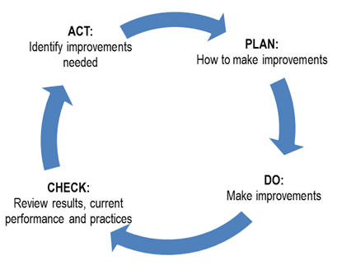
This is an opportunity to celebrate strengths and achievements. Communicating back to staff and customers/clients about the outcome of the self-assessment helps maintain their engagement in quality. .improvement.

Continuous Improvement

Resources
HSQF website:
www.dsdsatsip.qld.gov.au/our-work/human-services-quality-framework
Need more assistance?
Queensland Council of Social Service (QCOSS) website:
www.qcoss.org.au/

