Module two

Understanding impact of trauma for a child or young person

Activities

Brainstorm- slide 9 – Developmental stages

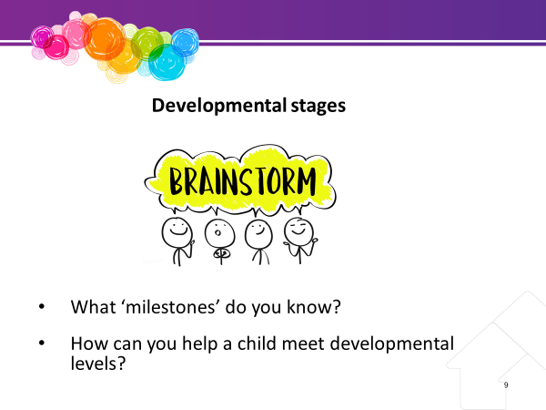
Time – 20 mins
Resources –
- Whiteboard
- Pens
- Handouts Child development & trauma
  - 0 – 12 months
  - 12 months – 3 years
  - 3 – 5 years
  - 5 – 7 years
  - 7 – 9 years
  - 9 – 12 years
  - 12 – 18 years

Display posters of child development from child health agencies around the room.

Ask the participants to brainstorm “milestones” that children and young people achieve as they grow.

Ensure the following is covered: for example:
- physical (walking, coordination)
- cognitive (thinking, speech development)
- emotional (trust, attachment)
- self confidence
- self-reliance
- social (sharing and cooperating) and
- moral (sense of right and wrong, consequences).

- Mark the years from 0-18 in increments of 2 years on the whiteboard.
- Now ask the participants to slot “milestones” against the age levels.
- Emphasise that all young people grow at different rates in all areas of development. Encourage discussion of how all children are different.
- Discuss why all children are different? Compare children whom participants have known. Discuss the environment, social conditioning, and biology as reasons for differences.
- What is likely to be happening for children in care? Use the case examples to show possible reasons for delays in development.
Ask the group what carers can do to assist a child or young person in meeting developmental levels? This should be an interactive session with participants giving examples from their experience/knowledge.

Physical – need to develop physical and coordination skills. Examples of what carer can provide –
- safety
- food
- shelter
- allow freedom to explore the environment
- encourage physical activities.
Cognitive – need to think, communicate, interpret the world. Carer can help develop:
- speech
- hold family discussions
- allow child or young person to take responsibility for tasks such as helping with shopping and menus.
Emotional - need a sense of trust, good self-esteem and exhibit appropriate behaviours. Carer can provide sense of:
- safety and security
- special room
- consistency
- encourage child or young person to identify and name feelings and deal with them in a positive way.
Social – need to develop relationships. Carer can provide opportunities for:
- social interaction
- invite friend’s home
- role model relationship skills.
Moral – need a sense of right and wrong, take responsibility for own behaviour. Carer can set:
- boundaries
- discuss consequences for behaviour and
- draw parallels from TV shows or books
Highlight that if a carer has concerns about developmental delays, they should discuss this with the CSO. A letter of support from a Doctor, Teacher or other can also be helpful in securing support for a referral.

Activity 1 – Slide 14 – Matching

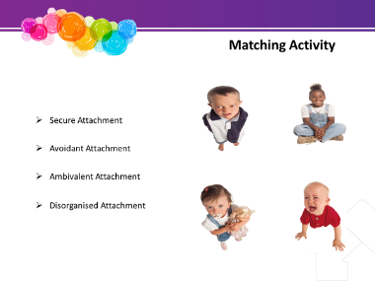
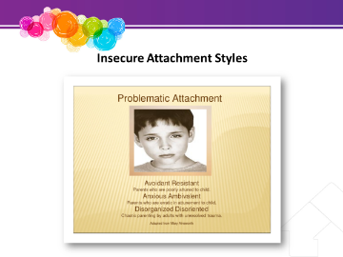
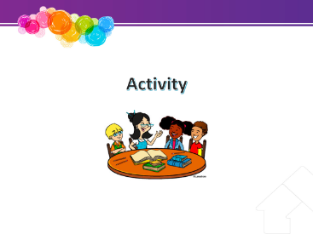

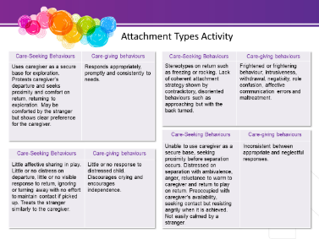

Time – 20 mins
Resources – Whiteboard /Pens
Handouts – Matching activity & attachment types

Provide participants with the matching activity and attachment types handouts.
Ask participants to match the child and care giving (the child’s carers) behaviours in the slide boxes to the four-attachment type Secure, Avoidant, Ambivalent and Disorganised.
Slowly read out the definitions of these as described for the trainer above next to slide 12 to assist the carers.
The trainer could also print out or write the definitions to assist the participants make the match. Then come back to the bigger group and discuss the answers
BRAINSTORM
Ask participants what might happen to prevent development of positive attachments for children. Examples might be:
- The person providing the care is unpredictable. This could occur because that person’s own needs are overwhelming (e.g. substance abuse), or they are experiencing domestic violence, or they are not able to parent effectively because of their own history and background or medical condition.
- The child or young person may have experienced repeated rejections by parents or foster carers. This may occur with repeated placement changes. Children learn that adults cannot be trusted.
- Inconsistencies in care or punishment techniques. This can occur with extremely stressful events – for example, abuse.

Activity 2 – Slide 19 – Behaviours of children who have experienced abuse

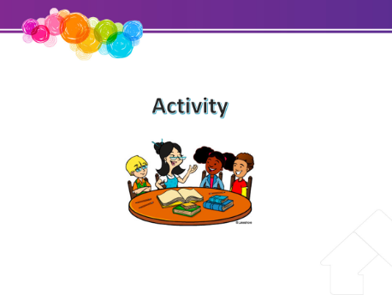

Time – 20 mins
Resources – Whiteboard /Pens
Handouts – Matching activity & attachment types

Explain that further information has been added to the case studies, although they are still about the same children.
Refer to Handouts “Case Studies 1, 2 and 3 - Part 2”. We have looked earlier at how each child would be feeling and the role the carer might play in meeting their needs. We will now consider the links between the experience of abuse and the child’s behaviour.
Consider the case studies again with Part 2. Ask participants to identify any behavioural indicators related to developmental stages, attachment issues and grief and loss for each child.
As a large group consider the following questions:
- What is the range of behaviours (both positive and negative) that each child is exhibiting? E.g. Possible behaviours – aggression, violence, attention seeking, self-harm, running away, clingy behaviour, overly dependent behaviour, lying, stealing.

- How could these behaviours be linked to the experience of abuse?

Activity 3 – Slide 21 – Myths and Facts about sexual abuse

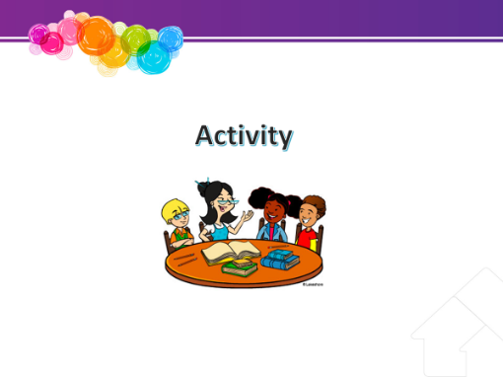

Time – 10 mins
Resources – Whiteboard /Pens
Handouts –The Myths and Facts about sexual abuse

It is common for children in care to have experienced sexual abuse.
Ask participants to get into small groups to read through and discuss “The Myths and facts about Sexual Abuse”
OPTIONAL Activity 4 – Slide 23 – Misunderstandings or allegations

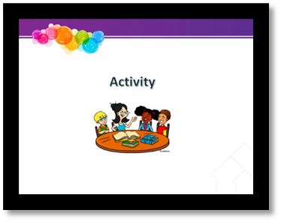

Time – 10 mins
Resources – Whiteboard /Pens

Experienced foster carer can facilitate
Ask the participants to get into small groups to discuss some ways they could reduce the likelihood that misunderstandings can occur, or allegations can be raised about them.
Bring back to the bigger group and discuss.

Activity 5 – Slide 29 – Role Play

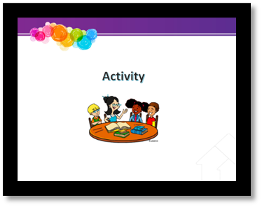

Time – 20 mins
Resources – Whiteboard /Pens

Presenters to role play a young person disclosing abuse to a foster carer.
Demonstrate an appropriate response:
- Remain calm and reassure the child that it is ok to talk about this. Tell them they have not done anything wrong
- Acknowledge their feelings
- Show them that you are listening to what they are saying and that you are taking it seriously
- Don’t conduct an interview or cross examine the child. Ask enough questions to act protectively e.g. “can you tell me some more about that?” “what happened next?”
- Refrain from offering your own opinions
- Tell the child or young person that you will both need to talk to their CSO together.

Brainstorm- slide 32 – Challenging behaviours

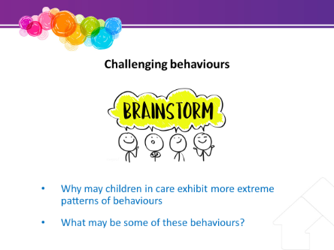

Time – 10 mins
Resources – Whiteboard /Pens
Handouts - Practice resource: Support Levels and behaviour characteristics

Experienced foster carer trainers to facilitate
Ask participants why children and young people in care may exhibit more extreme patterns of behaviours.
Ask the group what some of those inappropriate behaviours might be?
Relate these behaviours to the negative messages children and young people have learned about the world.
Handout – discuss briefly the different levels.

Activity 6 – Slide 41 – Positive behaviour support

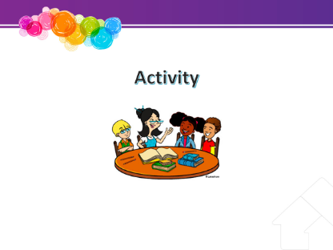

Time – 10 mins
Resources – Whiteboard /Pens

Ask large group for examples of inappropriate behaviour they have experienced in children or young people, either their own children, or children they have known. Point out that most children and young people will display some form of inappropriate behaviour at some time.
Ask participants about their attitude to inappropriate behaviour – illustrate how we can all have different attitudes to behaviours. Make the following points:
- We may have different thresholds of tolerance to some events – perhaps because of previous experiences. It is important to recognise what the “hot spots” are for us. Link to our own upbringing.
- The context of the behaviour may influence our attitude towards it, e.g. we may expect, or be more ready to understand changes in behaviour if a person is upset or has experienced a traumatic event.
Ask the participants for examples of where they effectively managed some challenging behaviour - what worked, why and would they so the same again?
Highlight the difficulties with providing general appropriate rules, boundaries and techniques to use because each child will be different and have experienced a different past. E.g. timeout might not be appropriate for children who have been abused by being left alone or excessively disciplined in this way.

Alternative activity
Alternatively, you could use the following activity.
Use some cardboard boxes and record on each box in large letters an example of one behaviour of a child. Ask for a volunteer to be a young person and ask them to hold each box as you identify the behaviour.
- Point out that this is how a child or young person will arrive on your doorstep. What will it mean for how you establish a relationship?
- How can you “relieve the load” – take each box away as the group identifies ways to respond to that behaviour?

Brainstorm- slide 47 – Discipline vs punishment

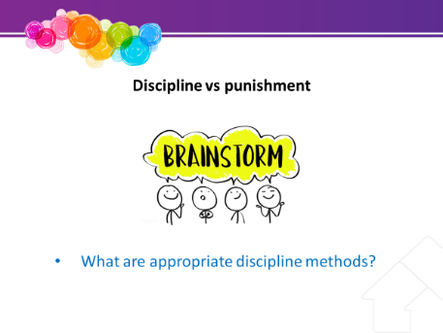

Time – 10 mins
Resources – Whiteboard /Pens

Advice participants that punishment should not be confused with discipline.
Appropriate discipline can assist the child or young person to feel safe and secure and in turn support the child or young person’s development. Appropriate discipline helps to keep children and young people safe from danger while supporting their emotional self-regulation and responsibility.

Brainstorm appropriate disciplinary methods. Record on the whiteboard.

