**Module one**

Context of Foster Care

## Activities

Activity 1 – Slide 7 - Why do you want to be a carer?

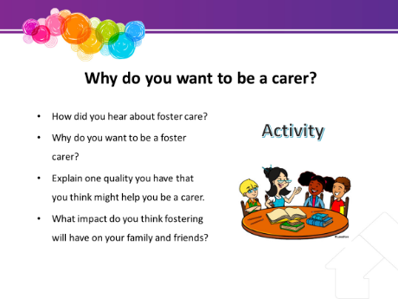

**Why do you want to be a carer?**

**Time** – 10 mins

**Resources** - none

Split into pairs and ask the other person the questions on the slide - Why do you want to be a foster carer?

When finished you will introduce the other person and provide their answers to the bigger group.

1. How did you hear about foster care?

2. Why do you want to be a foster carer?

3. Explain one quality you have that you think might help you be a carer.

4. What impact do you think fostering will have on your family and friends?

*The foster carer on the training team can run this part and give feedback from an experienced carer’s perspective.*

*Emphasise that everyone has different strengths and that there is no one “preferred” model. Children and young people coming into care have a wide range of needs and there needs to be a diverse range of people available to provide care.*

Activity 2 – Slide 8 and 9 – When does Child Safety intervene?

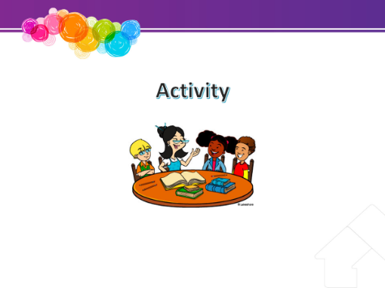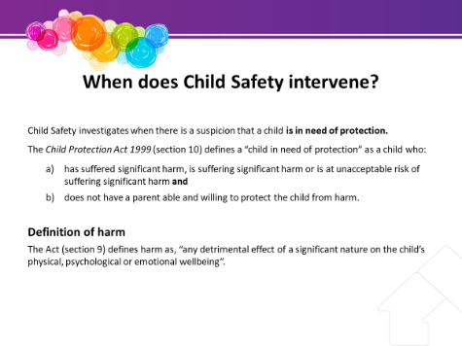

Provide participants with copies of the case studies 1 2 and 3 “Part 1” for them to read, noting the child’s background and current situation in each case study “part 1”.

Brainstorm- slide 10 – When does Child Safety intervene?

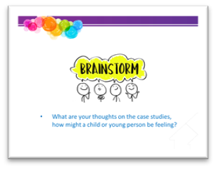

**Brainstorm**

**Time** –10 mins

**Resources** - Whiteboard / Pens

* Ask the group to give their initial responses to the case studies if used.
* Ask how they think a child or young person and their families may be feeling when placed in a care arrangement. Record these on the whiteboard.

Ensure the following is covered:

Feelings

* *helpless or depressed afraid*
* *ashamed*
* *sad and hurt*
* *angry*
* *frustrated and confused*

*Highlight how children and young people in care can have many varied experiences and it is important to recognise our own reactions in order to assist them deal with those experiences. It is also important to recognise that children and young people will not all respond in the same way to those experiences, and we should be mindful of their individual needs.*

Brainstorm – slide 16 and 17 – Types of abuse and harm

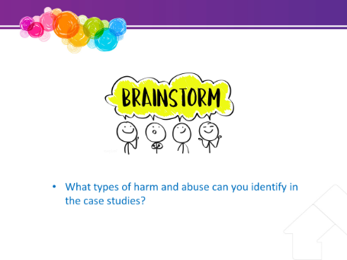

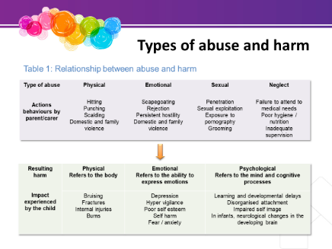

**Time** – 10 mins **Resources** – whiteboard / pens

Brainstorm with the group the abuse and harm (in two columns) in the case study. Also link to ongoing harm to the child that might be present when they are in care including low self- esteem, inability to express emotions appropriately, depression, suicide ideation, learning delays.

Record responses on the whiteboard. Responses should include physical, emotional, sexual abuse, neglect with examples of actions and impacts for each.

*Only where time permits- Introduce the concept of systems abuse – where a child is abused within the system designed for their care e.g.:*

*• abused in care arrangements*

*• drifting in care*

*• unnecessary dislocation from family and community*

***Optional Brainstorm***

**Time** – 10 mins **Resources –** Whiteboard / pens

*Only run this activity if you know it will fit within the timeframe for the day.*

* *Brainstorm protective factors and supports to parents.*
* *Ask the group to think of protective factors that may mean that a child can remain safe with their family even after harm has occurred.*

*If time permits also brainstorm:*

* *Any protective factors that they may have or use as a carer to support a child after a contact visit or to help enhance the child’s general wellbeing.*
* *Trainers can refer to the Appendix in the Practice Guide: the assessment of risk and risk of harm for more information on protective factors.*

Activity 3 – Slide 30 – PowerPoint String Sculpture

**Time –** 20 mins approx.

**Resources:**

* Name tags as per “roles” as described on PowerPoint slide “String Sculpture” and
* long roll of string or red tape.

***This activity is recommended for large training groups.***

* *String Sculpture – Alice’s story*
* *Refer to accompanying PowerPoint slide, notes for the activity can be found within the PowerPoint.*

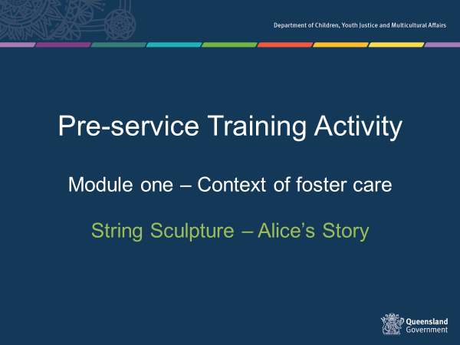

If you only have a single participant or a small training group, please complete the alternative activity on slide 51 – Jaxon’s scenario.

Activity 4 – slide 34, 35 & 36 – Principles of the Act

**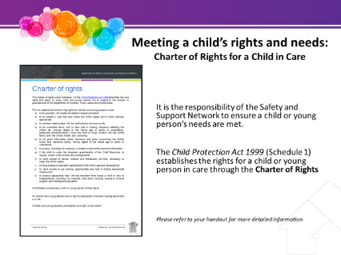***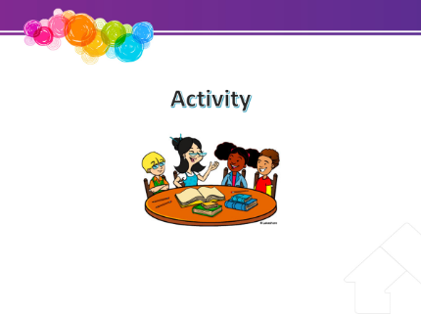*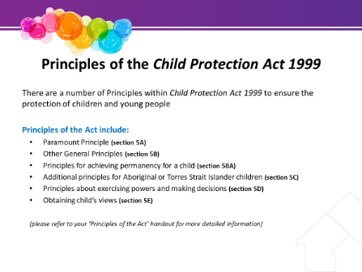

**Time –** 10 mins **Resources –** whiteboard / pens

* Do your values about families sit comfortably with the principles of the *Child Protection Act 1999*? Demonstrate with actual examples from within your own family or family of origin.
* Are there any conflicts or concerns between these principles and your own point of view?

*Give general feedback to the group.*

Activity 5 – slide 51 – Needs of Children

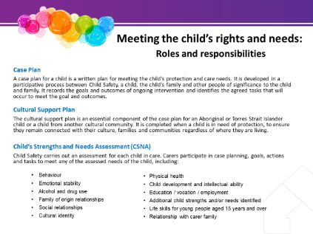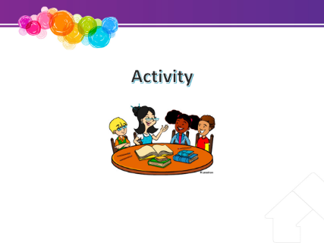

**Time –** 10 mins **Resources –** whiteboard / pens

***Refer to case studies 1, 2 and 3***

* Ask participants to read the case studies again and think about the needs these children or young people may have.
* Write these on the board
* Ask participants how they think a carer could meet these needs

Activity 6 – slide 51 – Jaxon’s situation

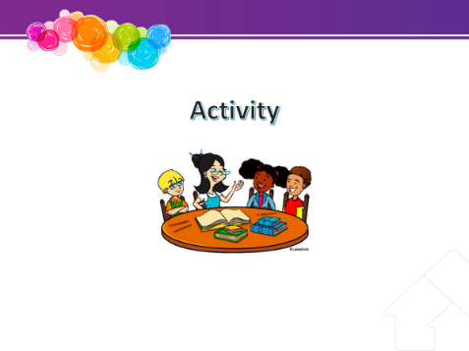

**Time –** 20 mins **Resources –** whiteboard / pens

***This activity is recommended for single participants or a small training group.***

* Provide the handout – *The situation - Jaxon* to your participants
* Work through the scenario with the participant/s and from the information discussed from ***Working together to meet the rights and needs of children and young people*** PowerPoint section have the participants discuss and complete the questions at the end of the scenario.