Strategic Overview
Director-General’s message
I am privileged to be the Director-General of the newly established Department of Child Safety, Youth and Women.
I am particularly grateful to our dedicated staff, service providers and partners who have worked tirelessly to ensure the strategic agendas and core business of both former departments have continued to be delivered while the new department has been consolidated.
Our service delivery
We have continued to bring greater safety and support, and hope and opportunity, to our most vulnerable families, women, children and young people, to engage young Queenslanders in shaping policy and services, and to improve gender equality and respect for women and girls across the state.
We continued to lead 82 of the 121 recommendations from the Queensland Child Protection Commission of Inquiry (Carmody Inquiry). As at 30 June 2018, 45 were completed and 37 on track under Supporting Families Changing Futures. In 2017-18, an additional 234 child safety staff were also employed, and more than 5200 foster and kinship carers continued to provide support for more than 8300 vulnerable children in home-based care.
Historic youth justice reforms commenced on 12 February 2018, with 17-year-olds transitioning to the youth justice system. Community-based bail and offender support services are already contributing to improved outcomes for young people held in youth detention.
We continued our strong commitment to the Queensland Domestic and Family Violence Prevention Strategy and Queensland’s 51st domestic and family violence shelter was opened in Far North Queensland. Our leadership of the Queensland Women’s Strategy and Queensland Youth Strategy also continued. In 2017-18, 46% of government board appointees were women. By June 2018, more than 1000 young people were on the Youth Engagement eHub and we held the inaugural Queensland Youth Week 2018 from 6 to 15 April 2018 to celebrate the achievements of young Queenslanders.
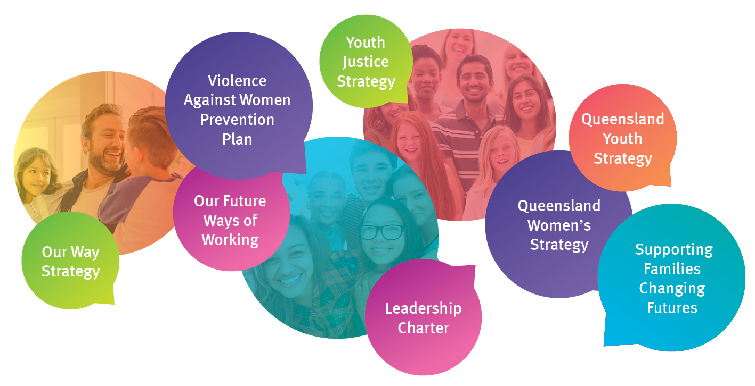
Our new department
The creation and transition to the new department was driven by a focus on better outcomes for children, young people, women and families.
The new structural and leadership arrangements were introduced in late March 2018. This brought together like functions to strengthen capacity and flexibility, and continue to give effect to our statutory and systems responsibilities. Changes to the central office structure came into effect on 3 April 2018 and changes to regional teams came into effect on 30 April 2018.
This realignment better targets our resources to client and community needs to ensure the department responds in a meaningful way to deal with increased demand and complexity.
Our valued staff
Our staff are dedicated and passionate about providing better services and support to Queenslanders experiencing vulnerability.
The department continues to create shared purpose, relationships, culture and leadership. There are already stronger links between our youth justice and child safety teams at a local and regional level and this will continue to mature, with a particular focus on children and families known to both statutory systems.
Our cultural capability
Building cultural capability and ensuring First Nations Peoples’ cultural identity, diversity and richness are central to our service delivery and decisions is at the core of our new department.
The First Nations Council was established to ensure culturally sensitive and respectful consultation and collaboration on matters of interest to Aboriginal and Torres Strait Islander staff. A permanent Indigenous Strategy and Partnerships team, led by a new senior executive, was also established to address the disproportionate representation of Aboriginal peoples and Torres Strait Islander peoples across our systems.
Our future state
Our new strategic plan provides a shared vision for Queenslanders to be safe and thriving in families and communities, and demonstrates how we contribute to Advancing Queensland’s Priorities. This is supported by new governance and engagement arrangements.
We will achieve our vision by working together to enable children, young people, women and families to be safe and to thrive in culture and communities, and to prevent and respond to crime, violence, abuse and neglect.
I look forward to continuing to build positive, collaborative engagement and partnerships with our staff, service providers and the community to deliver more holistic approaches to the complex and interrelated needs of our clients and communities into the future.

Michael Hogan
Director-General
Department of Child Safety, Youth and Women

Snapshot of our department
¹
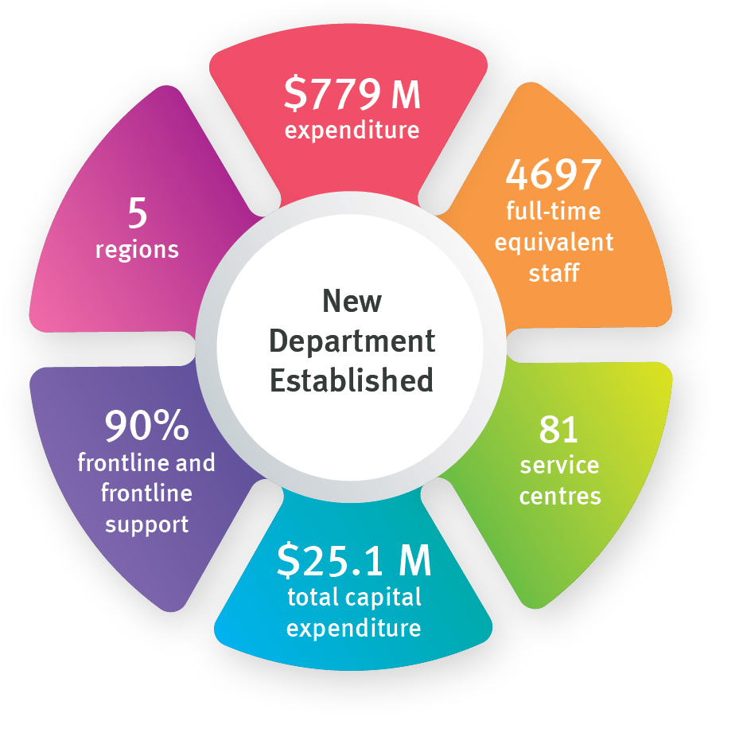
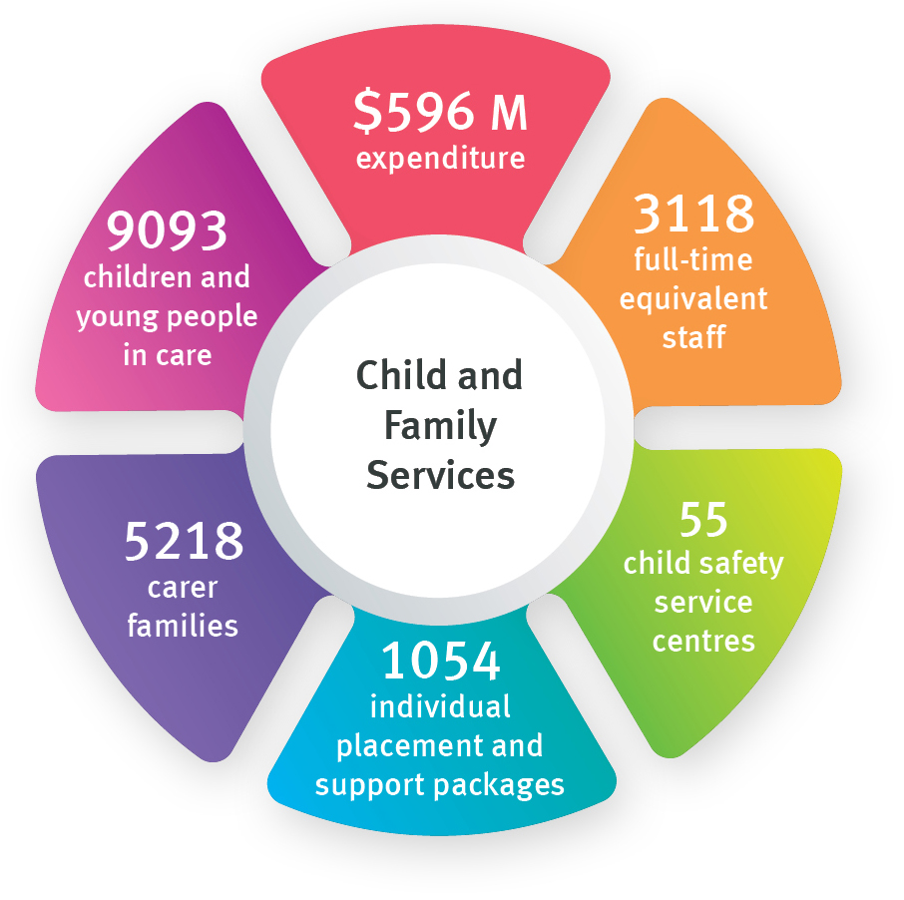
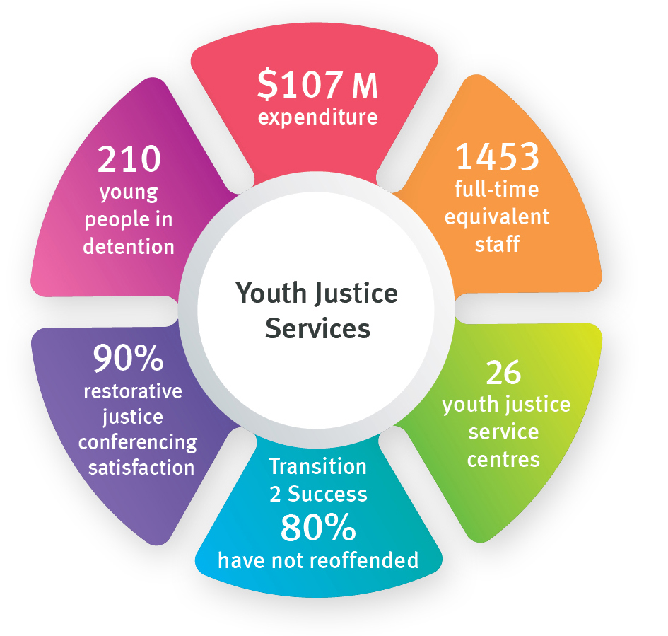
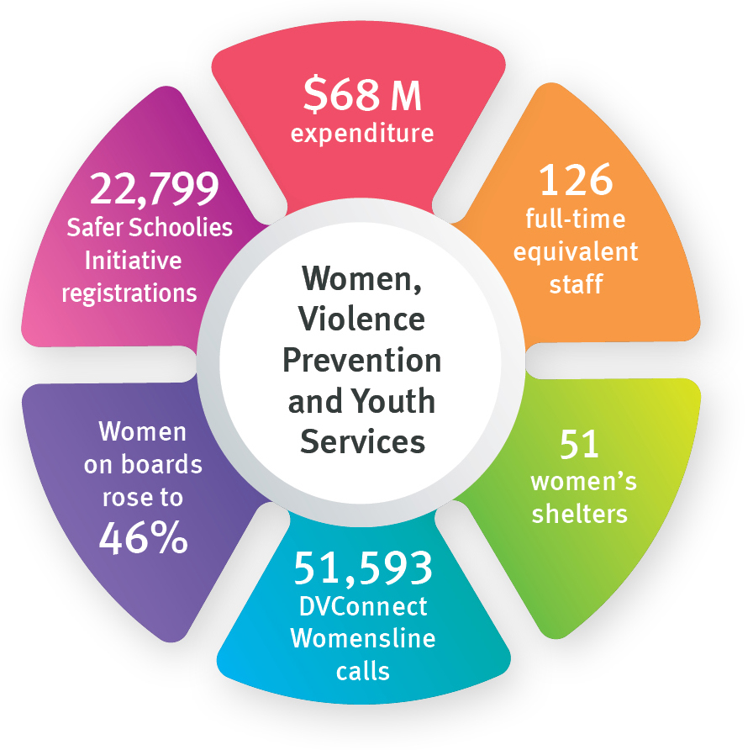
Notes:
- In accordance with the Annual report requirements for Queensland Government agencies, non-financial performance for service areas has been prepared on the basis that the service area has been in place for the full financial year. Financial performance reflects the establishment of the Department of Child Safety, Youth and Women effective 1 January to 30 June 2018. Full details on the department’s expenditure by service area is available in the financial statements on page 57.
Summary of financial performance
This summary of financial performance reflects the part year effect of machinery-of-government changes from 1 January to 30 June 2018. Accordingly, caution should be exercised when comparing financial years. A comprehensive view of the department’s financial performance is provided in the Financial Statements section of this annual report.
Operating result
The operating result for the department is a surplus of $15 million for the six months ending 30 June 2018.
Operating Result | 2017-18  Actual  $’000 | 2017-18  Adjusted Budget¹  $’000
Total income | 794,041 | 764,461
Total expenses | 779,033 | 764,461
Operating result | 15,008 | -
Income
The department’s primary source of income is appropriation revenue provided by the Queensland Government for provision of services. Appropriation revenue of $676.1 million from the former Department of Communities, Child Safety and Disability Services and $103.1 million from the Department of Justice and Attorney-General were reallocated to department as part of the machinery-of-government changes.
Revenue for the department totalled $794 million against the adjusted budget of $764.5 million. The variance of $29.5 million (3.87 per cent) is mainly due to the reallocation between departments as a result of machinery-of-government changes, increased user charges and other revenue.
Sources of income | 2017-18  Actual  $’000 | 2017-18  Adjusted Budget¹  $’000
Appropriation revenue | 779,332 | 760,086
User charges and fees | 8,952 | 3,746
Grants and other contributions | 1,076 | 612
Other revenue | 4,681 | 17
Total income | 794,041 | 764,461
Notes:
- These figures represent budgeted figures as published in the latest Service Delivery Statement tabled in Parliament.

