Governance, Accountability and Human Resources
Our objectives
- Provide capable, responsive, effective and accountable services.
- Value and support our staff.

Our strategy
We will invest in the development and capability of our staff, and enable them to partner effectively and drive innovation and improvement, and recognise their contributions. We will listen to our staff and address their concerns, provide safe, rewarding, flexible and supportive workplaces and make the safety, health and wellbeing of our staff a core priority so that we can achieve our vision.

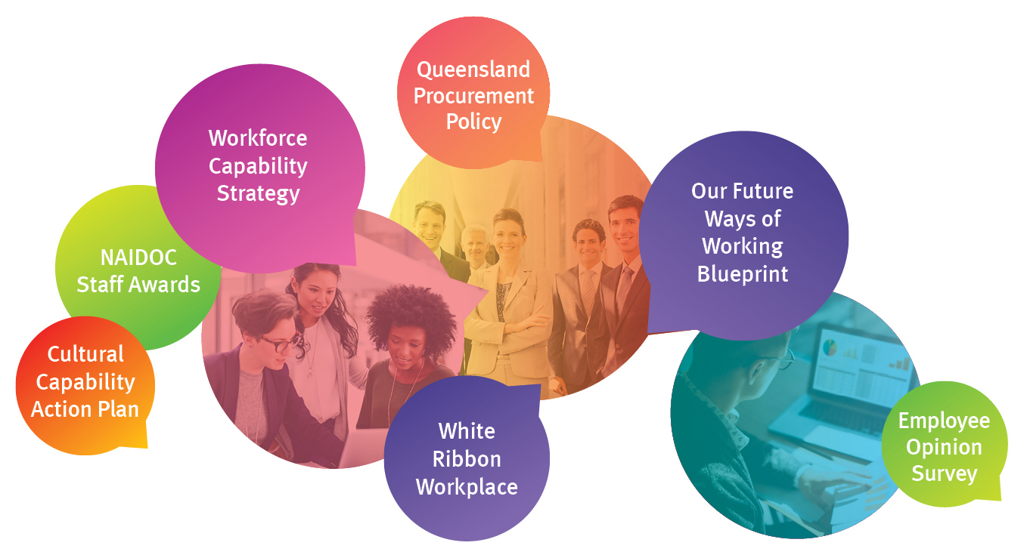

Our performance indicators
- Make our services easy to use, accessible and culturally meaningful.
- Provide capable, responsive, effective and accountable services.
- Positively engage employees and stakeholders.

Our achievements
- Continued maturing the department’s operating and organisational arrangements.
- Encouraged effective leadership, management and workforce planning practices.
- Strengthened the governance framework to support effective decision-making, integrity and accountability and driving performance improvement.
- Valued staff and enabled them to fully engage in priority reform programs, innovations and improvement initiatives.
- Built capability in progressing a performance architecture for the department.

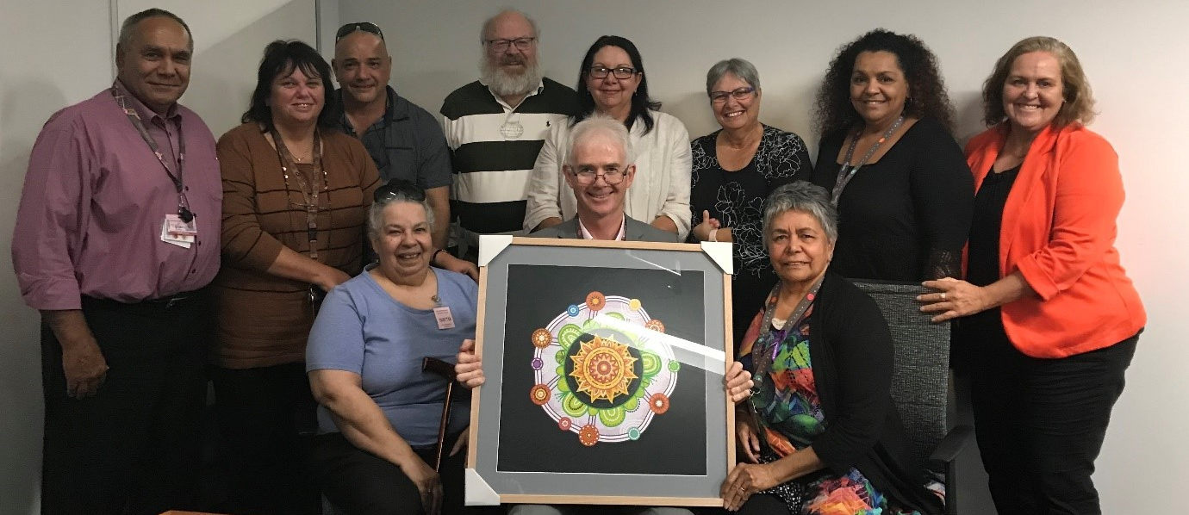
First Nations Council
The First Nations Council, formed in 2018, continues to provide strategic advice and a cultural lens on decisions, programs, policy and projects across the department. The First Nations Council’s role is to ensure culturally sensitive and respectful consultation and collaboration regarding decisions made in relation to Aboriginal and Torres Strait Islander children, families, communities and staff. The council gives Aboriginal and Torres Strait Islander departmental Elders, emerging leaders and other staff a voice at the highest level and acts as custodian of the Respectfully Journey Together Cultural Capability Action Plan and Cultural Capability Framework.
The department’s commitment to the three reconciliation themes of relationships, respect and opportunities from the Queensland Government Reconciliation Action Plan 2018–2021 is reflected in the continuation and support for the Council.
The First Nations Council works with the Portfolio Executive Board on priorities including: building Cultural Capability across the department; redress, healing and restorative justice; and the Our Way, child safety, youth and women strategies.
Current members of the First Nations Council as pictured from left to right, include: back row, Chair Ron Weatherall, Aunty Kim Thursby; Uncle David Don; Uncle Leslie Skelton; Aunty Sharon Smith; Aunty Rose Malone; Aunty Adelina Stanley; Aunty Tracey Motlop; front row, Aunty Maureen Ervine; Michael Hogan (as guest) and Aunty Lesley Williams. Members not pictured: Uncle Arnold Wallis and Aunty Helen Dingle.
NAVIGATE leadership and management program
The department’s leadership and management program NAVIGATE aims to strengthen Queensland’s child protection services by improving the leadership and managerial capabilities of child safety service centre managers and team leaders. NAVIGATE is a key deliverable of the Quality Improvement Program introduced to strengthen child protection service delivery and improve outcomes for children, young people and families.
NAVIGATE is delivered over 10 to 12 months, and is a combination of workshops, e-modules, action learning groups and supervision sessions, supported by workbooks, developmental tools and resources. The program is designed to complement the department’s existing REACH Leadership Framework, Leadership Charter and suite of leadership and performance development programs.

Innovation and technology
In 2018-19, the department successfully implemented the final phase of the Our Child Project. Our Child is a multi-agency information sharing platform, allowing for faster real-time sharing of information between agencies in the event of a child in care being reported as missing. Phase 1 was completed in March 2018 to enable real-time sharing of data between the Department of Child Safety, Youth and Women, Department of Education, Office of the Public Guardian and the Queensland Police Service. Phase 2 was completed in March 2019 and saw the introduction of key health data from Queensland Health.
In September 2018, the department launched Carer Connect, a web and mobile friendly app which was developed to provide Carers with improved and secure access to information and support. Carer Connect is an outcome of the Partners in Care initiative with Queensland Foster Kinship Care with more than 1,100 carers using the app since its launch. The app provides carers with immediate access to children’s important information such as their health history, cultural background, and critical care documentation such as Authority to Care forms and the child’s birth certificate.

Carer Connect also links with kicbox, the kids in care digital memory box which allows Carers to upload photos and post stories for the children in their care on their kicbox profile, providing them with a sense of belonging and lifelong memories. A huge benefit of the Carer Connect app is that child safety officers can show a child the carers profile when they are about to be placed, showing them photos of their home, their family and learning a bit about them, to help make the transition as easy as possible for the child.

Also in 2018-19, the department progressed the planning for the replacement of the core client management system, the Integrated Client Management System. This is a complex multi-year program called Unify, with the department delivering the Detailed Business Case, resulting in the Government committing funding for the first stage which commenced 1 July 2019.

These innovative solutions are complementing and continuously improving on the current child protection practices, providing more contemporary and direct channels between child safety staff and young people.

Building a fairer, more inclusive and harmonious Queensland
Under the Disability Services Act 2006, each Queensland Government department is required to develop a Disability Service Plan. The department’s Disability Service Plan 2018–2020 outlines the actions we will take to progress the priorities of the All Abilities Queensland: opportunities for all state disability plan. The plan clearly demonstrates how we will work with our partners to build a fairer, more inclusive Queensland where people with disability, their families and carers are able to access the same opportunities, on the same basis as everyone else. A copy of the plan and annual report on our progress can be found at: https://www.csyw.qld.gov.au/about-us/our-publications/corporate-publications.
Our story, our future is the Queensland Government’s multicultural policy promoting an inclusive, harmonious and united community for Queensland. The policy is being implemented through a three year Queensland Multicultural Action Plan. The policy and action plan are a requirement of the Multicultural Recognition Act 2016 (the Act) and represent one of three key provisions of the Act, together with establishing the Multicultural Queensland Charter and Multicultural Queensland Advisory Council.
In accordance with section 24 of the Act, a copy of our report on our progress can be found at: https://www.csyw.qld.gov.au/about-us/our-publications/corporate-publications.

Management and structure
Governance framework
An effective and efficient governance framework provides the best possible mechanisms for making decisions that are accountable, transparent and responsive to ensure delivery of the strategic intent of the department. The department’s governance framework was designed around eight key principles and minimum requirements demonstrating how the department meets these minimum requirements.
Principles | Requirements
Solid foundations for management and oversight | Clear strategic, corporate and operational plans
 | Regular reporting against plans
 | Clear accountability and delegations
 | Clear focus on diversity and cultural capability
Committees that add value | Well defined set of committees
 | Clearly defined organisational structure
Frameworks for ethical culture | Clear ethics and conduct framework
 | Strong fraud and corruption control framework
 | Compliance management
Safeguards for integrity in corporate reporting | Parliamentary and organisational governance committees
 | Internal and external audit
 | Director-General and CFO sign-off of financial reports and statements
Timely and balanced public reporting and disclosure | Annual report
 | Continuous disclosure of and access to information
Fair and responsible performance management | Executive performance and development agreements
 | Staff performance and development framework
Enterprise risk management approach | Risk management program
 | Director-General and CFO sign-off on adequacy of internal controls
Community, stakeholder, client and staff engagement | Community engagement, consultation and communication channels
 | Staff satisfaction, engagement and consultation

Governance committee structure
The department’s governance structure is based on four key governance tiers: executive governance; leadership and performance governance; corporate governance; and customer and stakeholder voices. This governance structure continued to support Youth Justice Services until machinery-of-government changes were finalised.
Our executive governance committees provide stewardship of the agency’s strategic direction and performance, and assurance of conformance with statutory obligations, probity and propriety, regulatory compliance and access, equity, inclusion, diversity and cultural capability. Our executive governance committees are:
- Portfolio Executive Board
- First Nations Council
- Executive Leadership Committee
- Audit and Risk Committee.

Our Child and Family Leadership and Performance Committee and Youth Leadership and Performance Committee (including Youth Justice Services) provide oversight of design, monitoring and review of strategy implementation and service delivery, economy and efficiency, cost-effectiveness, and access, equity, inclusion, diversity and cultural capability.
Our corporate governance committees provide oversight of resources and financial performance, information management and innovation, investment and partnerships, and access, equity, inclusion, diversity and cultural capability. Our corporate governance committees are:
- People, Safety and Culture Committee
- Finance and Budget Committee
- Investment and Partnerships Committee
- Information and Innovation Committee
- Fraud and Corruption Control Committee.

Our customer and stakeholder voices committees inform vision and strategy, design and implementation, monitoring and review, and access, equity, inclusion, diversity and cultural capability.
The Director, Governance undertook a review of the committees in 2018-19. The committees were generally found to be operating as intended, with some committees more mature than others.
It was recommended that in 2019-20 the two Leadership and Performance Committees be combined to reduce duplication and improve focus on strategy and delivery performance.
Following machinery-of-government changes, which transferred Youth Justice Services to the new Department of Youth Justice, in 2019-20 the Portfolio Executive Board will be renamed the Executive Board and focus only on the Department of Child Safety, Youth and Women.
Both departments will continue to share the expertise of the First Nations Council and the Information and Innovation Committee.

Executive management
The Portfolio Executive Board is the key strategic governing body for the department. It drives the department’s strategic goals that enable Queenslanders to be safe and thriving in families and communities.
It leads a whole-of-department approach to strategy and governance, leadership and performance, and risk management, and provides the right conditions to drive innovation and continuous improvement, while developing and fostering senior leadership talent.
Portfolio Executive Board members promote a collegiate culture, encourage robust discussion and exemplify the values of the public sector and the department’s commitment to growing our cultural capabilities. Portfolio Executive Board members as at 30 June 2019 are listed below.
Michael Hogan, Director-General (Chair), BA (Hons), LLB
Michael was appointed as Director-General, Department of Communities, Child Safety and Disability Services in April 2014 and as the Director-General for the Department of Child Safety, Youth and Women since late 2017.
Michael has held various senior executive roles in the department and its predecessors, as well as in the departments of the Premier and Cabinet in Queensland and New South Wales since 1997.
Michael also spent 10 years in the non-government sector and has served on a number of community sector and government boards.
Leigh Roach, Deputy Director-General, Strategy, BA (Economics), GradDip Securities Institute of Australia
Leigh was appointed as Deputy Director-General in the former Department of Communities, Child Safety and Disability Services in May 2015 and is now the Deputy Director-General, Strategy.
Leigh has worked in senior positions in both Australian and state governments and developed expertise in trade, industry, innovation, employment and consumer policy and programs.
Leigh also has expertise in managing organisational change and has facilitated major change processes in service delivery for business and across the public sector.
Rob Seiler, Deputy Director-General and Chief Operating Officer, Service Delivery, BA (Humanities), GradDip Education
Rob was appointed Deputy Director-General and Chief Operating Officer on 1st July 2018.

Rob has held various senior executive roles in Government and Statutory Authorities in Queensland. Rob began his career as an educator and served as a principal at many schools throughout the state, ranging from small rural communities to large metropolitan settings.

Rob has a commitment to supporting the pathways for children and young people. Rob was awarded a Public Service Medal / Australia Day Achievement Award in 2013 for outstanding client service.

Amanda Currie, Assistant Chief Operating Officer, Service Delivery, BSocSc (Human Services)
Amanda was appointed to the temporary role of Assistant Chief Operating Officer in August 2018.
Amanda has been actively engaged in the youth and community care sector since 1995 as a Family Services Officer for the then Department of Families, Youth and Community Care at the Inala and Goodna offices. Amanda gained a wide range of policy development and implementation experience in areas as diverse as youth justice, child protection and violence prevention.
In 2009, she was appointed Regional Executive Director for South East Region, Department of Communities, Child Safety and Disability Services
Arthur O’Brien, Assistant Director-General, Corporate Services, FCPA FIPA, MBus (Professional Accounting), BBus (HRM)
Arthur was appointed Assistant Director-General, Corporate Services on 3 May 2018, following appointment as the Chief Finance Officer for the new department from 12 December 2017 to 3 May 2018. Prior to this he was Chief Financial Officer of the former Department of Communities, Child Safety and Disability Services.
Arthur has more than 37 years’ experience in the Queensland Government with 20 years’ experience in senior management roles. Arthur has held a variety of senior executive positions across a number of Queensland Government agencies with experience in strategic management, planning, policy, risk management, finance and business continuity, as well as leading a number of major change projects for the Queensland Government.
In 2008, Arthur was awarded the Distinguished Service Medal for his commitment and contribution to the Queensland Ambulance Service and the Queensland community.
Darrin Bond, Assistant Director-General and Chief Information Officer, Information, Innovation and Recovery, BSc (IT/Mathematics)
Darrin was appointed the Chief Information Officer for the former Department of Communities, Child Safety and Disability Services in 2012; and post machinery of government changes, was appointed the role of Assistant Director-General and Chief Information Officer of the Department of Child Safety, Youth and Women in late 2017, taking the role of CIO for not only CSYW but also the Department of Communities, Disability Services and Seniors and the Department of Youth Justice.
Darrin has over 32 years’ experience working in Government and Executive management roles and the Information and Communication Technology industry. Darrin has overseen the delivery of a number of strategic and innovative initiatives including moving services to the cloud; automation of ICT service delivery; integrating data across government agencies to assist in the search for missing children, with the implementation of the Our Child solution; and digitising services across the child protection system to staff, partners, foster carers and vulnerable children by delivering solutions such as kicbox, Carer Connect and CS Xpress.
Darrin has recently overseen the delivery of the Detailed Business Case for the replacement of the Integrated Client Management System and the commencement of the Unify Program Stage 1 in July 2019.
Arna Brosnan, Regional Executive Director, North Queensland Region, BSocWk, LLB
Arna was appointed as Regional Executive Director, Northern Queensland Region in November 2016. Prior to this appointment, Arna was Regional Director, Child and Family Services, Far North Queensland since 2009. She has extensive experience in both the child protection and youth justice sectors.
Arna has worked in the human services sector across Far North and North West Queensland leading structural changes and practice reform principally in the child protection sector. Arna is an executive lead for the Cairns Safer Streets, a cross government initiative to improve outcomes in particular locations in Cairns.
Michael Shearer, Regional Executive Director, Central Queensland Region, BHumanMovSt
Michael has 33 years’ experience in the human services sector having worked within several Queensland Government departments throughout the state. He was first appointed to the role of Regional Executive Director in 2005.
He has delivered, managed and led child protection, youth justice, social housing, disability and community services during his long career. Michael has been instrumental in developing the department’s cultural capability framework and in progressing a number of significant service delivery initiatives.
Michael is an ANZSOG fellow, and plays a coordinating role in the OneGovCQ Leadership Group which aims to improve collaboration and build public sector capacity in Central Queensland.
Julieann Cork, Regional Executive Director, Moreton Region, BSocWk
Julieann was appointed to the role of Regional Executive Director, Moreton Region in September 2016. Prior to this, Julieann was the Regional Director, Child and Family Services, North Coast Region since September 2010.
She commenced in the department in 1999 following work as a Clinical Social Worker in the Mater Hospitals, Brisbane. Julieann has held leadership roles across a wide range of the department’s business areas, including strategic policy, program development, service development, legislative and funding reform units. Immediately prior to moving to North Coast Region, she was Director of the Right to Information, Information Privacy and Screening unit.
Tracey Ryan, Acting Regional Executive Director, South East Region, BPsych (Hons)
Tracey has been employed as the Regional Director, Child and Family and Adoption Services (Gold Coast and Bayside) since 2016. Most recently Tracey is acting as the Regional Executive Director, South East Region.
Tracey has worked in human services for more than 26 years including in service delivery for mental health and child protection and the development and implementation of policy, program and commissioning functions for a broad range of human services delivered in Queensland.
Prior to her position as Regional Director, Tracey was employed as Director, Child and Family Services in South East Region from 2012 to 2016 and Regional Director for Community Services and Sport and Recreation in the former Department of Communities for a number of years previous to this.
Tracey has also worked in leadership positions in Queensland Treasury and the Department of Housing and Public Works, and has extensive experience in developing and leading non-government organisations.
Bernadette Harvey, Regional Executive Director, South West Region, BA (Welfare and Psych), BSc (Psych), LLB, EMPA
Bernadette commenced as Regional Executive Director, South West Region in April 2018.
Prior to this, Bernadette was the Executive Director, Child and Family Reform from 2016 and then Executive Director, Operations. Bernadette was the Regional Director, Child and Family (Central Queensland) from 2011 to 2016.
Bernadette joined the department in 1992 as a child care officer working in statutory child protection and juvenile justice. Over the past 27 years, she has worked in a variety of regional direct service delivery and leadership positions across both youth justice and child protection.
Danny Short, Chief Finance Officer, Financial Services, FCPA BCom
Danny was appointed the Chief Finance Officer, Department of Child Safety, Youth and Women in March 2018.
Danny has almost 30 years’ experience in accounting, governance and financial management across a broad range of Queensland Government organisations. In the past 15 years at a senior management level, he has been responsible for corporate and strategic governance, financial performance, budget management and strategy together with risk management, business services and procurement.
Danny provides expert advice and support to the department in relation to financial and resource management, budget strategy, statutory financial reporting and policy, and governance. Danny works collaboratively with colleagues from across government including Queensland Treasury, Department of the Premier and Cabinet and the Queensland Audit Office.
Shannan Quain, Executive Director, People and Culture, and Chief Human Resources Officer, B App Sci, Grad Cert Bis, Dip Business, Dip Training and Assessment
Shannan is currently Executive Director, People and Culture, and Chief Human Resources Officer.
Since commencing in the role in December 2018, Shannan has led People and Culture to be more focussed on human centred design and the employee experience. Shannan has implemented a whole of sector Workforce Planning Community of Practice and is leading the way on workforce design reforms with Child Safety. Safety and Wellbeing has been a key focus with the launch of the Wellbeing Portal for all staff to access resources that help to support and promote safety and wellbeing.
Shannan has worked in a range of senior leadership roles in state and federal government and was a finalist in the HR Manager of the Year in 2018 and was named as a HR Rising Star 2018 by HR Director Magazine. As part of the National Australia Day Awards, Shannan received the Australian Statisticians Award for her work in Capability Development in the Australian Public Service.
Shannan has a Bachelor of Applied Science from Queensland University of Technology and a Graduate Certificate in Business from the University of Queensland.
Ron Weatherall, Executive Director Indigenous Strategy and Partnerships, B Bus (Accounting)
Ron is an Aboriginal man descendent from the Kamilaroi peoples of South West Queensland and northern New South Wales.
Ron was appointed to the position of Executive Director, Indigenous Strategy and Partnerships, in June 2018. Ron has over 30 years’ experience in senior executive positions across the State and Commonwealth public services, and was a former Deputy Director-General, for the Department of Aboriginal and Torres Strait Islander Partnerships (DATSIP) in Queensland, and the Regional Director, Child Safety, in Central Queensland.
Ron has experience in strategic management, planning, and policy development in the areas of Indigenous affairs, child protection, and employment and training, and has led a number of major reforms across these areas.
Darren Hegarty, Senior Executive Director, Youth Justice Services and Sandra Moore, Regional Executive Director, North Queensland Region were members of the Portfolio Executive Board until commencement of the Department of Youth Justice on 20 May 2019.

Public service values and ethics
The department has embraced the Queensland public sector values (customers first, ideas into action, unleash potential, be courageous and empower people) which define the way we do business. We pursue a positive organisational culture that fosters a high performing, impartial and productive workforce to actively support Queensland’s most vulnerable people.
We are committed to the highest level of ethical conduct and promote a culture that reflects the department’s integrity framework, ensuring any allegation of corrupt conduct is taken seriously and thoroughly assessed. Public service values and ethics are reflected in our departmental policies, procedures and plans. The department also regularly provides ethical decision-making and code of conduct training with a total of 2,417 staff completing the ethics related training during 2018-19.
Allegations of corrupt conduct, or breach of the Code of Conduct for the Queensland Public Service or certain legislation are referred to the department’s Professional Standards unit to ensure all allegations are properly assessed. The matter is assessed with consideration given to the definition of corrupt conduct outlined in section 15 of the Crime and Corruption Act 2001 and the Public Interest Disclosure Act 2010.
During 2018-19 the department finalised:
- 13 corrupt conduct matters for Child and Family Services
- No corrupt conduct matters relating to Women, Violence Prevention and Youth Services.

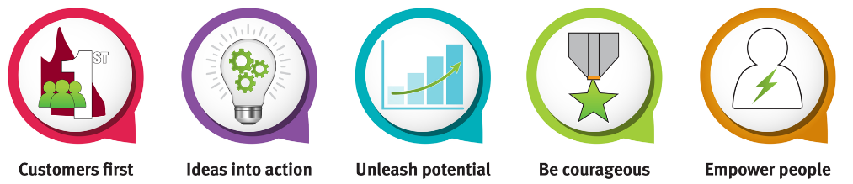
Risk management and oversight
Risk management
The Financial Accountability Act 2009 requires the accountable officer to establish and maintain appropriate systems of internal control and risk management. The new governance arrangements ensure risks are considered at all levels of the department, with the Audit and Risk Committee providing oversight of the effective performance of the department’s risk management framework.
The framework, based on the revised international standard ISO 31000:2018 Risk management guideline, outlines a consistent method of managing risk across the organisation. The risk management program has been designed to ensure the risks facing the department are identified and managed, in an effective, structured and coordinated way. Mitigation plans and a robust control environment ensure risk management is a contributory factor in the successful achievement of our objectives.
The department’s strategic risks have been revised in-line with the updated strategic plan. The department manages its financial risks and liabilities by reviewing financial performance through our governance framework. The Audit and Risk Committee, supported by the Fraud and Corruption Control Committee, provides risk guidance and leadership around audit activities, audit recommendations, financial reporting, fraud and corruption, internal controls and compliance.

Audit and Risk Committee and internal audit
The department’s Audit and Risk Committee, with responsibility for overseeing the performance of the internal audit function, meets quarterly and is chaired by an external member.
The department receives its internal audit and compliance services from the Department of Communities, Disability Services and Seniors (DCDSS). The arrangement is formalised under a Memorandum of Understanding, which provides independence of departmental management and external auditors.
The appointed Head of Internal Audit, Ms Aline Fos Dupret satisfies the requirements of a Head of Internal Audit under the Financial Accountability Act 2009 and the Financial Accountability Regulation 2019 Section 5 as a Professional Member, Institute of Internal Auditors – Australia (PMIIA) and a Certified Internal Auditor (CIA).
The internal audit function is undertaken in accordance with a strategic internal audit plan approved by the Director-General. The Internal Audit Charter is consistent with relevant legislation, better practice guides and international internal auditing standards. Internal Audit’s assurance activities complement departmental monitoring practices and oversight from external regulators and central agencies.
In 2018-19 the following Internal Audit Reviews were completed:
- Child Safety Data Governance Framework
- ICT Procurement Process.
Legislative Compliance and the Separation Process audits were completed for Youth Justice Services.
External scrutiny
The department is subject to a number of external review bodies, including Queensland Audit Office, State Coroner, Crime and Corruption Commission and Queensland Ombudsman. Significant 2018-19 audits and reviews that relate to the department are outlined below.
Queensland Audit Office reports tabled in the Queensland Parliament
The Queensland Audit Office (QAO) is the independent auditor of the Queensland public sector. They conduct financial audits and performance audits to provide public confidence in the reliability of public sector entity financial statements and operating performance. The following reports are applicable to the department:
Audit report | Audit remediation
Report 1: Monitoring and managing ICT projects | In this audit, QAO explored whether monitoring projects at the departmental and whole-of-government levels have improved successful delivery of ICT programs and projects.  Recommendation was all departments implement efficient and automated processes for collecting, collating, approving and publishing dashboard data; publish data to the dashboard that is consistent with QGCIO publishing criteria and guidelines and consider the needs for projects with high business impact to undergo periodic health checks.
Report 3: Delivering shared corporate services in Queensland | In this audit QAO assessed whether the government’s shared service providers are delivering value for money and are positioned to successfully deliver into the future.  Recommendation was that each customer of a shared corporate service provider contribute to driving the effectiveness and efficiency of shared corporate services by providing providers with quality inputs, consider the effect on efficiencies and economies of scale; continue to communicate any proposed changes to demand for services; effectively monitor performance of shared service providers and continue to collaborate on improvement initiatives.
Report 20: Follow-up of managing child safety information | In this follow-up audit, QAO assessed whether the department has effectively implemented the recommendations they made in Managing child safety information (Report 17: 2014–15) to improve information sharing and security.  They also assessed whether the actions taken have addressed the underlying issues that led to our recommendations in that report.  No new recommendations were made as a result of the follow-up report and the department has taken steps to address some of the underlying issues.
For a complete list of reports tabled by the Queensland Audit Office visit: https://www.qao.qld.gov.au/reports-resources/parliament.
State Coroner
Under the Coroners Act 2003, coroners are responsible for investigating reportable deaths that occur in Queensland. On occasion the coroner may decide to hold an inquest and make recommendations to prevent similar deaths. The department’s Legal Services branch directly manages the department’s response where the Coroner is interested in actions of the department. The Coroner made no recommendations for the department in 2018-19.
Crime and Corruption Commission
The Crime and Corruption Commission (CCC) aims to reduce the incidence of major crime and corruption in the public sector in Queensland. Its functions and powers are set out in the Crime and Corruption Act 2001. The CCC made no recommendations for the department in 2018-19.
Queensland Ombudsman report
The Queensland Ombudsman’s role is to give people a timely, effective and independent way to have administrative actions of agencies investigated; improve the quality of decision-making and administrative practice in government agencies; and provide oversight of the Public Interest Disclosure Act 2010.
The Queensland Ombudsman made no recommendations for the department in 2018-19.
It is noted that the Brisbane Youth Detention Centre report was tabled in parliament in March 2019. Due to machinery-of-government changes this submission now relates to the new Department of Youth Justice, which was established on 20 May 2019.
Queensland Family and Child Commission
The Queensland Family and Child Commission (QFCC) works collaboratively to influence change so Queensland is a safe place where children, young people and their families thrive in supportive communities. It keeps a check on the system through reviews, research and by listening to children, families and communities. While no reports were released during 2018-19, implementation of relevant previous QFCC recommendations has continued.
Office of the Public Guardian
The Office of the Public Guardian (OPG) provides a visiting program to protect the rights and interests of children and young people in care and at visitable sites, including youth detention centres and adult corrective services facilities.
This is complemented by the Public Guardian’s child advocate program.
Both of these services aim to help children and young people to resolve issues and disputes, make complaints, and provide support for them in court proceedings and other processes where decisions are to be made in relation to their care.
The Office of the Public Guardian made no recommendations for the department in 2018-19.
It is noted that a Submission to the Legal Affairs and Community Safety Committee on the Youth Justice and Other Legislation Amendment Bill 2019 was tabled in Parliament in April 2019. Due to machinery-of-government changes this submission now relates to the Department of Youth Justice, which was established on 20 May 2019.
Child death reviews
Queensland has a two-tiered review system for reviewing involvement with children and young people known to the department who have died.
Internal
The department undertakes systems and practice reviews of its involvement following the serious physical injury or death of a child who is known to the department in the year prior to their injury or death or at the request of the Minister.
Systems and practice reviews are conducted in accordance with Chapter 7A of the Child Protection Act 1999 and focus on facilitating ongoing learning and improvement in the provision of services and promoting the accountability of the department.
External
Independent and external Child Death Case Review Panels review the department’s reviews as the second tier of the review system.
Findings from Child Death Case Review Panels are used by the department to inform improvements to practice and implementation of the reform program.
In accordance with section 246HL of the Child Protection Act 1999, within three months after the end of each financial year, the Director-General will prepare, and give to the Minister, a report about the operations of review panels during the financial year and actions taken during the financial year in response to reports given to the Director-General.
Workforce planning and performance
Workforce profiles
Our staff are dedicated and passionate about providing professional support to some of Queensland’s most vulnerable people, and we continue to grow our workforce to improve our services with almost 90 per cent of all staff employed in either frontline or frontline support roles. The service delivery breakdown of our 3486.78 full-time equivalent staff is highlighted below. This figure is post machinery-of-government change.
Service Delivery | Department Total
Frontline and frontline support | 3,008.14 (86.27%)
Corporate | 478.64 (13.73%)
Total | 3,486.78 (100%)
A breakdown of our full-time equivalent employment status is as follows:
- 2813.43 permanent staff (80.69% of the total staff)
- 642.51 temporary staff (18.43% of the total staff)
- 26 contract staff (0.75% of the total staff)
- 4.84 casual staff (0.14% of the total staff).

The department’s employment diversity (as at 21 June 2019) compared to the Queensland Public Sector (QPS) benchmark average (as at the quarter ended 31 March 2019) is detailed below.
Diversity category | Department¹ | QPS average
Gender Diversity – Women | 83.40% | 69.55%
Culturally and linguistically diverse | 9.70% | 9.51%
Aboriginal and/or Torres Strait Islander | 5.63% | 2.26%
People experiencing disability | 2.19% | 2.87%
Notes:
- As at pay period ended 21 June 2019, the Equal Employment Opportunity response rate was 84.32% for the department compared to the Public Service Commission target response rate of 85%.

Workforce capability strategy
We are invested in the development and capability of our staff and will enable them to partner effectively and drive innovation. Frontline child protection staff deal with serious domestic and family violence, substance misuse, mental health, sexual abuse and other complex matters to keep children safe. We are dedicated to listening to our staff and providing a safe, supportive, rewarding and flexible workplace. The safety, health and wellbeing of our staff are a core priority for all leaders in the department, as this enables us to achieve our vision.
The department is highly committed to developing and supporting its staff through contemporary people and culture solutions such as leadership development programs, wellbeing and safety systems, accessible human resources policies and processes and human centred design approaches to our strategic workforce planning. The department has made a commitment to ensure:
- we make our services easy to use, accessible and culturally meaningful
- we provide capable, responsible, effective and accountable services
- we positively engage our workforce and stakeholders.

Staff can access a wide variety of development opportunities including leadership development programs, mentoring programs, an e-learning platform with over 170 courses and financial assistance and/or paid leave for study. Investment in management and leadership skills is a priority. The NAVIGATE program was implemented to complement existing leadership and performance development programs. Our leadership charter outlines expected behaviours and outcomes from leaders, including:
- Authenticity – We build and sustain honest and respectful relationships.
- Connection – We collaborate with our stakeholders and engage with our staff to build capability.
- Stewardship – We deliver a customer centred approach and perform within an ethical framework.
- Value – We are passionate and proud and we recognise our diversity by building cultural competence.

Staff performance development
Through the Achievement and Capability Planning process staff are able to negotiate, plan and share information about their role and performance. This two way feedback and planning process allows employees to have a clear view of their responsibilities and areas of development. This jointly developed plan is continually updated through regular conversations between an employee and their manager. The discussions focus on role expectations, performance, career planning and development. Managers receive training on how to best engage with their teams through the range of leadership development programs available.
Workforce attraction, recruitment and retention
There remains a strong focus on attracting, developing and supporting our highly skilled and dedicated staff. In 2018-19 we undertook a review of our attraction and recruitment approach and a key focus in 2019-20 will be the delivery of improvements in tools and practices so that our processes are culturally appropriate, flexible and efficient. To support work-life balance, we provide flexible work arrangements including compressed work hours, flexible start and finish times, and telecommuting.
We continually invest in our staff’s wellbeing through a broad range of professional workplace health services for both staff and their family members. In 2018-19 we increased the number of counselling sessions that staff can access at no cost from our Employee Assistance Provider program.
The absenteeism rate for staff for the quarter ended 30 June 2019 was 4.1 per cent. The Queensland Public Sector (QPS) benchmark was 4.51 per cent (this is a quarterly benchmark).
Early retirement, redundancy and retrenchment
There were 28 voluntary redundancies recorded for 2018-19 attributable to the National Disability Insurance Scheme transition that were previously managed by the Department of Communities, Seniors and Disability Services.
Complaints management, information systems and recordkeeping
Complaints management system
The department provides a complaints management system, in accordance with 219A of the Public Service Act 2008, allowing clients and the general public the opportunity to voice their satisfaction or dissatisfaction with our services. From 1 July 2018 to 30 June 2019, the department received 672 complaints, relating to the following service areas:
Service Areas | 2018-19
Child and Family Services | 653
Women, Violence Prevention and Youth Services | 19
Total | 672
In accordance with section 219A of the Public Service Act 2008, by 30 September each year we are required to publish the following information on the department’s website:
- number of customer complaints received by the department in the year
- number of those complaints resulting in further action
- number of those complaints resulting in no further action.
This information can be found at: https://www.csyw.qld.gov.au/contact-us/compliments-complaints.
Information systems and recordkeeping
As a Queensland Government agency, we meet the accountability requirements of the Public Records Act 2002, as well as other whole-of-government policies and standards, including the Records Governance Policy which was released by the Queensland State Archives to supersede the Information Standard 31: Retention and disposal of public records and Information Standard 40: Recordkeeping policies.
During 2018-19, the department demonstrated its commitment to compliant recordkeeping practices by:
- ensuring the life-cycle management of all departmental public records was undertaken in accordance with legislative requirements
- continuing data cleansing of recordkeeping systems to ensure quality and integrity of records
- providing timely and effective state wide recordkeeping awareness and process support
- providing relevant training to departmental staff
- working to implement an electronic document and records management system.

