Proposed funding declaration under section 12, Community Services Act 2007

Department of Children, Youth Justice and Multicultural Affairs Funding Declaration 2022
Community Services Act 2007, section 12

Short Title

This declaration may be cited as the Department of Children, Youth Justice and Multicultural Affairs Funding Declaration 2022.

Commencement

This declaration commences on 1 December 2022.

Funding

This declaration relates to the following funding provided, or available to be provided, under a program of funding administered by the Department of Children, Youth Justice and Multicultural Affairs (the funding) -

Funding provided under the following Investment Specifications published by the Department from time to time:
  - Child Protection (Support) Services
  - Child Protection (Placement) Services
  - Family Based Care (Kinship Care)
  - Families
  - Individuals
  - Young People
  - Service System Support and Development

Declaration
The funding is declared to be funding to which the Community Services Act 2007

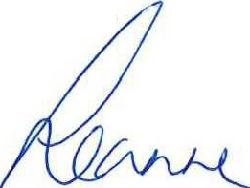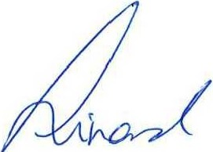
applies.

Leanne Linard MP
Minister for Children and Youth Justice and Minister for Multicultural Affairs

Q\ I \ 2- I 2022

