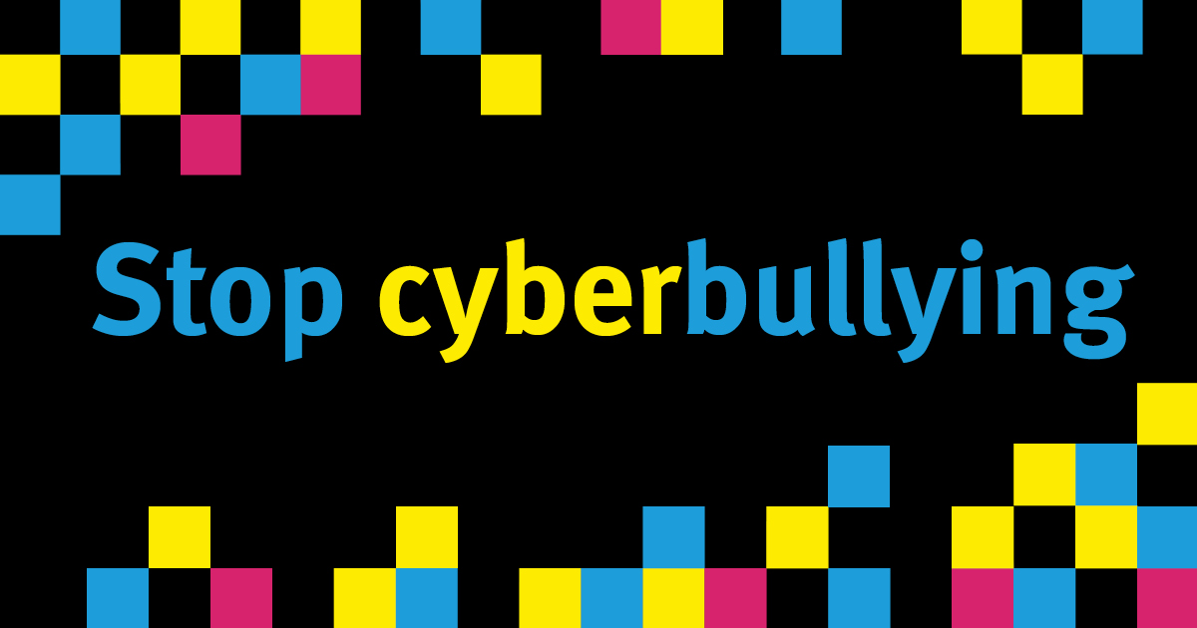

  - 2020 Stop Cyberbullying Grants Program Grant Information Paper: young people

2020 Stop Cyberbullying Grants
The Queensland Government has committed $500,000 over two years to support the Stop Cyberbullying Grants Program as part of a community-wide approach to address cyberbullying. 2020 is the second program year.
The Program supports young people and community organisations to develop and implement local initiatives to address cyberbullying and build their capacity to respond into the future.
The Queensland Government recognises young people have a significant role to play in shaping community approaches to addressing cyberbullying and can provide the critical insight needed to design creative solutions. Evidence of young people’s involvement in the design of projects is a mandatory requirement.

Purpose of the 2020 grants: young people
The purpose of the Stop Cyberbullying Grants Program: young people grants is to support projects designed by young Queenslanders (aged 10 to 25 years) to help stop cyberbullying in their local communities. Young people must apply with the help of an eligible sponsoring organisation (further details below).

Funding available
One-off grants of $1000 to $2,000 (excluding GST) are available to young people aged between 10 and 25, with a sponsoring organisation to deliver projects across Queensland between 1 August 2020 and 30 October 2020.

How the application will be assessed
Eligible applications will be assessed based on four criteria:
- The project aim and intended outcomes
- How young people are involved in the project
- The young people the project is targeting
- How you plan to spend the money.
In allocating funds, the geographical spread of applications will be considered to ensure a good spread of funding across the state

Priority will be given to applications that:
- support the development of positive and respectful relationships
- demonstrate innovation in the project’s design and delivery e.g. in the use of technology
- demonstrate how the project will support long-term behavioural change
- display collaborative approaches across diverse cohorts of young people e.g. high school students working with primary school students
- prioritise key groups, including Aboriginal and Torres Strait Islander young people and those from rural and remote communities.

What will not be funded
Funding will not be provided to projects:
- where the applicant does not meet the eligibility criteria
- that are not designed with input from young people
- which do not meet the funding purpose
- planned for delivery, or requiring travel, outside of Queensland
- that promote or are held for political purposes
- that involve commercial or fundraising activities
- proposing to purchase assets with an individual value over $50 and a cumulative value of over 30 per cent of the total requested grant funds
- that duplicate existing resources or initiatives, including those provided by the eSafety Commissioner, Kids Helpline, and Student Wellbeing Hub
- where grant funds are allocated to: acquittal, auditing or reporting costs; existing debt or loan repayments; purchase of gifts or prizes; fees associated with an auspice agreement; purchase of alcohol.
While projects demonstrating collaboration across multiple organisations are strongly encouraged, a maximum of one application will be accepted for any one project.

Eligibility
Young people applying for a grant must:
- be aged between 10 and 25 years at the time of application
- be a resident of Queensland and/or attend a Queensland school
- if under 18, have parent/guardian consent to undertake activity and apply for the grant
- confirm the project is original
- complete the Young Person Application Form at www.qld.gov.au/stopcyberbullying and submit to an eligible sponsoring organisation who will receive and administer the funding on your behalf, should your application be approved.
Sponsoring organisations must:
- be a not-for-profit legal entity or a local government entity; AND
- hold public liability insurance of at least $10 million for the duration of the project; AND
- have no outstanding financial accountability, service delivery or performance issues for funds provided by the Department of Child Safety, Youth and Women (the department).
Please note:
- State-run entities such as schools and hospitals are not eligible to receive funding, however Parents and Citizens Associations are encouraged to apply.
- Indigenous local councils and Indigenous Knowledge Centres are encouraged to apply.

Projects must:
- be new initiatives; AND
- be designed with input from young people; AND
- be delivered between 1 August 2020 and 30 October 2020; AND
- be delivered in Queensland; AND
- support the purpose of this grant program.
The sponsoring organisation must provide:
- an Australian Business Number on your application form; OR
- a copy of your government issued certification of incorporation or other incorporation documentation (e.g. a constitution), to demonstrate the not-for-profit status of your entity.
The department may contact the sponsoring organisation to request:
- a copy of your most recent audited annual financial statement;
- further details be submitted; or
- clarification of the information provided.

Requirements of successful applicants
Sponsoring organisations must:
- comply with the Community Services Act 2007
- ensure contact information of young people involved in the funded project is managed with consideration to their age, and the Privacy Act 2009
- ensure suitability checks are undertaken for all staff in direct contact with young people, in line with the Working with Children (Risk Management and Screening) Act 2000
- ensure young person understands the grant obligations and has parent/guardian consent
- confirm the project is not a duplication or modification of an existing project
- understand the department may request the right to use, communicate, reproduce, publish, adopt and modify resources/projects developed during delivery of the project, and may provide local Members of Parliament with your contact details
- enter into a Short Form service agreement with the department prior to receiving funds http://www.hpw.qld.gov.au/SiteCollectionDocuments/ShortFormTermsConditions.pdf
- pay invoices on behalf of the young person for resources to deliver the project, as outlined in the proposed budget, and not redirect grant funding to the young person
- acknowledge the funding source on any promotional materials relating to the project, including websites, and contribute to the department’s broader cyberbullying campaign
- within 30 days of completing the funded project:
  - complete and return the specified activity report, outlining the activity and outcomes achieved, including a declaration of funds expenditure; AND
  - provide evidence of the project delivery, in the form of photographs and/or video/audio files of the funded activity, along with written consent from participants on the approved consent form, and, parent/guardian consent for participants under the age of 18.
Young people, on completion of the project, must:
- provide the sponsoring organisation with a sample of any photographs, and/or video or audio files taken at the funded activity available for use by the department, along with written consent on the approved consent form from the people captured.

Timeframes
Applications close | Midnight 10 May 2020
Assessment | June 2020
Applicants notified of outcome | June 2020
Activities to be delivered | 1 August 2020 to 31 October 2020

How to apply
Young people must complete a Young Person Application Form at www.qld.gov.au/stopcyberbullying and provide a copy to their nominated sponsoring organisation.
The sponsoring organisation must complete the online 2020 Stop Cyberbullying Grant – young people application form at https://csyw.smartygrants.com.au/stopcb20youth and upload the completed Young Person Application Form by the closing time and date.
Please note:
- A separate application must be submitted for each project.
- Email applications will not be accepted.
- Late applications may be accepted on a case-by-case basis at the discretion of the department.
- Letters of support (e.g. from your local Member of Parliament, local service providers, stakeholders or Aboriginal and Torres Strait Islander Elders) are welcomed.
- The personal information of applicants will be handled in accordance with the Information Privacy Act 2009. Personal information and project details of successful applicants (i.e. individual/organisation name, project title, description and funding amount) may be published online and in ministerial media releases and articles.

Contact details
All enquiries regarding the 2020 Stop Cyberbullying Grants program should be directed to Office for Youth.
Email: cbgrants@csyw.qld.gov.au
Contact officers cannot provide advice on individual applications.

