Reclaiming our storyline

Transforming systems
and practice by making decisions in our way
The artwork used in Reclaiming our storyline is derived from Our Way: A generational strategy for Aboriginal and Torres Strait Islander children and families 2017–2037 and was created by Rachael Sarra, an Indigenous artist and designer from creative agency Gilimbaa. Rachael is a Bunda woman from Goreng Goreng Country.

The motif elements used for delegated authority reflect the many conversations to be maintained throughout the journey of a partnership to nurture and guide our children, depicted by the hand at the centre of the coloured circles.

The four coloured circles are an important part of the motif depicting the four core Building Blocks, all playing an essential part in the Journey.

The bordered orange line acknowledges the growth for the future through an honest and truth telling process that provides a voice for children and families to connect back to their culture and communities.

Contents
Acknowledgment of Peoples and Country 4
Joint statement of commitment 4
Introduction 5
Legislative framework for the delegation of functions and powers 6
Purpose of Reclaiming our storyline 6
Reclaiming our storyline: An outline 7
Part 1: The journey ahead 8
Our vision and objectives 8
Our principles 8
Overarching principles 9
Principles to guide the implementation of delegated authority 9
Part 2 – Implementation pathways 11
Timeline 12
Building and supporting the foundations: Stage one implementation plan 13
Building and supporting the foundations: Stage one implementation plan (2023–2025) summary 15
Part 3 – Implementation approach 17
Readiness and change management 17
Local implementation process framework 18
Resourcing implementation 20
Supporting quality 21
Embedding culture into systems and practice and our strategic implementation guidance 21
Governance arrangements 21
Capability building 21
Part 4: Tracking our progress and looking forward 23
Monitoring and evaluation 23
Action learning 23
Looking forward 24
Appendix 25

Acknowledgment of Peoples and Country
We respectfully acknowledge the First Nations people in the State of Queensland, we acknowledge the cultural and spiritual connection that Aboriginal and Torres Strait Islander peoples have with the land and sea.
We respectfully acknowledge Aboriginal people and Torres Strait Islander people as two unique and diverse peoples with their own rich and distinct cultures.
We pay our respects to Elders past and present as well as the existing and emerging leaders who walk together in partnership on this journey.

Joint statement of commitment
Together we share a commitment to transform service delivery and improve outcomes for Aboriginal and Torres Strait Islander children and families across the child protection system. This process will challenge and strengthen our partnerships, and we commit to growing our trust, shared accountability and transparency in leading this change.
Walking together as partners, we commit to achieving the vision and aspirations outlined in Reclaiming our storyline. This aligns with the continued efforts outlined in the Our Way: A generational strategy for Aboriginal and Torres Strait Islander children and families 2017–2037 and the national Family Matters campaign. We also recognise the importance of Closing the Gap and Path to Treaty as cornerstones of supporting self-determination for Aboriginal and Torres Strait Islander peoples.
We acknowledge that the objectives of the delegation of child protection functions and powers as outlined in Reclaiming our storyline are strongly connected to healing and breaking the cycle of trauma families experience. We uphold our belief in the strength and resilience of Aboriginal and Torres Strait Islander peoples, their connection to culture and country and the right of children to grow up safe with family, community and culture.
We further promote Reclaiming our storyline and our work to implement delegated authority arrangements through an honest and truth telling process that provides a voice for children and families to connect back to their culture and communities.
Reclaiming our storyline is a shared commitment and use of the word ‘we’ and ‘our’ throughout refers to the shared voice of the Department of Children, Youth Justice and Multicultural Affairs and the Queensland Aboriginal and Torres Strait Islander Child Protection Peak in committing to this work, while recognising that as partners we have different roles and responsibilities in realising our aspirations for children and families.

Garth Morgan, Chief Executive Officer, Queensland Aboriginal and Torres Strait Islander Child Protection Peak
Deidre Mulkerin, Director-General, Department of Child Safety, Seniors and Disability Services

Introduction
Aboriginal and Torres Strait Islander peoples’ continued cultural and community networks and child Aboriginal and Torres Strait Islander peoples’ continued cultural and community networks and child rearing customs have nurtured strong and resilient families and children for millennia. Grounded in culture, kinship and community connectedness, these customs are key protective factors for Aboriginal and Torres Strait Islander children. They demonstrate the strength, resilience and richness of Aboriginal and Torres Strait Islander families and cultural practices and support Aboriginal and Torres Strait Islander children to grow up safe and supported by those who know them best. Most Aboriginal and Torres Strait Islander children in Queensland live safely at home and are connected to their communities and culture. However, in Queensland, as in all other Australian states and territories, Aboriginal and Torres Strait Islander children and families are disproportionately represented in the statutory child protection system. Aboriginal and Torres Strait Islander children make up only eight per cent of Queensland’s child population, and yet as at 30 June 2022, Aboriginal and Torres Strait Islander children made up 45.2 per cent of children in out-of-home care (see Appendix).
The Our Way: A generational strategy for Aboriginal and Torres Strait Islander children and families 2017–2037 (Our Way) represents a long-term commitment by the Queensland Government and the Aboriginal and Torres Strait Islander community to work together to address the disproportionate representation of Aboriginal and Torres Strait Islander children involved in the statutory child protection system and to improve their life outcomes. Specifically, our target for Our Way is to close the gap in life outcomes for Aboriginal and Torres Strait Islander children and families and eliminate the disproportionate representation of Aboriginal and Torres Strait Islander children in the child protection system by 2037. Our Way recognises the importance of self-determination and the need to partner with the community in a genuine way to set the right conditions so each child can reach their full potential and thrive. The Queensland Government has also committed to these priorities at the national level through the Safe and Supported Framework and the National Agreement on Closing the Gap and at the state level through a reframed relationship with Aboriginal and Torres Strait Islander peoples.
Delegated authority transforms how child protection responses (services) are delivered to develop culturally safe and responsive ways of protecting children. Delegated authority represents a significant opportunity for positive change and as such, is a high priority action under Our Way and supports efforts towards Closing the Gap and implementation of Safe and Supported: The National Framework for Protecting Australia’s children 2021—2031.
Delegated authority implementation is part of several processes being undertaken with the objective of addressing disproportionate representation in the child protection system and improving outcomes for Aboriginal and Torres Strait Islander children. Of key importance, the Department of Child Safety, Seniors and Disability Services (DCSSDS) will also progress the transition of resources allocated for the delivery of departmentally funded services for Aboriginal and Torres Strait Islander children and families to Aboriginal and Torres Strait Islander community-controlled organisations. This shift in resourcing will enable growth in the Aboriginal and Torres Strait Islander community-controlled sector, which is an important change to support the delegation of statutory child protection functions and powers over time.

Legislative framework for the delegation of functions and powers
Delegated authority is the process undertaken to implement Chapter 4 Part 2A of the
Child Protection Act 1999 (the Act) that provides for the delegation of one or more of the chief executive’s (Director-General, Department of Child Safety, Seniors and Disability Services) functions or powers in relation to an Aboriginal or Torres Strait Islander child to a ‘prescribed delegate’.
The prescribed delegate must be:
- an Aboriginal or Torres Strait Islander person, and
- the chief executive officer of an ‘appropriate Aboriginal or Torres Strait Islander entity’ (an ‘appropriate Aboriginal or Torres Strait Islander entity’ is defined in s148BA as an entity that has a function of providing services to Aboriginal or Torres Strait Islander peoples and whose members include individuals who have knowledge of, or expertise in, child protection), and
- have a current positive prescribed notice or a current positive exemption notice (Blue card or exemption).
Additionally, the chief executive must be reasonably satisfied the prescribed delegate is appropriately qualified and a suitable person to perform the function or exercise the power in relation to the child. The prescribed delegate, the same as any existing DCSSDS delegate, is required to apply all other relevant parts of the Act when making a decision or performing a function.
The legislation is broad and allows for the delegation of many of the chief executive’s functions or powers in relation to an Aboriginal or Torres Strait Islander child at any point along the child protection continuum. The delegation may be in relation to a child who is:
- in need of protection; or
- likely to become in need of protection.
The delegation of particular functions and powers usually provided by DCSSDS began in 2020 in Rockhampton, Maroochydore and Caloundra, through the work of the early adopter organisations Central Queensland Indigenous Development (CQID) and Refocus. Reclaiming our storyline builds on the findings from these early sites, to support implementation progressively over time in other locations across Queensland.

Purpose of Reclaiming our storyline
As outlined in the statement of commitment, Queensland Aboriginal and Torres Strait Islander Child Protection Peak (QATSICPP) and DCSSDS have partnered to develop a 10 year blueprint for implementing delegated authority in Queensland. Reclaiming our storyline outlines the process and actions to be taken over time to progress this new way of working with Aboriginal and Torres Strait Islander children and families. This blueprint also signals the shared vision and objectives for this new way of working and how this approach will be actioned in a way that gives respectful consideration to the readiness, priorities and needs of local communities. It is a long-term plan for shifting the decision making and delivery of child protection functions and powers to the individuals and organisations that know children and families best. The approach recognises that the change process is complex and will take a sustained commitment from DCSSDS and Aboriginal or Torres Strait Islander entities to work together in new ways.
7
In shaping this 10 year blueprint, Reclaiming our storyline, QATSICPP and DCSSDS engaged with Aboriginal or Torres Strait Islander entities and other stakeholders with experience and expertise in working with children and families who are involved with child protection systems. Further engagement was also undertaken with DCSSDS staff, in recognition that implementation will require dedication and solid commitment to implementation at all levels of the department. This engagement sought to promote participants’ knowledge of delegated authority and to understand their aspirations and concerns for this new way of working. We also heard about their priorities, capability and support needs in preparing for this new approach, and how local implementation processes should be designed to encourage genuine partnership.

Reclaiming our storyline: An outline
Reclaiming our storyline includes the following parts:
- Part 1 –The journey ahead outlines the vision, objectives, overarching and enabling principles for delegated authority which guide the journey ahead.
- Part 2 – Implementation pathways highlights the pathway for delegated authority and the associated three implementation plans. The first implementation plan is presented in this section.
- Part 3 – Implementation approach provides an in-depth overview of the local and systems approach to implementation.
- Part 4 – Tracking our progress and looking forward defines the way that we will track our progress and look forward through the ongoing implementation of a robust monitoring, evaluation and learning framework.

Part 1: The journey ahead
Reclaiming our storyline commits DCSSDS and QATSICPP to work with each other and Aboriginal or Torres Strait Islander entities to implement delegated authority in a way that upholds a clear commitment to:
- a vision and objectives that speak to the best hopes and aspirations for this work
- overarching principles to guide the delegation of functions and powers
- enabling principles to support implementation and decision making.

Our vision and objectives
Our shared vision for delegated authority is that Aboriginal and Torres Strait Islander children and families who are involved in the child protection system (or at risk of becoming involved in the system) may receive support from the organisations that know them best and have their safety, rights and voice upheld in this process, so they grow up safe and connected to family, community and culture.
The vision reflects the outcomes we are seeking to achieve by changing how child protection decisions and functions are delivered, and is closely aligned to the vision of Our Way:
- that all Aboriginal and Torres Strait Islander children and young people in Queensland grow up safe and cared for in family, community, and culture
- to close the gap in life outcomes for Aboriginal and Torres Strait Islander children and families
- eliminate the disproportionate representation of Aboriginal and Torres Strait Islander children in the child protection system by 2037.
Our shared aspirations and objectives include:
- Safety, culture, wellbeing, healing and connection are central to the child protection responses provided to Aboriginal and Torres Strait Islander children and families.
- Self-determination of children, families and communities is realised through choice and having a voice in decision making.
- Aboriginal and Torres Strait Islander children and families have their right to culture recognised and grow up with a strong sense of identity and connection.
- Aboriginal and Torres Strait Islander children and families freely seek out help when they need it and can access child protection responses from organisations who are embedded in the community and understand their needs.
- Sustained partnership and collaboration is developed across DCSSDS and Aboriginal or Torres Strait Islander entities to work in this new way.
- Our systems support effective transition of decision making to Aboriginal and Torres Strait Islander peoples.

Our principles
Reclaiming our storyline is guided by principles that support our decision making and reflect our shared priorities through the implementation process. Implementation principles are to be considered in connection to the principles outlined in the Act and the commitment to rights enshrined in the Human Rights Act 2019. They are also consistent with the Family Matters principles which underpin efforts to eliminate the disproportionate representation of Aboriginal and Torres Strait Islander children and young people in the child protection system as outlined in Our Way.

Overarching principles
- The Aboriginal and Torres Strait Islander Child Placement Principle: The intent of delegated authority is fundamentally aligned to the Aboriginal and Torres Strait Islander Child Placement Principle (ATSICPP). Active efforts to implement the ATSICPP are required under the Act and all planning and service delivery must incorporate efforts to strengthen family and cultural connections.
- Self-determination: The right of Aboriginal and Torres Strait Islander peoples to self-determination and the right to live in culture is understood and upheld. Delegated authority implementation should be directed by the views of Aboriginal and Torres Strait Islander peoples and Aboriginal or Torres Strait Islander entities can shape their service models and their practice, having regard to legislative requirements.
- Child centred and family focused: A child’s safety and wellbeing remains paramount in our decision making. Implementation processes must focus on the needs and rights of children and families, and children have a voice and choice in their support and care, and whether they participate in this process. Family is accepted as the foundation of Aboriginal and Torres Strait Islander children’s social, cultural and emotional wellbeing and is their most important lifelong support, and actions and decisions are made in a way that upholds a child’s rights, including their right to be connected to their family and culture.
- Supporting healing: The need for healing supports to address the impacts of intergenerational trauma on families resulting from experiences of colonisation, the Stolen Generations and other discriminatory government policies is acknowledged. Delegated authority implementation will embed trauma informed principles enabling Aboriginal and Torres Strait Islander people to be empowered, increase their choice, be culturally safe, and enable services to act holistically to meet the healing needs of children and families.

Principles to guide the implementation of delegated authority
- Transforming systems and practice: Aboriginal and Torres Strait Islander culture and ways of knowing are upheld and respected and Aboriginal or Torres Strait Islander entities are enabled to redesign responses to embed cultural knowledge and practices.
- Shared accountability: Accountability for achieving safety and the best possible outcomes for children and families is shared. As partners we will support the new way of working by co-designing processes that drive the capacity, autonomy, allocation of resources in a manner that supports the success of culturally strong practice.
- Co-designed and locally driven: Development of specific local arrangements must respond to the needs of the local community and give regard to people and place. By embedding co-design, our intention is that Aboriginal or Torres Strait Islander entities and the department partner to deliver functions and decisions in a way that leverages our respective strengths and experience.
- Quality: Safety is promoted through quality, consistent standards of practice and making decisions based on evidence, which is grounded in culture.
- Capability building: Aboriginal or Torres Strait Islander entities are supported to build their capability and organisational infrastructure to deliver delegations over time and equally, the department will support its staff to build their capacity to participate in and enable the new way of working.

Part 2 – Implementation pathways
The delegation of child protection functions and powers to chief executive officers of Aboriginal or Torres Strait Islander entities requires transformational practice and systems change that will take sustained effort and partnership. The imperative to improve outcomes for Aboriginal and Torres Strait Islander children is driving our commitment to action. To support this action over the next 10 years, Reclaiming our storyline will be delivered across three implementation plans that are grounded in self-determination and detail:
- priority activities
- commitments and their objectives
- timeframes for delivery.
These implementation plans will align with action plans under the Our Way strategy. This approach acknowledges that encouraging culturally strong child protection practice through the implementation of delegated authority is one important element amongst several other measures to address the disproportionate representation of Aboriginal and Torres Strait Islander children in the child protection system and drive better outcomes.
The implementation plans that support Reclaiming our storyline are:
- Building and supporting the foundations: Stage one implementation plan (2023–2025)
- Embedding the transformation: Stage two implementation plan (2026–2028)
- Our decisions, our way: Stage three implementation plan (2029–2032).
Throughout these plans, the safety, rights and voices of Aboriginal and Torres Strait Islander children, families and communities will be at the forefront.

Timeline
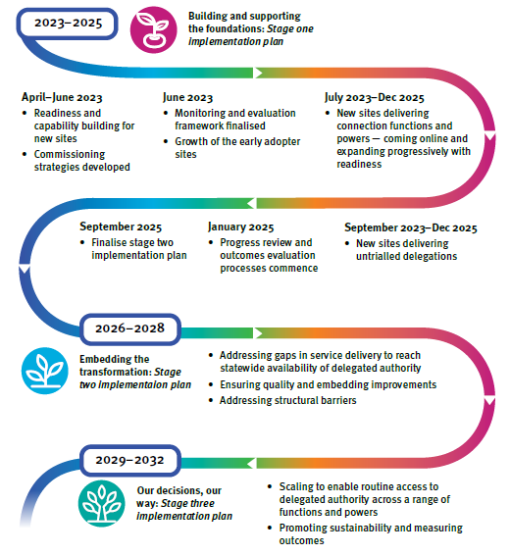
Figure 1: The timeline for Reclaiming our storyline: Transforming systems and practices by making our decisions in our way 2023–2032.

Building and supporting the foundations: Stage one implementation plan
Our stage one implementation plan — Building and supporting the foundations — outlines the pathways into delegated authority. At the centre of this first plan is a focus on listening to children, families and communities. Building and supporting the foundations starts the work to embed the authority for decision making in the organisations that understand the needs and aspirations of children and families. It is about giving primacy to Aboriginal and Torres Strait Islander ways of being and knowing so that we shape the systems and processes that can deliver and sustain genuine change.

The priorities
To build on our strengths, Building and supporting the foundations will:
- build the solid foundational capability supports required
- focus on the delegation of functions and powers related to connection in new locations as the starting point for future expansion
- explore models for delegation of functions and powers related to other parts of the child protection continuum.

The foundations
Effective delivery of functions and powers by Aboriginal or Torres Strait Islander entities requires building readiness and capability across DCSSDS and Aboriginal or Torres Strait Islander entities to work together in this new way. Priorities for Building and supporting the foundations include: continuing to support and grow our early adopter entities; delivering a range of co-designed readiness and planning activities at the local level (including implementing collective decision making and shared governance arrangements); and, developing tailored practice resources to support delivery across Queensland. This implementation plan also prioritises the establishment of a monitoring and evaluation framework so we can learn and gather evidence.

Focus on connection
One of the key priorities for the stage one implementation plan is to establish new sites providing delegated authority responses that are focused on increasing the connection of Aboriginal and Torres Strait Islander children involved in the child protection system to family, kin, culture, country and community. To promote connection, most Aboriginal or Torres Strait Islander entities that are participating in delegated authority will predominantly commence with the delivery of delegations that provide for contact with a child’s parents and family, and with a child’s culture (sections 87 and 88 of the Act).
This approach builds on the strengths of Aboriginal or Torres Strait Islander entities and their broad knowledge of families, community and culture, and acknowledges the fundamental importance of connection to safety and wellbeing. The work of the early adopter entities, CQID and Refocus, in performing these functions has demonstrated the benefits of strong connection to improved outcomes for children and young people. The knowledge from their experience in delivering these functions will be built into program and practice resources to support the delivery of these functions and powers in an efficient and intentional manner.
Most new entities will commence with these contact delegations and then expand their service delivery to include other delegations for individual children over time as experience grows. This expansion may include delivery of other delegations that strengthen connection including reunification of children with their parents where this is safe (utilising section 82(2) decisions and including providing ongoing post-reunification support).

13
The expansion of delegations will be undertaken in a planned approach, using the local implementation process cycle (see page 18). It is expected that expansion of the delegations offered by new entities providing contact will grow over time in response to the needs and views of the children and families involved.

Exploring opportunities
Building and supporting the foundations will provide Aboriginal or Torres Strait Islander entities the opportunity to work with DCSSDS and their communities to explore and deliver delegations that have not yet been trialled or delivered. This exploration will provide a better understanding of the benefits and impact of delegated authority across the child protection continuum and how systems or practice barriers can be addressed over time. Emphasis will be placed on exploring opportunities for this new way of working in different geographic locations such as in remote and discrete communities.
Exploring opportunities also enables delegated authority to be aligned with other programs and the delivery of other funded service responses. In particular, delegation of decisions may be an additional tool that can be used to enhance the impact of other programs over time, noting the case by case needs of each child will be upheld as part of this process.

Building and supporting the foundations: Stage one implementation plan (2023–2025) summary
Action | Commitment | Objectives | Timeframe
Solid foundations
Support the continuation and expansion of the early adopter sites | Continue to implement and expand delegated authority arrangements in the two early adopter sites.  Continue progressing toward full case management powers and functions being delegated.  Continue to develop and implement workforce development and resourcing strategies across early adopter sites. | Continue to provide quality, culturally led services to children and families.  Share the solid foundations created by the early adopter sites and leverage their findings.  Grow culturally led practice expertise in DCSSDS in partnership with Aboriginal or Torres Strait Islander entities.  Share and track ongoing learnings of early adopter sites sustained growth over time. | 2023
Deliver readiness and capability support | Support DCSSDS staff and Aboriginal or Torres Strait Islander entities to grow their knowledge of delegated authority and prepare for local implementation.  Co-design place-based capability strategies that encourage connection, partnership, quality and flexibility. | Ensure all partners have the knowledge required to commence implementation.  Support effective change management and communication at both the strategic and local levels.  Promote a skilled and capable workforce across DCSSDS and Aboriginal or Torres Strait Islander entities. | Ongoing
Develop targets for delivery | Develop a set of targets related to community and departmental priorities, agreed by QATSICPP and DCSSDS. | Ensure delivery momentum through targets for priorities to reduce over-representation of First Nations children in the child protection system. | September 2023
Develop investment and commissioning strategies to underpin further statewide implementation | Deliver investment strategies that are sustainable and culturally responsive. | Ensure that investment can support the systems and practice required to implement this new way of working. | June 2023
Finalise a monitoring and evaluation framework | QATSICPP and DCSSDS co-design the methodology for measuring our progress and understanding the outcomes of this new way of working. | Enable a framework that embeds Aboriginal and Torres Strait Islander ways of knowing and provides for continuous learning. | June 2023
Focus on connection and exploring opportunities
Develop practice and process tools to support delivery of priority connection functions | QATSICPP and DCSSDS co-design packages of priority delegations for implementation in new delegated authority sites that can be tailored to local conditions based on findings from the early providers of delegated authority. | Create and establish quality and consistency in the delivery of delegations while maintaining flexibility. | March 2023
Establish delegated authority responses in all DCSSDS regions – commencing with connection | DCSSDS and Aboriginal or Torres Strait Islander entities co-design and deliver new delegated authority arrangements. | Grow delegated authority across Queensland progressively in a way that supports local and regional priorities and needs. | July 2023  July 2024  July 2025
Exploring opportunities for new models | Co-design and explore models for delivering functions and powers, in different places, and across the child protection continuum that are yet to be tested. | Derive lessons on the impact and benefits of delegated authority across the child protection continuum.  Explore opportunities and barriers to implementation that require action as part of the Embedding the transformation: Stage two implementation plan. | December 2023 – July 2025
Looking forward
Review of implementation progress and early outcomes, including ways to streamline implementation | QATSICPP and DCSSDS will review implementation progress and emerging lessons from practice in collaboration with delegated authority providers.  DCSSDS and QATSICPP will develop options to address policy and systems issues emerging from the first implementation plan that will increase effectiveness of design and delivery. | Measure progress and realisation of the intent of delegated authority and impacts for children and families.  Continuous quality improvement by consideration of policy and systems constraints and opportunities. | January 2025  September 2023 and ongoing
Completion of Stage Two plan (Our Impact) | Based on findings of the stage one review, a stage two plan will be co-designed by QATSICPP and DCSSDS in consultation with key stakeholders. | Set the plan for further expansion and resourcing of delegated authority for the next three-year implementation plan. | September 2025

Part 3 – Implementation approach
Reclaiming our storyline and its implementation plans commit to developing delegated authority arrangements across Queensland progressively. To support the effectiveness of this process, the implementation approach will embed:
- readiness and change management
- local implementation cycle to guide partnership and growth over time
- strategic oversight and governance
- resourcing processes
- support for quality practice.

Readiness and change management
Having the legal authority to make decisions relating to children and young people, and their families is different to the basis on which Aboriginal or Torres Strait Islander entities and DCSSDS currently work with and for families. The implementation process also requires a significant change in practice and process for DCSSDS. An important part of building the foundations for delegated authority is preparing for change and addressing any barriers that may stand in the way of better outcomes for children.
DCSSDS must focus on developing local readiness and strategies to support continuous quality that are supportive and take staff on the implementation journey. This will include:
- Building knowledge and understanding of delegated authority.
- Strengthening work to embed cultural capability and cultural security.
- Embedding change management and effective communication strategies.
- Embracing collaborative practice and shared decision making.
- Updating relevant policies and procedures to incorporate delegated authority.
- Cultivating commitment and personal attributes that promote strong partnerships and underpin power sharing.
A list of competencies has been developed by QATSICPP to provide guidance for Aboriginal or Torres Strait Islander entities on the experience and capabilities that will support delivery of delegated authority responses. These key factors in determining readiness to take on delegated authority include:
- Experience and expertise in working within child protection systems and services alongside Aboriginal and Torres Strait Islander children, families and communities.
- Understanding the legislative requirements and knowledge and understanding of delegated authority, including the important role of the CEO.
- Having strong linkages and partnerships (or willingness to build this) with the Child Safety Service Centres and the local community.
- Having staff confidence and capability to implement delegated authority and the capacity to support and supervise staff to work in this new way.
- Having strong governance arrangements to exercise the power/s to meet obligations and organisational support.
- Holding community trust as a culturally safe service provider.
It is acknowledged that some Aboriginal or Torres Strait Islander entities may not want to explore this new way of working in the shorter term. The implementation approach will promote ongoing capability building and workforce development through QATSICPP as the peak body in Queensland, and delivery of ongoing implementation readiness for DCSSDS.

Local implementation process framework
The findings from the early adopter sites and engagement with stakeholders has highlighted that a flexible local implementation process framework to guide development of responses at place will work best to meet the needs of children and families.
Implementation must be driven by strong local planning and partnership processes between Aboriginal or Torres Strait Islander entities and DCSSDS. The implementation process framework outlines the key phases involved in the development of delegated authority arrangements at the local level. Each stage involves several processes to enable both DCSSDS and Aboriginal or Torres Strait Islander entities to formalise partnerships, undertake readiness, and to co-design local processes to support delivery and expansion of delegations over time.
Local implementation is expressed in a cyclical model to enable ongoing improvement and learning, and for responses to grow with experience. A reflection and action learning focus is embedded to promote continuous improvement and quality responses. This approach acknowledges that child protection decision making involves risk and is complex, and the relationships, infrastructure, systems and policies and practice to support formal delegation of functions and powers may take time to develop across DCSSDS and partner organisations. In practice, decision making within this implementation process framework will be supported by the implementation principles (see Part 1) and use practice and program guidance materials developed by QATSICPP and DCSSDS to support service delivery, which are tailorable to meet local needs and encourage new ways of working.
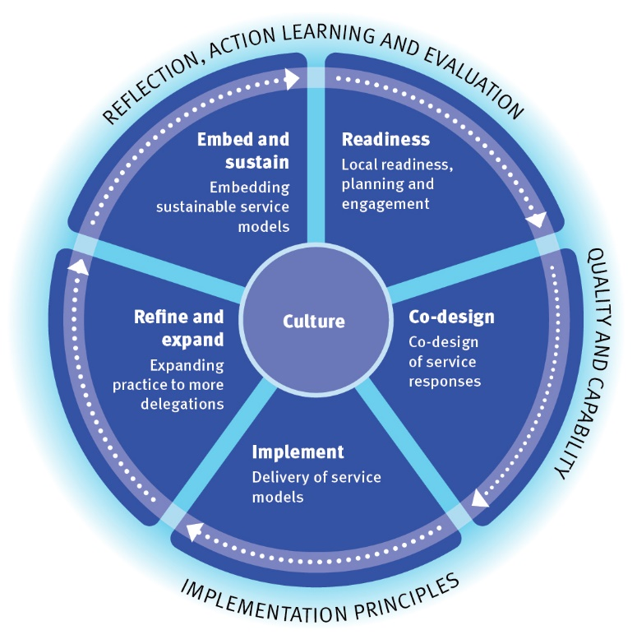
Figure 2: Local implementation process framework
The implementation process framework should be considered as a living tool that enables DCSSDS and Aboriginal or Torres Strait Islander entities to flexibly adjust their approaches as issues arise. A summary (non-exhaustive) list of the types of activities that will be undertaken at each stage are as follows:

Readiness
Local readiness activities, planning and engagement actions:
- Growing local knowledge of delegated authority across DCSSDS staff and Aboriginal or Torres Strait Islander entities and stakeholders.
- Local DCSSDS and Aboriginal or Torres Strait Islander entities regional change management and implementation planning.
- Partnerships are built and relationships are prioritised, truth-telling is supported, and open communication pathways are developed.
- Resourcing arrangements for providers of delegated authority are formalised to support the next steps in the implementation process.

Co-design
Co-design of service response actions:
- Induction into the legislative context for delegated authority is jointly undertaken by DCSSDS and Aboriginal or Torres Strait Islander entities.
- Co-design of the service model to deliver proposed set of functions and powers using the legislative requirements as a framework.
- Aboriginal or Torres Strait Islander entities develop service models that reflect cultural safety and ways of knowing.
- Operational processes are established between DCSSDS and Aboriginal or Torres Strait Islander entities to support the practice and administration associated with the delivery of functions and powers.
- Communication with stakeholders (including children and families) about this opportunity and encouraging their choice and voice.
- Interim strategies to grow partnerships and practice may be undertaken prior to formal making of delegations (e.g. testing practice prior to requesting delegations).

Implement
Delivery and testing of service model actions:
- Administrative processes are undertaken to enable functions and powers to be delegated.
- Ongoing information sharing and joint case management processes are developed.
- Increasing numbers of children and families transitioning to this new way of working growing over time as experience and capacity grows.
- Identifying challenges and creating solutions is collectively prioritised.

Refine and expand
Refinement and expansion actions:
- Lessons from early implementation are used to refine systems and practice.
- Expansion is supported to enable delivery of new delegations.
- Expansion may also relate to supporting higher numbers of children, and/or to broader locations within the service delivery catchment of the entity.

Embed and sustain
Embedding and sustaining actions:
- Ongoing reflection on implementation issues and embedding the change process.
- Sustainability of responses is considered, and issues collaboratively addressed.

Continuous learning
Monitoring and evaluation, action learning and reflection points actions:
- Analysis and reporting on implementation and the experience of children and families, and to track the outcomes.
- Action learning processes are built into the implementation cycle to support continuous learning and to address emerging issues.
- Governance arrangements support strong feedback mechanisms between partners.
A suite of tools and resources will be developed to support these implementation actions by DCSSDS and QATSICPP.

Resourcing implementation
A flexible, responsive and sustainable resourcing approach is required to support development of the systems, processes and practice required for implementation of Reclaiming our storyline.
To support delivery of Building and supporting the foundations: Stage one implementation plan, a culturally secure commissioning approach will be delivered to enable the expansion of delegated authority. DCSSDS will actively seek advice from QATSICPP on the development of commissioning and investment strategies that are transparent, culturally secure and give regard to the readiness, experience and aspirations of Aboriginal or Torres Strait Islander entities and areas of need. The key resourcing processes aligned to the first implementation plan will be focused on supporting the readiness and co-design and commencement of new responses in all DCSSDS regions.
It is accepted that the co-design and delivery of new delegated authority arrangements will take time. Resourcing processes that support growth to new locations, expanded delegations in a responsive manner will need to be staged across the life of Reclaiming our storyline.

Supporting quality
Quality practice is vital for safe and consistent services to children and families. Quality practice is underpinned by multiple and connected actions that build skills, relationships and mutual accountability and processes that enable strong relationships. Quality will be supported through specific tools and systems including:
- embedding culture into systems and practice and our strategic implementation guidance
- governance arrangements
- capability building.

Embedding culture into systems and practice and our strategic implementation guidance
The local implementation process framework promotes consistent understanding of the processes and actions required to develop local responses. These local processes will be supported by strategic guidance that embeds culture into systems and practice and promotes consistency and quality. The following tools to support implementation will be developed jointly by QATSICPP and DCSSDS:
- Standards of practice: shared standards developed by Aboriginal and Torres Strait Islander child safety experts that prioritise the safety and rights of children and reflect cultural expertise.
- Program and procedural guidance: clear guidelines to support the new way of delivering functions and powers in accordance with legislative requirements while enabling place-based models grounded in culture.
- Tools to support local collaboration: shared working agreements and procedural documentation that uphold cultural ways of working.
- Regional planning: templates and culturally secure processes to guide local readiness and implementation and quality improvement.

Governance arrangements
The implementation process will be overseen by local and strategic governance arrangements that encourage collaboration and partnership and support resolution of issues. Governance groups will involve representatives from Aboriginal or Torres Strait Islander entities, QATSICPP and DCSSDS.
The Queensland First Children and Families Board will maintain a strong role in providing advice on implementation in the context of their broader responsibility for guiding the implementation of Our Way.

Capability building
Children and families who participate in delegated authority arrangements should expect quality services and support. All partners are collectively accountable to children and families to deliver the best possible responses that uphold their safety, rights and voice and promote connection to family, community and culture. This is a shared priority for all stakeholders.
Staff from Aboriginal or Torres Strait Islander entities and DCSSDS need to be equipped with the information, skills and support they need to enable this new way of working and achieve quality responses. DCSSDS will continue to partner with QATSICPP to deliver capability strategies that are responsive to the needs of all partners.
Promoting quality and safety also includes providing practice skilling activities such as tailored information and awareness raising activities, training, practice resources and best practice guidance. Support to both Aboriginal or Torres Strait Islander entities and DCSSDS staff will be provided across the implementation cycle from readiness to induction along with ongoing professional development.
Other strategies to encourage exchange of knowledge and skills will be encouraged locally to create the conditions for success. This will include close collaboration between local Child Safety Service Centres and Aboriginal or Torres Strait Islander entities in response to specific local priorities for practice development.
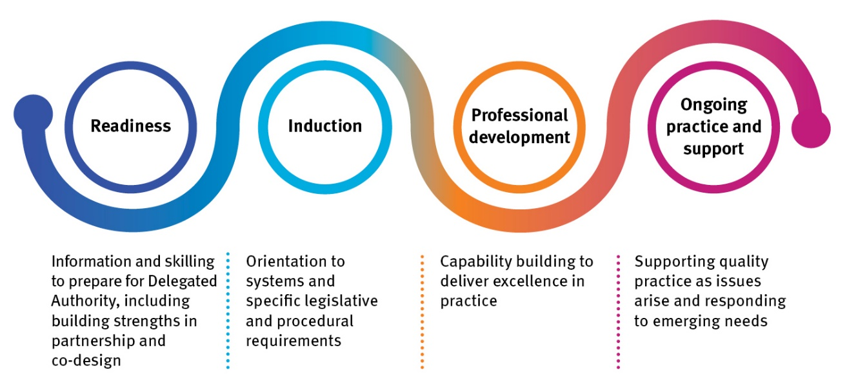
Figure 3: Capability building processes

In tandem with this practice support, QATSICPP as the peak body is delivering further actions to grow the workforce of practitioners and other support roles over time. This includes the development of a workforce strategy to implement the reform agenda.

Part 4: Tracking our progress and looking forward
It is crucial that implementation promotes continuous improvement and mechanisms to ensure we remain on track towards achieving our shared vision for delegated authority:
- monitoring and evaluation framework
- action learning and reflection
- looking forward to future implementation plans.

Monitoring and evaluation
A monitoring and evaluation framework will be developed collaboratively by QATSICPP and DCSSDS to allow for ongoing documentation of the implementation process and to measure the impact and outcomes of this work. This will include building a theory of change to ensure effective measures are identified that are relevant, reliable and realistic.
This monitoring and evaluation framework will mean we can:
- understand what works and how change occurs at both systemic and practice levels
- create opportunities to reflect on both the process and the impact of the work throughout implementation
- understand the outcomes of this new way of working including hearing from children and families about their experiences
- track our implementation progress and identify barriers and enablers
- learn continuously and improve our practice
- enable accountability through publishing reports and insights.
The monitoring and evaluation framework will continue to embed action learning processes but will also identify other appropriate quantitative and qualitative measures that will support robust evaluation processes being embedded. This will build on existing processes to ensure consistency of approach.

Action learning
Led by QATSICPP, action learning has been a significant part of the implementation of delegated authority to date. This will be continued and embedded as it centres practice in the design and delivery of the response and supports reflection and continuous improvement. Action learning methodologies will be prioritising new and emerging sites and where different delegations are being tested.
To date, embedding this quarterly reflective process has assisted in ensuring that all participants are empowered to have an equal voice and contribute to the knowledge generation and translation in a culturally secure way.

Looking forward
Reclaiming our storyline and its Building and supporting the foundations: Stage one implementation plan set the foundations for an implementation process that is centred on achieving the best possible outcomes for Aboriginal and Torres Strait Islander children and families and lays out the path for a ten-year commitment to transforming how child protection decision, functions and powers will be delivered.
Looking forward to the next implementation plan, Embedding the transformation: Stage two implementation plan, our focus will be on:
- ensuring responses are meeting quality expectations and are clearly achieving our shared objectives
- continuing to increase the number of locations working in this new way with the aspiration to reach statewide availability of delegated authority
- embedding improvements
- addressing systems barriers and other opportunities identified in the Building and supporting the foundations: Stage one implementation plan.
The final implementation plan, Our decisions: our way will seek to work with stakeholders to further scale and sustain the delegation of functions and powers so that this service response may be available to Aboriginal and Torres Strait Islander children and families across Queensland.

Appendix
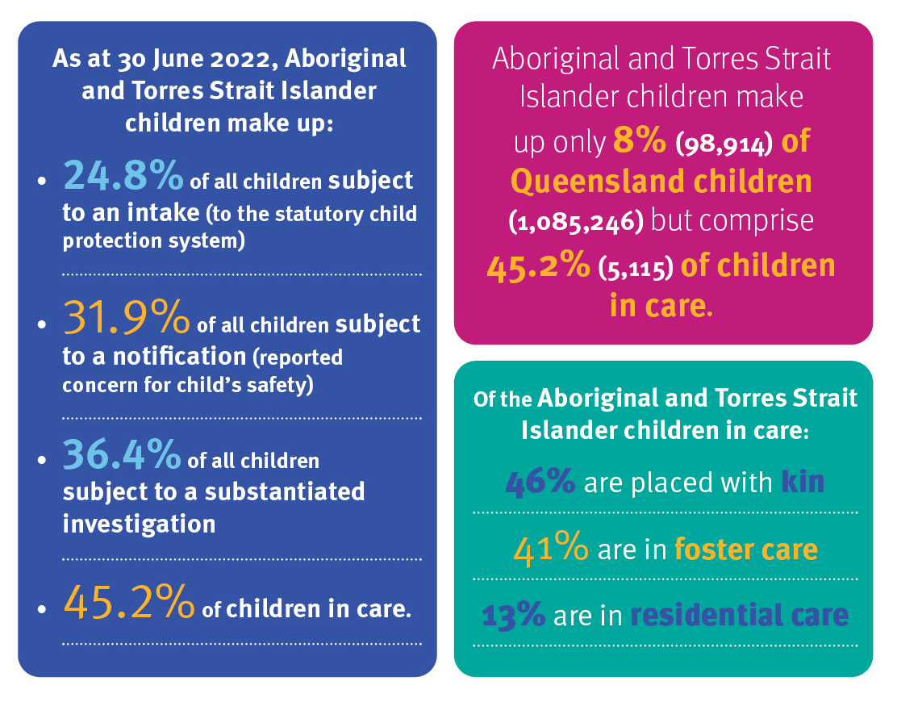
Figure 4: Snapshot of key data

1. This document uses the terminology Aboriginal or Torres Strait Islander entities in reference to the definition in the Child Protection Act 1999 at section 148BA — Aboriginal and Torres Strait Islander community controlled organisations that meet the requirements of this Act may be appropriate Aboriginal or Torres Strait Islander entities.

