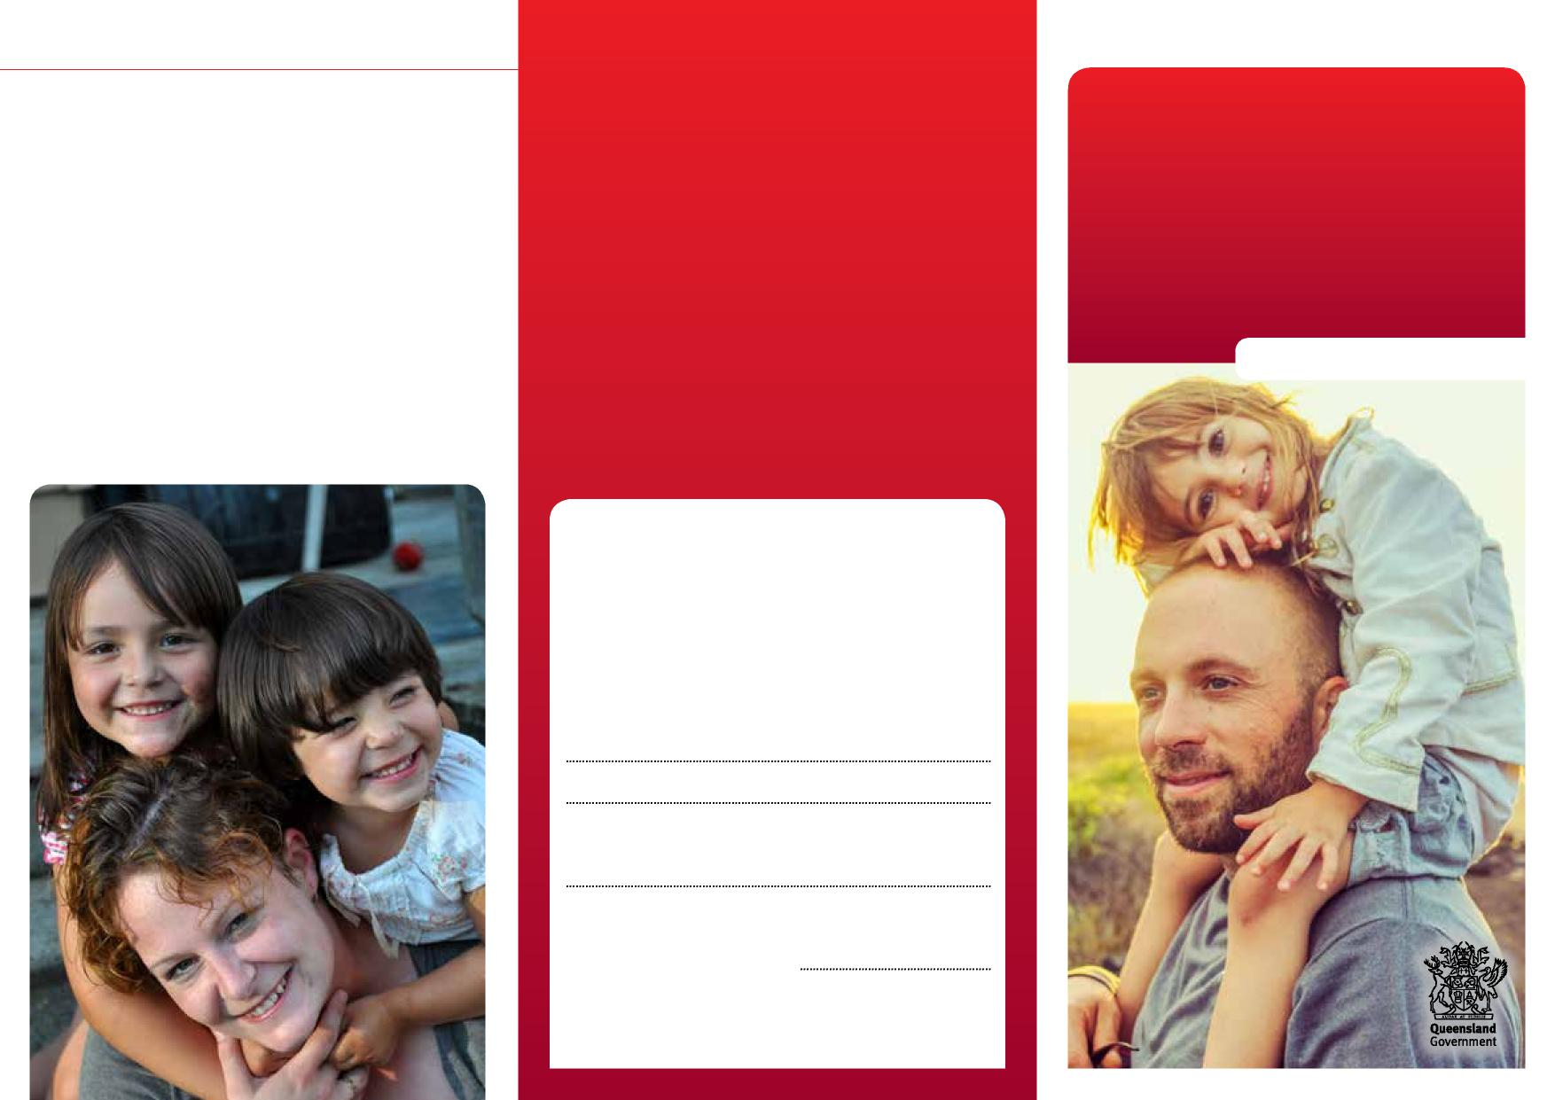
Department of Children, Youth Justice and Multicultural Affairs
Intervention with parental agreement
How does intervention with parental agreement end?
In most cases, intervention with parental agreement ends when you’ve made the changes in your case plan and we’re confident you can safely care for your child.
If you change your mind about working with us or can’t make the changes in your case plan, we’ll ask for a child protection order. To do this, we’ll talk to the Director of Child Protection Litigation that handles child protection legal matters.
Intervention
with parental
agreement
Information for parents
More information
We recognise that this may be a worrying time for you, and we want to work with you to do what’s best for your child. You can talk to us at any time about what’s happening.
Child Safety Officers:
Senior Team Leader:
Child Safety Service Centre:
Phone:
Child Safety After Hours Service Centre: Phone: 3235 9999 or freecall 1800 177 135
0959_JULY2022

Intervention with parental agreement

Caring for children and keeping them safe and well is very important. Sometimes, parents need help to do this.
There are a number of different ways we work with families to help them protect and care for their children.
If we’re worried about your child’s safety at home and you’re willing to work with us to help you care for your child, we’ll talk to you about intervention with parental agreement.
What is intervention with parental agreement?
Intervention with parental agreement is a way of working with you when we’ve assessed that your child is in need of protection, and you’re willing to get help to safely care for your child at home.
Under this agreement, there are no court orders. You’ll keep custody of your child.
Intervention with parental agreement is different for every family, and usually lasts up to 12 months.
How does it work?
We’ll organise a family group meeting with all the important people in your child’s life. We’ll talk about what’s happening and what changes your family can make to keep your child safe.
At this meeting, we’ll work with you to develop a case plan setting out the changes you’d like to make for your family. We’ll also connect you to support services to help your family.
We’ll meet with you regularly to support you in making the changes needed, and review the case plan.
Where does your child live during this agreement?
Usually, your child continues living at home with you.
Sometimes, your child may need to live somewhere else for short time while we help you make the changes in your case plan.
If you agree this would be best for your child, we can arrange for your child to stay with an approved carer.
Who can you talk to?
As Child Safety Officers, we’re trained to help families who are having problems. You can talk to us about your worries or ask for help.
If you want someone else to talk to, you can call the Senior Team Leader or manager from the local child safety service centre.
You can also talk to a lawyer, or a local community organisation for legal advice:
- Legal Aid Queensland
Phone: 1300 651 188
- Community Legal Centres Queensland Phone: 3392 0092
- The Aboriginal and Torres Strait Islander
Legal Service (Qld)
Freecall: 1800 012 255

