Is your information confidential?
Yes, your information is confidential. We only share
it with people who need to know or have a right
to know.
By sharing information, we can arrange the right support for your family to get back on track.
If you want to know the information recorded about your family, call our Right to Information, Information Privacy and Screening unit on freecall 1800 809 078.
What if you disagree with our assessment?
If you disagree with our assessment about what should happen next, you can ask for a review by calling any of the following organisations:
- Queensland Civil and Administrative Tribunal (QCAT) Phone: 1300 753 228
- Queensland Ombudsman
Freecall: 1800 068 908
- Crime and Misconduct Commission
Freecall: 1800 061 611
- Aboriginal and Torres Strait Islander
Legal Service (Qld)
Freecall: 1800 012 255
If you want to make a complaint, call our Complaints unit on freecall 1800 080 464.

Department of Child Safety, Seniors and Disability Services
When Child Safety Officers visit your home
When Child Safety
Officers visit your
home
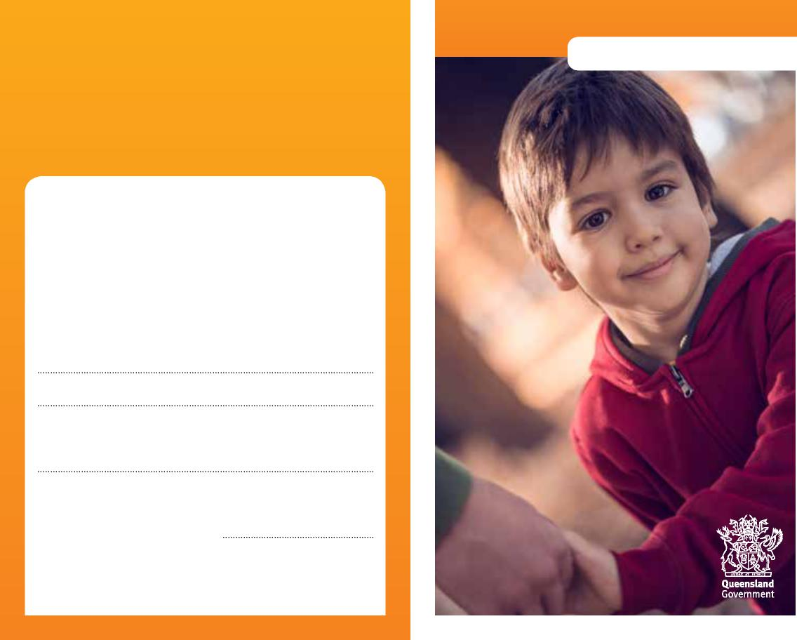
Information for parents
More information
We recognise that this may be a worrying time for you, and we want to work with you to do what’s best for your child. You can talk to us at any time about what’s happening.
Child Safety Officers:
Senior Team Leader:
Child Safety Service Centre:
Phone:
Child Safety After Hours Service Centre: Phone: freecall 1800 177 135
0959_OCT23

Caring for children and keeping them safe and well is very important. Sometimes, parents need help to do this.
What happens next?
When Child Safety Officers visit your home
We work with families to help them protect and care for their children.
We’re visiting your home because someone who has concerns about your child’s safety has contacted us. Legally, we can’t tell you who spoke to us, but we need to talk to you about their worries.
What happens when we visit?
We’ll talk about the information we’ve received about your child, and ask you to tell us about your family situation.
We’ll also talk to your child and other people who know your family, such as:
- your partner
- any other adult who lives in your house
- other family members
- your child’s teacher or child care worker
- your family doctor.
If needed, we can talk to your child at school or child care before talking to you. If this happens, we’ll talk to you as soon as possible afterwards about our concerns.
We’ll be thoughtful and respectful in working with you and your family. You’ll be involved in discussions about your child’s safety and care. You may choose to have a family member or friend with you when talking to us.
What can you do to help?
It’s important that you help us as much as you can so we understand what you might be worried about and how we can help.
You can choose not to talk to us, but it’s better if you can tell us about your family situation.
We may need to make further visits to your home if we need more information.
If you decide not to talk to us, we may apply for an order from the Childrens Court so we can talk to your child and get the information we need.
Who can you talk to?
As child safety officers, we’re trained to help families who are having tough times. You can talk to us about your worries or ask for help.
If you want someone else to talk to, you can call the senior team leader or manager from the local child safety service centre.
You can also talk to a lawyer, or a local community organisation for legal advice:
- Legal Aid Queensland
Phone: 1300 651 188
- Community Legal Centres Queensland Phone: 3392 0092
- Aboriginal and Torres Strait Islander
Legal Service (Qld)
Freecall: 1800 012 255
If we assess that your child is being safely cared for at home, we’ll close the case.
If we’re worried about your child’s safety, we may:
- help you work out a safety plan to care for your child at home
- put you in touch with an intensive family support service if you’re facing a lot of difficult problems all at once
- allow you to arrange for your child to stay with a relative or trusted friend, or we can arrange for your child to stay with a foster carer while we help you get the support you need.
If we think your child is at immediate risk of harm, we may apply for an order from the Childrens Court to take your child into our custody to keep them safe while we finish our assessment of the situation.

