Water Safety Awareness – Quiz 2
  - Where can drowning occur?
There are 7 questions as part of this quiz, please answer every question to the best of your knowledge, you do not need to get every question right as this is not a pass or fail activity.
Your facilitator will provide the answers to the quiz at the end of the activity.
Participants name: |  | Date of training:

Question 1
View all the images below and select those items that may pose a drowning risk to children.

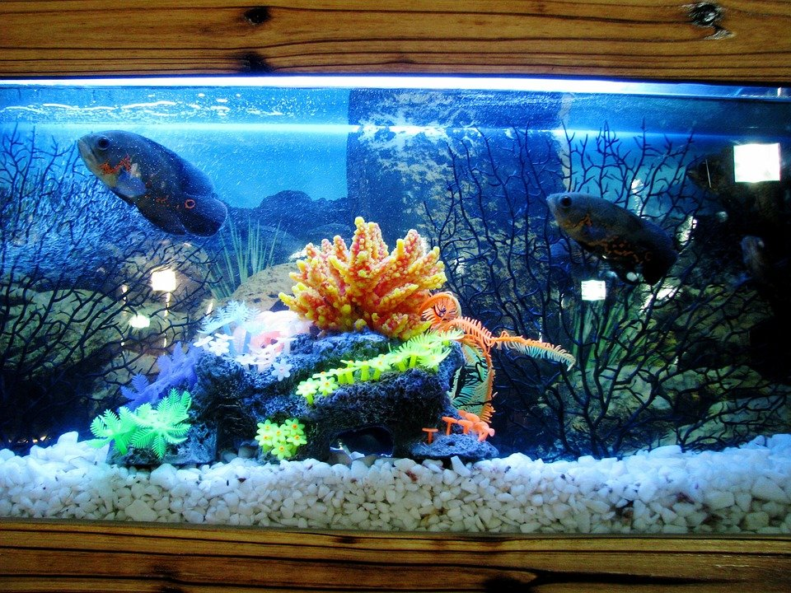 | 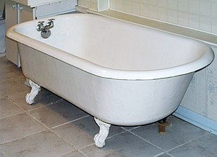
 | 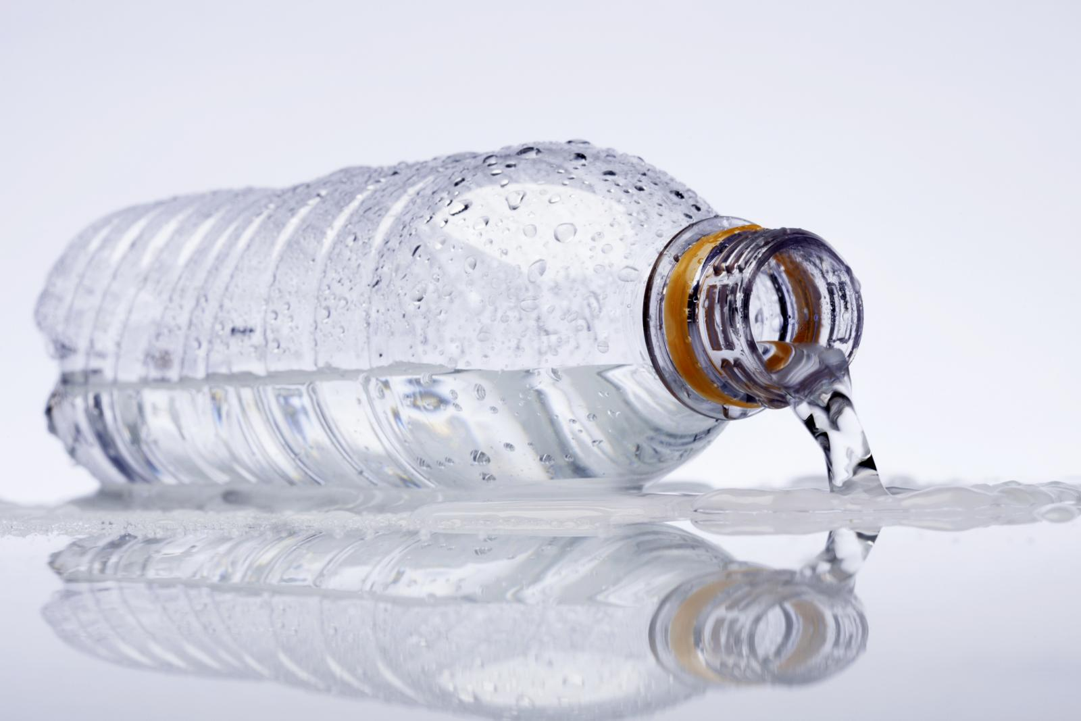 | 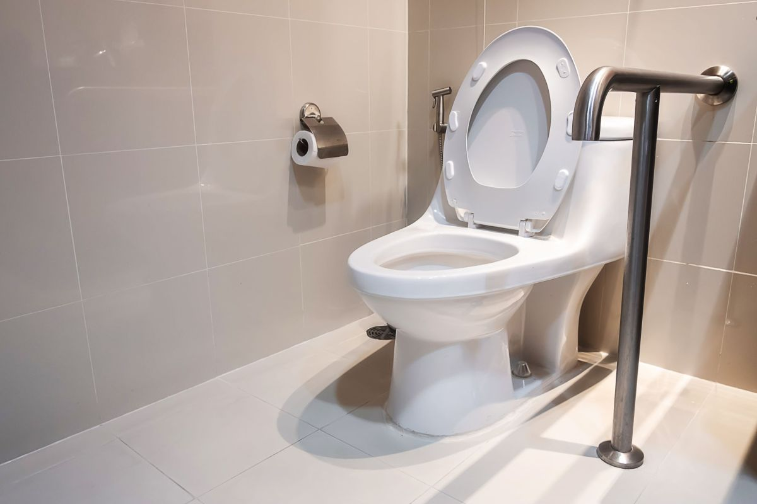

Question 2
Is the following statement true or false?

Using a bath seat or bathing aid for children can increase the child’s safety?

True
False

Question 3
Select the correct response from the options below:

You are at a local public pool and supervising a 7-year-old child who is new into your care and who is swimming in the pool, you are sitting on the edge of the pool when you receive a text message, you pick up your phone and start texting back which takes all of your attention. Would this be considered as providing acceptable safe supervision of the child?

Yes, this is acceptable supervision
No, this is not acceptable supervision

Question 4
Select the correct response from the options below?

You are applying to become a carer and a CSO has come to complete a Household Safety Check on your home. You live on a large rural property which has several water troughs and a dam for the animals which are all visible from your home. Do these water areas pose a risk to children?

Yes, the water troughs and dam are drowning hazards and pose a significant
drowning risk to children if they were to live on the property

No, as the water trough and dam is only for the animals, children can be told this
and would understand not to go near them.

Question 5
Select the correct answer/s from the options below:

You are caring for a 2yo and a 4yo and its bath time, you fill up the bathtub and put both children into the bath together and duck to the kitchen to quickly make a cup of tea. Have you put the children at risk of drowning?

Yes, young children should not be left alone in a bathtub with water at any time.
No, you are only going to be quick, they should be fine for a couple of minutes.

Question 6
Is the following statement true of false?

It’s safe to leave water in small portable pools (such as the popular “clamshells”) as they don’t pose a drowning risk?

True
False

Question 7
Select the correct response below:

Which of the statements about flood water is NOT correct?

A strong current can life a heavy vehicle off the road
It’s impossible to tell the condition of a road or bridge when it’s under water
If you see other cars drive safely through flood water, then its safe to follow them
Parents/caregivers should have a back up plan in case severe weather or flooding
occurs around the school pick-up time

This is the end of quiz 2.

Please hand in your marked quiz to the facilitator after they have gone through and discussed the correct answers with the group.

