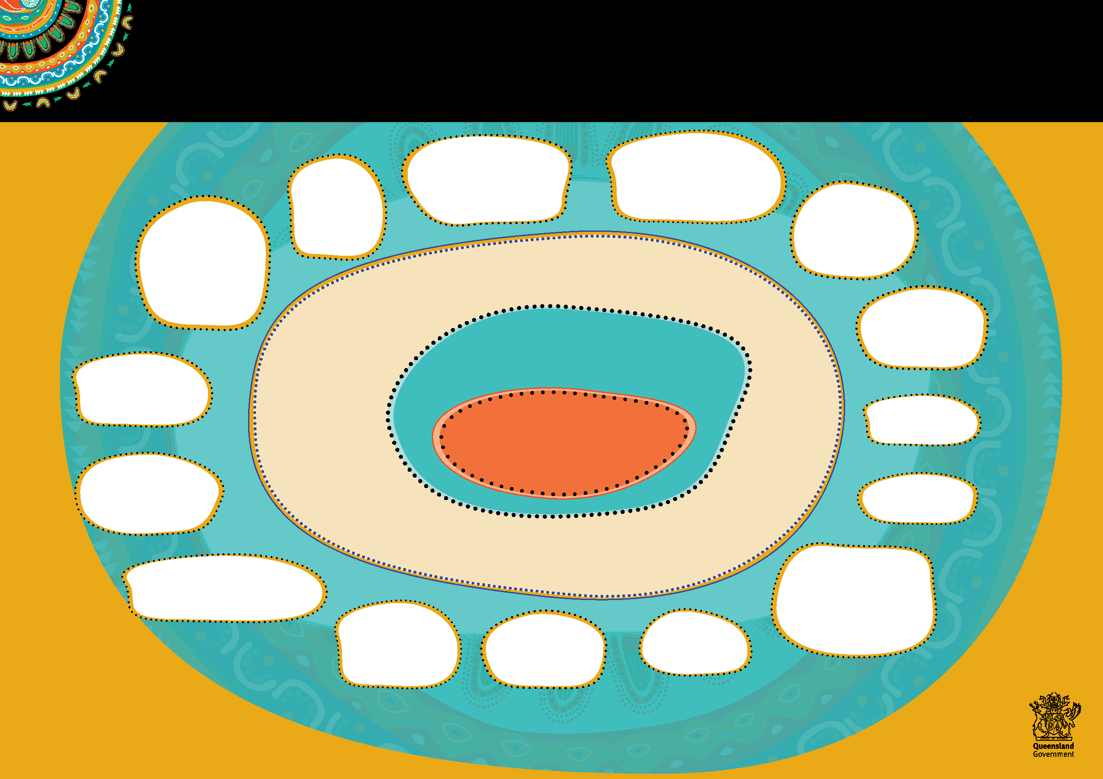

Department of Children, Youth Justice and Multicultural Affairs

**Respectfully Journey Together**

**Aboriginal and Torres Strait Islander Cultural Capability Action Plan**

**Embed Aboriginal and Torres   
Strait Islander perspectives   
into reforms and the design and   
delivery of services, programs   
and facilities.**

**Learn about the significant impacts of past government policies on Aboriginal and Torres Strait Islander peoples and apply that knowledge to contemporary responses.**

**Understand   
and respond to those   
aspects of history   
and culture that unify   
Aboriginal and Torres   
Strait Islander peoples   
as well as those that are   
specific and unique to   
each community.**

**Make cultural capability core to the department’s culture, governance, workforce, performance and risk management processes.**

**Recognise and commemorate significant Aboriginal and Torres Strait Islander events.**

**Culturally responsive services and systems**

**Value culture**

**Demonstrate**

**leadership and accountability for cultural capability at all levels across**

**the agency.**

**Seek out and value   
the cultural wisdom,   
experiences and knowledge   
of Aboriginal and Torres   
Strait Islander staff.**

**Our vision**

**To be the most culturally capable government agency in the nation.**

**Our purpose**

**To enable vulnerable Aboriginal and   
Torres Strait Islander peoples in   
Queensland to improve their lives.**

**Embrace innovation   
and new ways of   
thinking.**

**Leadership   
and**

**accountability**

**Recognise and respect   
Traditional Owners,   
Custodians and Elders and   
historical and contemporary   
connections to country.**

**Aboriginal and   
Torres Strait Islander   
engagement and   
stronger partnerships**

**Match our**

**workforce to our clients’ cultural needs.**

**Build cultural capability to improve economic and social participation**

**Make every interaction with Aboriginal**

**and Torres Strait Islander peoples,**

**customers and partners genuine, respectful and culturally appropriate.**

**Provide and purchase the right range of services for vulnerable Aboriginal and Torres Strait Islander**

**Queenslanders.**

**Genuinely and respectfully   
engage, collaborate and partner   
with Aboriginal and Torres Strait   
Islander peoples, organisations and   
communities to design, develop and   
deliver departmental responses and   
client focussed solutions.**

**Promote and   
share achievements,   
best practice strategies   
and resources.**

**Make   
the department   
a place where Aboriginal   
and Torres Strait Islander   
peoples want to work.**

***We acknowledge Aboriginal and Torres Strait Islander peoples as the Traditional Owners and Custodians of   
this country and recognise their connection to land, wind, water and community. We pay our respect to them,   
their cultures, and to the Elders both past and present.***