Breaking Cycles Flagship Forum findings

21 November 2022 Prepared by

Kristal Kinsela & Alexandra Almond

On behalf of the Department of Children, Youth Justice and Multicultural Affairs; Family Matters Queensland; and Queensland Aboriginal and Torres Strait Islander Child Protection Peak

Acknowledgement

We respectfully acknowledge the First Nations people in the State of Queensland, we acknowledge the cultural and spiritual connection that Aboriginal and Torres Strait Islander peoples have with the land and sea.

We respectfully acknowledge Aboriginal people and Torres Strait Islander people as two unique and diverse peoples with their own rich and distinct cultures.

We pay our respects to Elders past and present as well as the existing and emerging leaders who walk together in partnership on this journey.

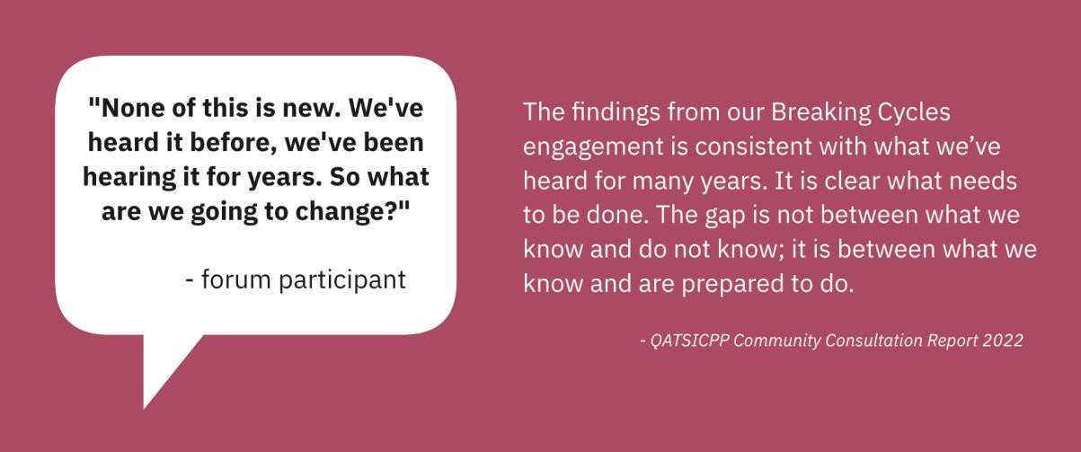

Table of Contents
Context 4
What will break the cycle? 4
Breaking Cycles Flagship Forum 6
Engagement before the forum 6
Involvement of young people in the forum 7
Forum approach 8
Findings from the forum 10
- Listen to the voice of the child 11
- Partner with us: invest in our responses 12
- Let us make decisions and lead for change 14
- Give our kids the best start in life with housing, education and culturally safe support 16
- Address cultural racism and bias in the service system 19
- Governments and services held accountable to Aboriginal and Torres Strait Islander peoples 21
Appendix 1: Raw data from table groups 24
Appendix 2: Attendees at the forum 32
Appendix 3: Post-forum participant survey responses 36
Appendix 4: Links to relevant strategies and initiatives 41

Context
The Queensland Government worked in partnership with Family Matters Queensland (FMQ) and community organisations to develop Our Way: A generational strategy for Aboriginal and Torres Strait Islander children and families 2017–2037 to close the gap in life outcomes and eliminate the over-representation of Aboriginal and Torres Strait Islander children in the child protection system by 2037.
The vision is that all Aboriginal and Torres Strait Islander children and young people in Queensland grow up safe and cared for in family, community, and culture.
Our Way is a 20-year strategy being delivered via a whole-of-system and partnership approach with FMQ, Queensland First Children and Families Board and Queensland Aboriginal and Torres Strait Islander Child Protection Peak (QATSICPP), which articulates a three-staged approach to achieving the vision:
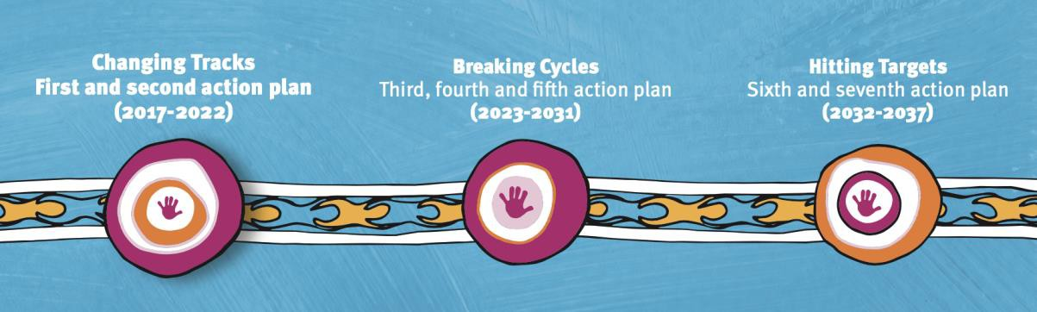

Changing Tracks
Changing Tracks: an action plan for Aboriginal and Torres Strait Islander children sets the foundation for change focusing on the systems and policy settings required to achieve the Our Way vision.
Breaking Cycles
Breaking Cycles will change the way services are designed and delivered to break the cycle of inter- generational disadvantage.
Hitting Targets
Hitting Targets will focus on a further incremental approach to reach targets.

Family Matters Campaign Building Blocks
The Family Matters Roadmap sets the foundation for changes required to achieve the Our Way vision. This includes the following four Building Blocks and sub-targets.
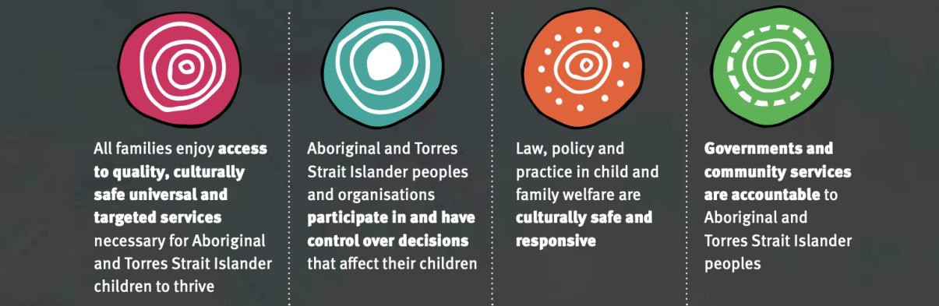

Sub-targets:
- Aboriginal and Torres Strait Islander children enjoy equal access to early intervention and prevention services as non-Indigenous children by 2020
- Aboriginal and Torres Strait Islander children in out-of-home care enjoy equal rates of reunification with their parents or family as non-Indigenous children by 2025
- Eliminate the over-representation in rates of notification of child abuse or neglect of Aboriginal and Torres Strait Islander children by 2030
- Eliminate the over-representation of Aboriginal and Torres Strait Islander children subject to a substantiation of child abuse or neglect by 2035
- Eliminate the over-representation of Aboriginal and Torres Strait Islander children subject to an order of removal into out-of-home care by 2035.20
This strategy, at its heart, is about self-determination: empowering Aboriginal and Torres Strait Islander families to exercise opportunities to live well, according to Aboriginal and Torres Strait Islander values and beliefs and the United Nations Convention on the Rights of the Child.

Alignment
The Our Way strategy sits in the context of other National and State agreements that are working towards equality for Aboriginal and Torres Strait Islander peoples, such as Closing the Gap and the Path to Treaty. The diagram on the following page shows how all the pieces fit together.

BREAKING CYCLES 2023-2025
ALIGNMENT DIAGRAM

~--.1-
Nat/anal Agreement on
: CLOSING THE GAP

{®2
lluldr,g u. C-ornru!ftrContrall9d Sedar
-------- --. ---·-
=-=-==-------

Target 12: By 2031, reduce the rate of over-representation of Aboriginal and Torres Strait Islander children in out-of-home care by 45 per cent.

Breaking Cycles
Third, fourth and fifth action plans 2023- 2025
2026-2028
2029- 2031

Listen to the voice ol the child

Place child and family
at the centre.

Partner with us· invest in our responses

Invest in the Aboriginal & Torres Strait Islander Community Controlled Sector

Let us make decisions and lead for change

Enableself­ determinationand the shift of power
Give our kids the best start In life with housing,
education and culturally safe support

Accessible &
coordinated services

Address cultural racism and bias in the service system

Acknowledge and address systemic racism
Governments & services held accountable to Aborigina I & Torres Strait Islander people

Shared Accountability & Responsibility

Changing the way that services are designed, developed and delivered to Aboriginal and Torres Strait Islander children and families by government and non-government partners.

::..-SAFE&----·
SUPPORTED·

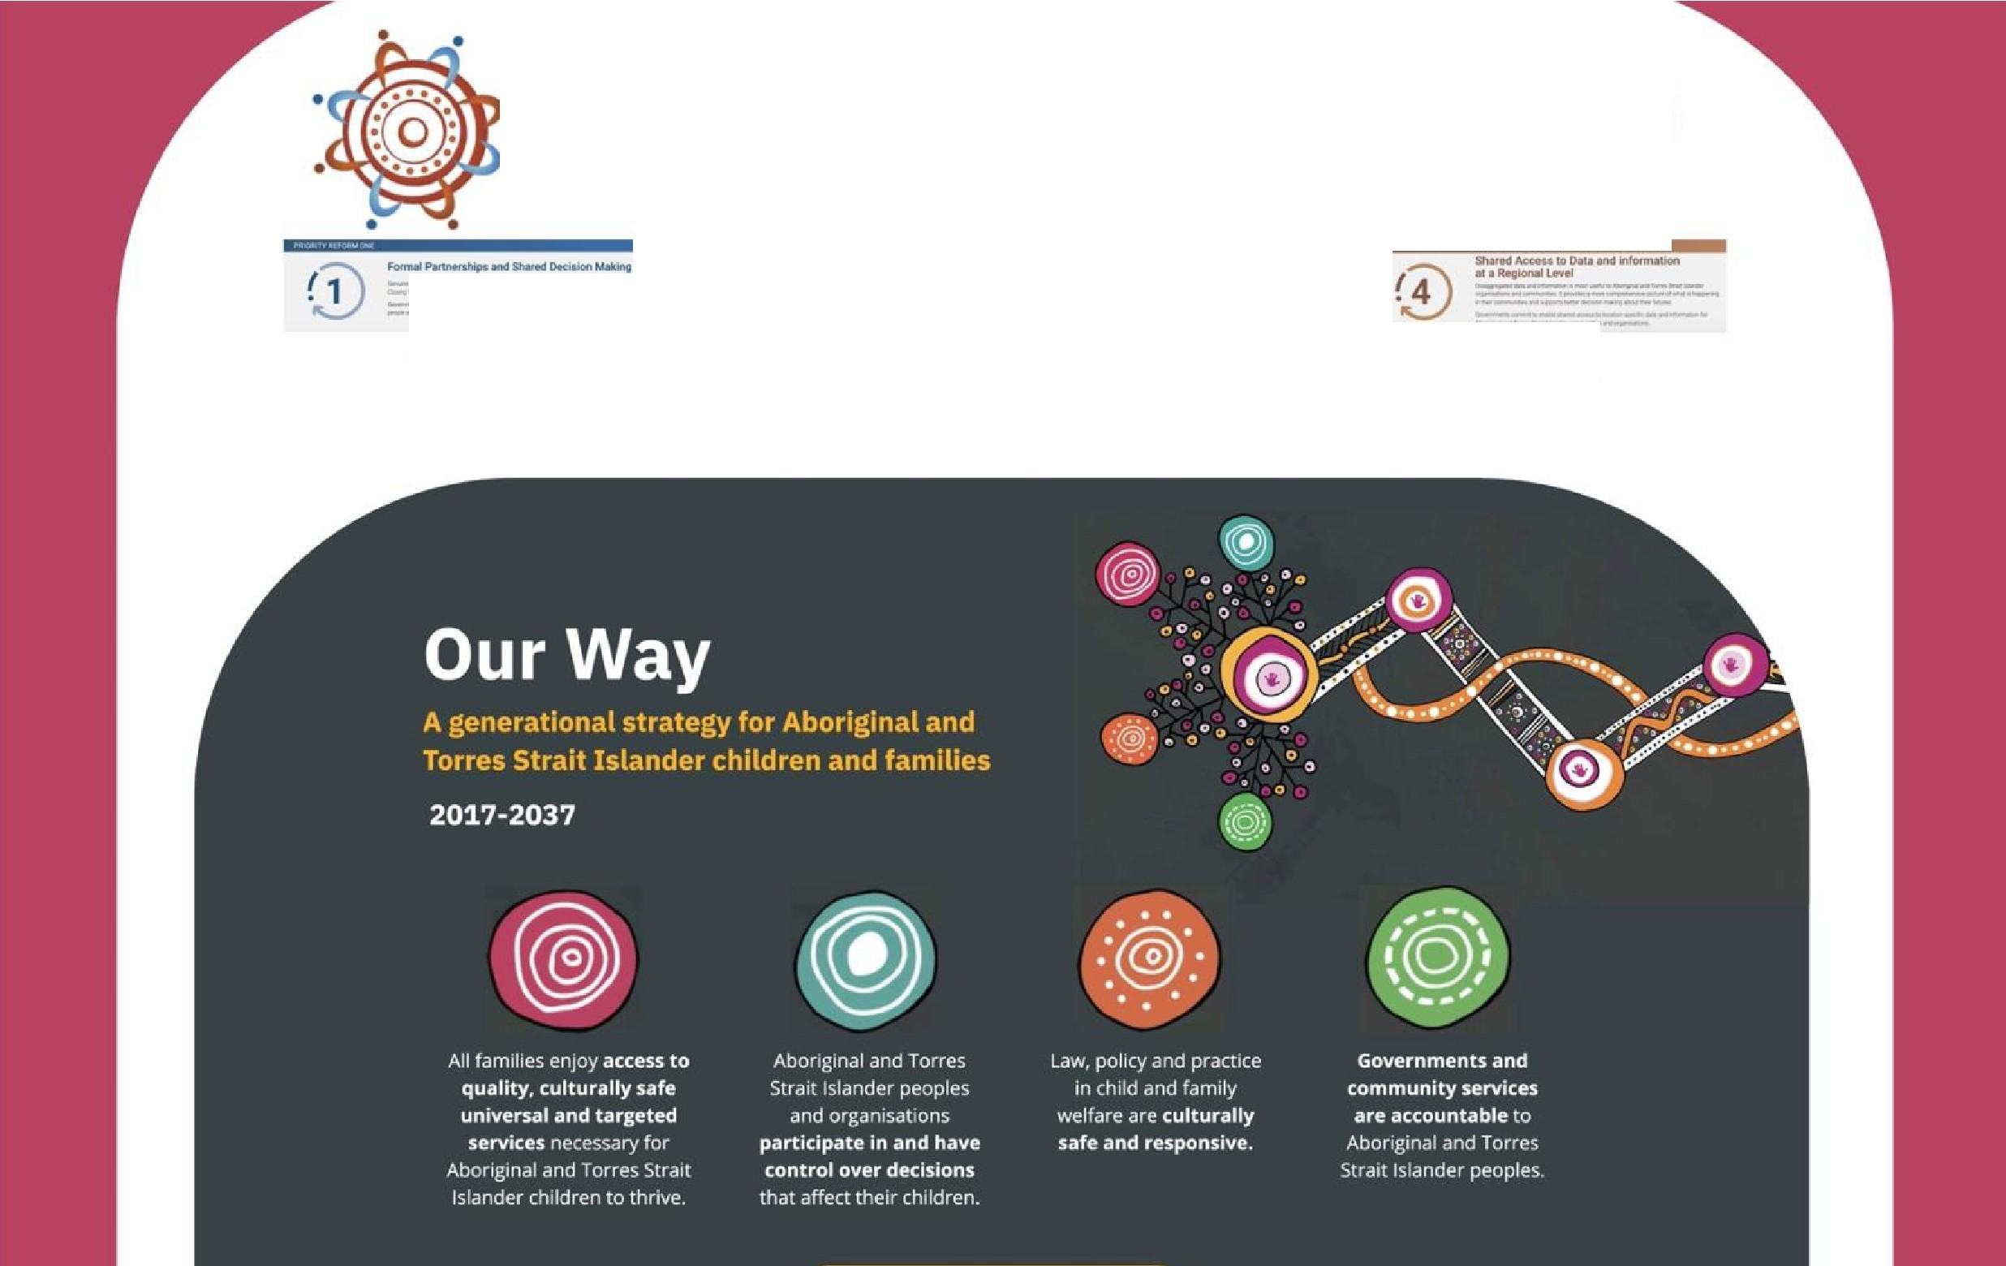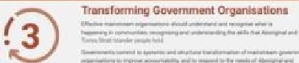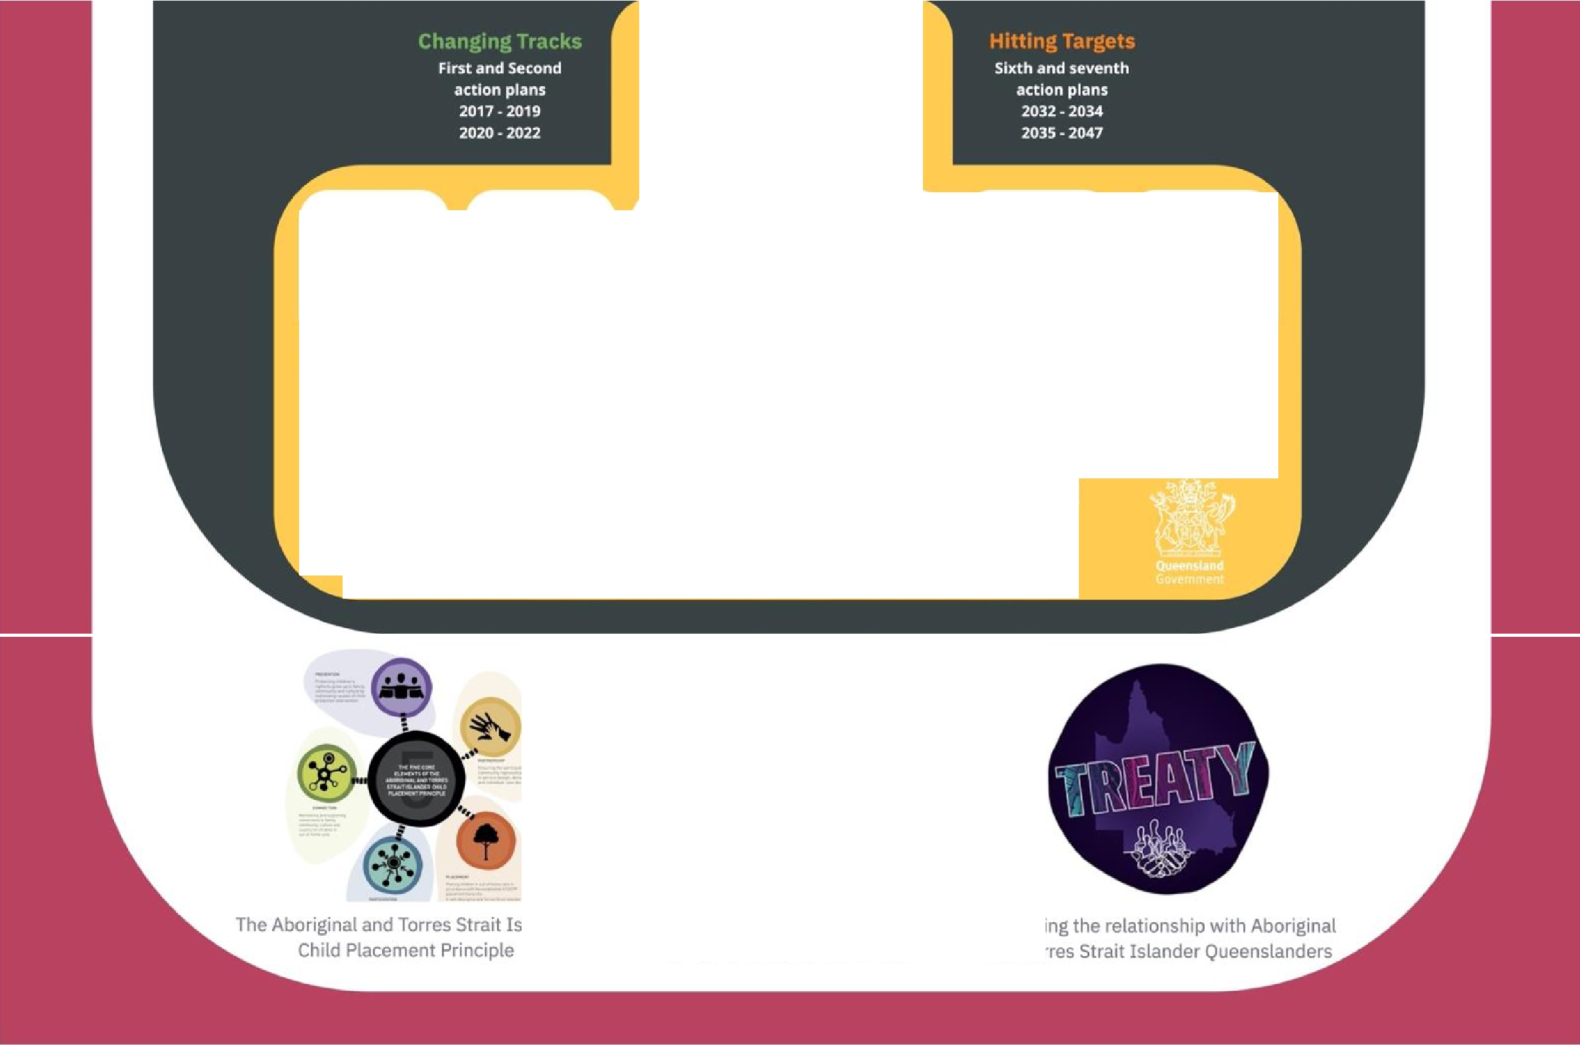The Aboriginal and Torres Strait Islander Child Placement Principle
National Framework for Protecting Australia's Children 2021-2031
Reframing the relationship with Aboriginal and Torres Strait Islander Queenslanders

What will break the cycle?
To successfully achieve the vision and goals of the Our Way strategy and commitments under the National Agreement on Closing the Gap, transformative systems change as part of Breaking Cycles will be critical.
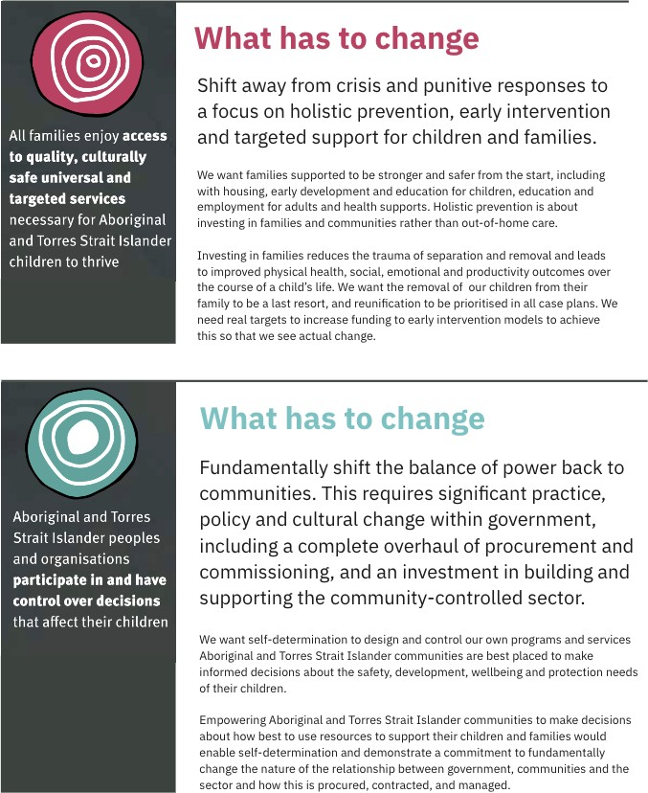

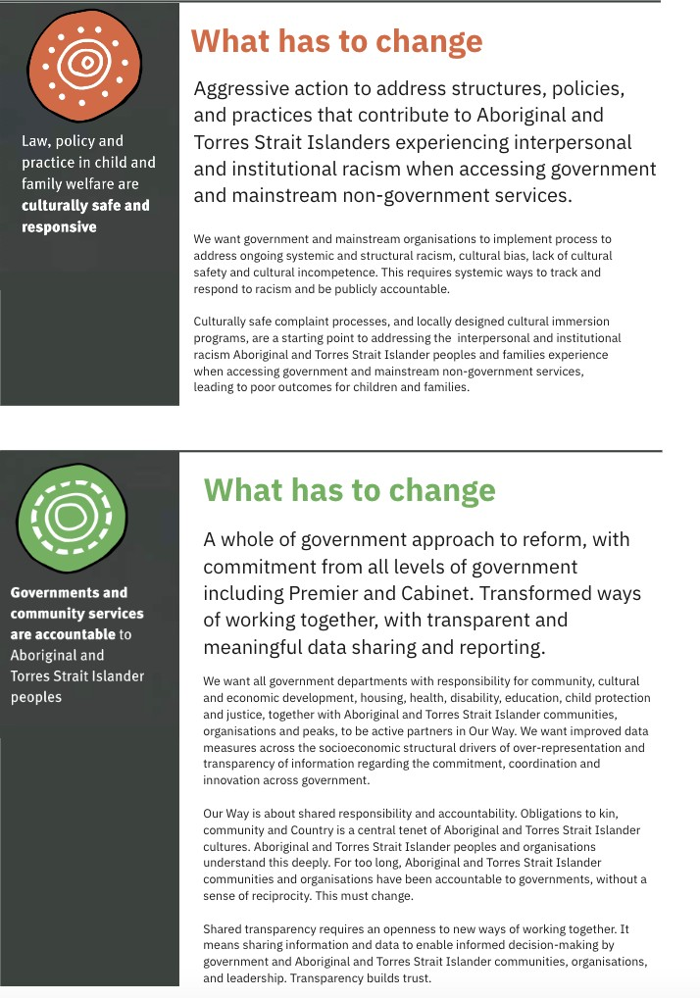

Breaking Cycles Flagship Forum
The Breaking Cycles Flagship Forum was held on Wednesday 12 October 2022 in Brisbane. The forum brought together more than 150 people from across government, Indigenous peak bodies, non-Indigenous peak bodies and community controlled organisations, and Aboriginal and Torres Strait Islander peoples from communities across Queensland. This included 12 young people who shared their stories through panel discussions, videos, and a performance on the day, as well as taking part in table discussions.

Engagement before the forum
In the lead up to the Breaking Cycles Flagship Forum (Forum), Department of Children, Youth Justice and Multicultural Affairs (DCYJMA) led a comprehensive engagement program with government agencies and non- Indigenous peaks, while QATSICPP took the lead in engaging over 950 Aboriginal and Torres Strait Islanders from fifteen communities, as well as Indigenous peak bodies and Family Matters Queensland leaders.
This engagement process brought a breadth of voices and perspectives to the Breaking Cycles Flagship Forum.

Who was engaged before the forum
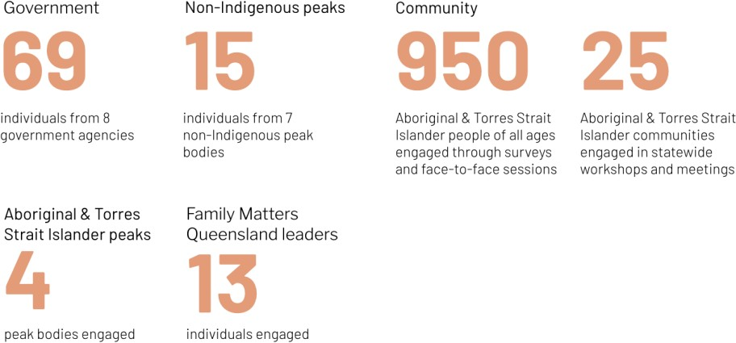

How people were engaged before the forum
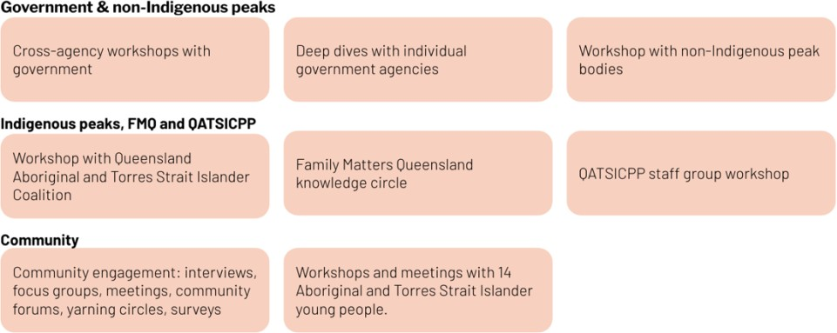

Involvement of young people in the forum
Twelve Aboriginal and Torres Strait Islanders aged between 18-21 shared their stories at the forum through panel discussions, videos, and a performance, as well as taking part in table discussions.
On the panels and in the videos participants answered questions about why it’s important for children to be with family and kin, what priorities they thought Breaking Cycles should be focussing on, and their key message for the people at the forum.
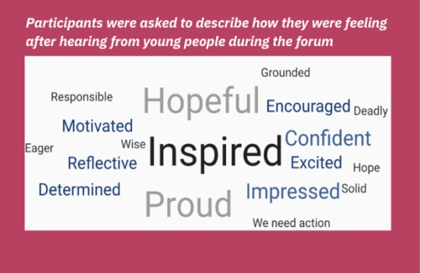
In the role play, three young people created a silent performance that used movement and music to represent young people’s experience of the difference between western context and cultural context, and the anguish and trauma that can result.
Some of the key messages from young people were around the importance of:
- Culture as the foundation for everything, including healing
- Keeping families together
- Young people having a voice in everything
- Strengthening families and parents

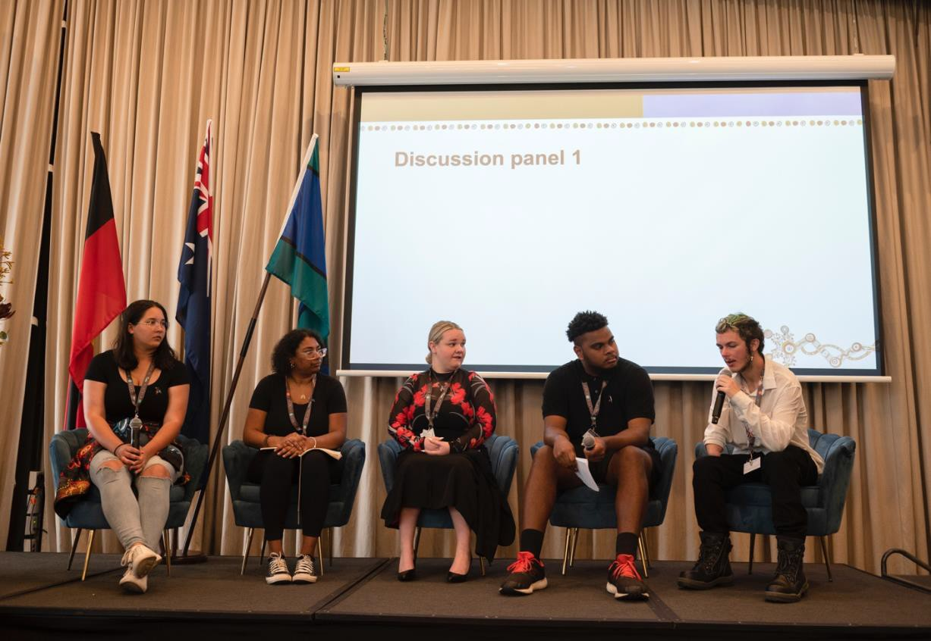

Forum approach
David Baird from the Queensland First Children and Families Board provided an Acknowledgment of Country. Prominent Queensland leaders opened the forum, including Minister Linard, Director-General Diedre Mulkerin and Family Matters Co-Chairs Aunty Rachel Atkinson and Michael Currie. From Director-General Diedre, forum attendees heard first-hand two key targets: to halve the number of young people in residential care and double the number in kinship care.
Forum attendees were allocated to tables allowing for a mix of representation in each group. This approach ensured there were different perspectives represented at the tables, and those from government and non- Indigenous organisations were able to hear directly from Aboriginal and Torres Strait Islanders.
However it also meant the Aboriginal and Torres Strait Islander participants were carrying their cultural obligations to whole communities, and had to represent their community not just themselves as individuals. Forum feedback indicates there was varying levels of success in how effective single participants were in being listened to and in working the solutions as intended.

Priority areas
For consistency and recognition that the priority areas identified at the commencement of the Our Way Strategy remain current based on pre-forum engagement, the following six priorities were discussed at each table:
- Listen to the voice of the child (place child and family at the centre)
- Partner with us - invest in our responses (invest in the Aboriginal and Torres Strait Islander Community Controlled Organisation sector)
- Let us make decisions and lead for change (enable self-determination & the shift of power)
- Give our kids the best start in life with housing, education & culturally safe support (accessible and co- ordinated services)
- Address cultural racism and bias in the service system (acknowledge and address systemic racism)
- Governments and services held accountable to Aboriginal and Torres Strait Islander people (shared accountability and responsibility)
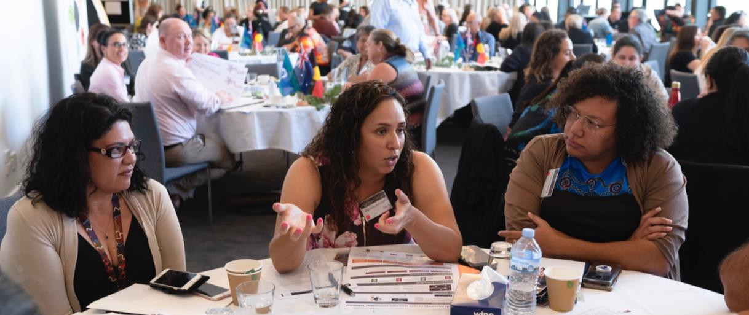

Flow of the day
For each priority area, tables were asked to discuss and identify specific actions that could be taken to address this priority, how those could be implemented and who would be responsible. Each priority was allocated thirty minutes discussion time.
At the end of the day, tables were asked to nominate three key priority actions and discuss ways success could be measured.
AGENDA
Session Time | Session Topic | Presenter
8.45 – 9.00 | Arrival at venue (tea and coffee on arrival() | Attendees
9.00 – 9.10 | Acknowledgement of Traditional Owners | David Baird QFCFB
9.10 – 9.15 | Welcome message | Minister Linard (video)
9.15 – 9.30 | Official opening of the Forum | Director-General & Family Matters Queensland
9.30 – 9.45 | Overview | Facilitators
9.45 - 10.00 | Group activity / Ice breaker  SLIDO | Facilitators
10.00 – 10.20 | Discussion panel 1 | Young People
10.20 – 10.30 | Videos | Young People
10.30 – 10.50 | Morning Tea | Venue
10.50 – 12.30 | Group activity  - Set up 10 mins  - 3 x priority area focus 30 mins each | Facilitators
12.30 – 1.20 | Lunch | Venue
1.20 – 1.40 | Discussion panel 2  SLIDO | Young People
1.40 – 3.10 | Group activity  - 3 x priority area focus 30 mins each | Facilitators
3.10 – 3.30 | Afternoon Tea | Venue
3.30 – 3.45 | Role play | Young People
3.45 – 4.30 | Prioritisation  - What are our priorities  - How will we measure | Facilitators
4.30 – 4.35 | Poem  SLIDO | Young People
4.35 – 4.50 | Individual commitments | Facilitators
4.50 – 5.00 | Wrap up and event close (next steps) | Facilitators

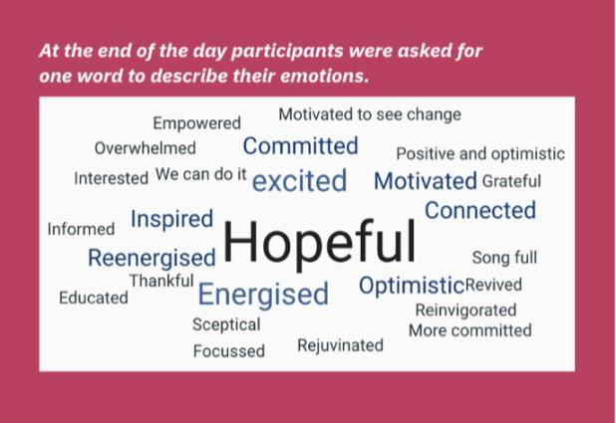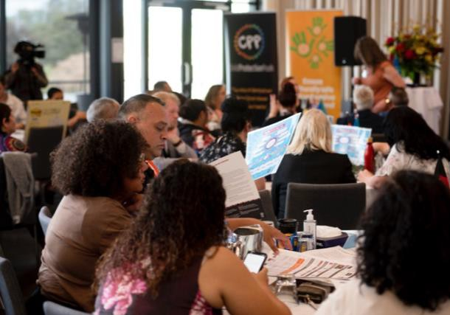

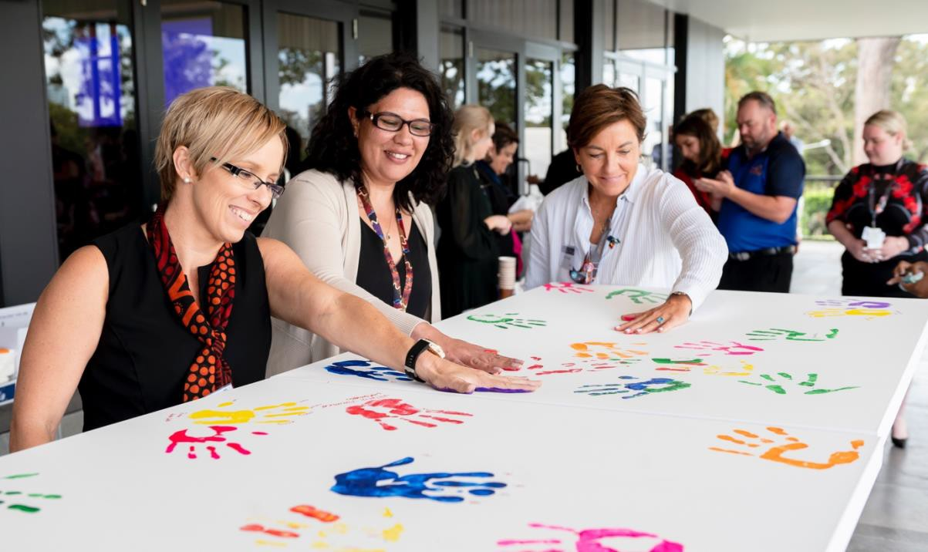

Attendees at the forum
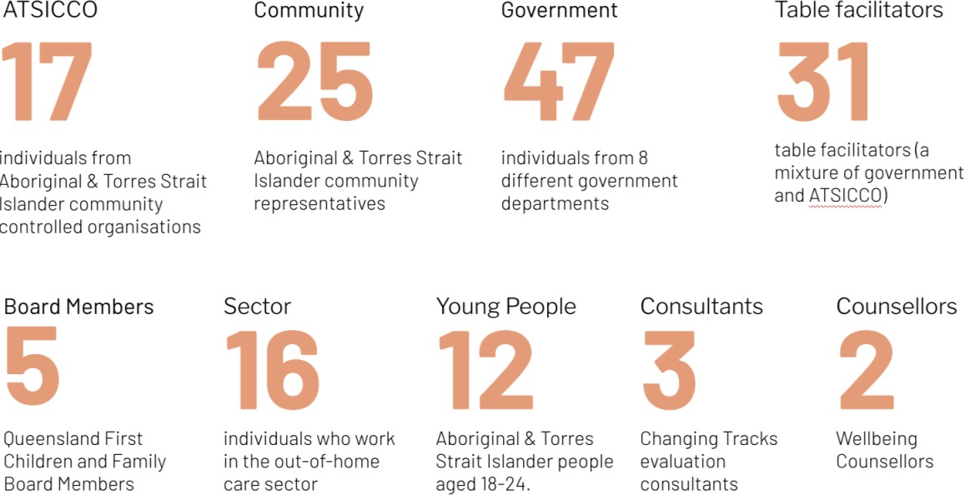

Findings from the forum
On the following pages we have detailed the findings from the forum, aligned against each of the priority areas.

Listen to the voice of the child

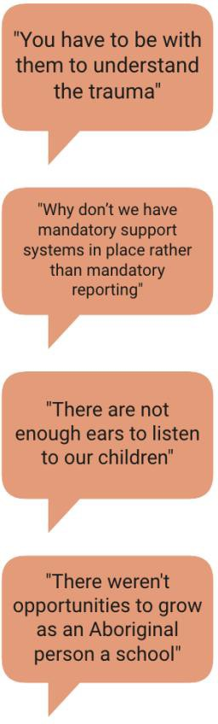
What we heard
For many this is fundamentally about the wellbeing of families and children and providing early and ongoing support to prevent young people entering out-of-home care. There was a very clear message from the young people in attendance that what they want is their parents to be looked after too. People want to hear the voices of young people interacting across government agencies, not just those at risk of entering care; and they want those voices to be embedded in all decisions about families and children.
There was a strong emphasis on healing, and the need for young people to have connection to country and family to be able to heal. It was stressed that this needs to be local, in
community; and that it’s always about place-based decision making not top down directives from a central authority.
The role of schools came up a lot. Young people spend a lot of time at school and it’s one place where we could listen to their voices and provide access to safe people. Issues with the current school system include the high number of expulsions and suspensions, and an often culturally unsafe environment. Those are things we’d be addressing if we were listening to the voice of the child.
It is also about listening, not just asking for young people’s opinions. Not everyone is able to or feels safe to respond to direct questions, or to speak up in any kind of formal environment. There were suggestions about non-verbal communication and body language, and other ways we can bring in the voice of young people in the service context.

Possible actions
Nine of twenty-one tables (43%) selected actions related to listening to the voice of the child among their top three priorities. Below we have collated and categorised the possible actions for ease of reading. The raw data from each of the tables is listed at the end of the section.
Please note: actions around shifting focus to preventing kids from entering care, have been captured under the previous topic give our kids the best start in life with housing, education and culturally safe support and are not repeated here.

EMBED THE VOICE OF THE CHILD

Goal | Possible actions
Governance bodies to embed the voice of young people | Establishment of Aboriginal and Torres Strait Islander young people advisory group to policy makers / to inform changes.
 | Dedicated Aboriginal and Torres Strait Islander Family and Child Commissioner.
 | Establishment of an Aboriginal and Torres Strait Islander Ombudsman - somewhere young people can go to.
Different ways of listening to the voice of young people | Explore different opportunities for kids to say what they want, (e.g. children point and tell, children younger than one to show how they feel).
 | Natural mentoring program (see next step program).
Focus on families not just individuals | Need a holistic lens to consider wellbeing of the whole unit—the parents, family and community—instead of just focussing on a child’s immediate safety.
Policy change | Change policy to require the input of children and young people in annual reports, updates for  Our Way and monitor participation in decision making.

Partner with us: invest in our responses

What we heard at the forum
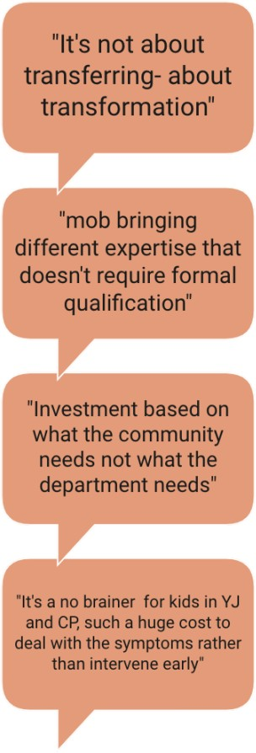
“Rethink” and “Reimagine” are words we heard over and over again at the tables for this topic. These words refer to many different parts of the system where it’s clear that the government way of thinking is not working for Aboriginal and Torres Strait Islander peoples.
Some of system elements identified as needing reimagining included:
  - Funding: thinking about continuity of care and funding across holistic needs rather than siloed departmental streams.
  - Procurement: an emphasis on collaborating not competing because we’re all working towards the same goal, and longer-term contracts and arrangements for CCOs.
  - Accountability: focusing on outcomes rather than process.
  - Decision making: local and place based rather than central, with community designing what this looks like for them.
  - Collaboration: no more us and them.
A fundamental area for change is local and community decision making; a reimagined space isn’t a different set of top-down rules, it’s where community designs what this looks like for them. It means each community gets to invest in what their community needs, not what government needs.

Possible actions
Fourteen out of twenty-one tables (67%) selected actions related to Partner with us: invest in our responses among their top three priorities. Below we have collated and categorised the possible actions for ease of reading. The raw data from each of the tables is listed at the end of the section.

WORKFORCE
Goal | Possible actions
Develop the Community Controlled Organisation (CCO) workforce | Take action to:  - Attract and recruit the right people  - Build and promote professional identity  - Grow and develop staff  - Nurture and retain staff  (sourced from the Community Controlled Child Protection Sector Workforce Strategy)
 | Establish regional working groups to identify and prioritise local infrastructure needs, to support development of the Community Controlled Sector.
 | Invest in meaningful transfer of resources, including training and upskilling (e.g. Study and Research Assistance Scheme).
 | Explore alternate opportunities to build up workforce capability (e.g. scholarships, traineeships).
Recognise that mob bring different expertise that doesn't require formal qualification “find the
will then the skill”.

PROCUREMENT AND COMMISSIONING

Goal | Possible actions
Revise procurement process to enable transition of funds from NGOs to CCOs | Review of commissioning (procurement process)
 | Transition to outcomes-based procurement: contracts not based on number of clients but keeping kids out of care and continuing support if child does have to come into care-supporting reunification.
 | Design a funding methodology that will enable funding to follow the child to ensure continuity of care and service delivery. This will require a different workforce.
 | Refine project and contract management processes to reduce competition and enhance collaboration.
 | Transition to long term contracts and funding.
 | Offer a dedicated budget to start up an ATSICCO.
 | QATSICPP holds the funding, not government.
 | Have Aboriginal and Torres Strait Islander staff provide a cultural lens on tender/funding applications.
 | Have community-led procurement.
Funding stability | Lock down longer-term contracts certainty and continuity.
 | Funding to be more place-based as regions have specific or more pressing issues than others. Look at oversight to keep investments local.

SERVICE APPROACHES

Goal | Possible actions
Joined-up services | Integrated co-located services and programs in one centre. Develop a "One-stop-shop" for Aboriginal Torres Strait Islander Families, and children . A purpose built facility, friendly and non-threatening, multifunctional to meet local needs.
 | Explore a single case plan approach so that whoever is the first agency becomes the lead agency for any individual or family, helping them navigate government agencies.
Place-based decision making | Introduction and expansion of local community decision making about what the priority needs are and the best responses to invest in.
 | Acknowledge service delivery choice in remote areas challenges and different ways of delivery for choices.

Let us make decisions and lead for change

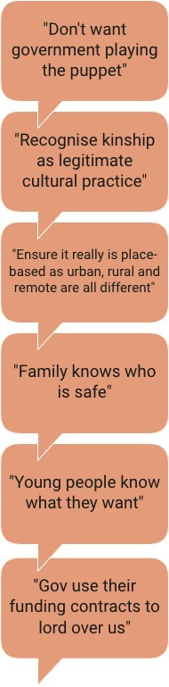
What we heard at the forum
Government needing to let go of power was a strong theme at the table discussions. They’re still holding the final decision making authority, and preferencing government approaches over cultural authority.
This requires a fundamental shift in mindset but it’s also going to need legislative and procedural changes; e.g. the Blue Card process is seen as racist and working against Aboriginal and Torres Strait Islander families getting good outcomes. Until that process is changed, it’s going to be hard for communities to be effective even where Delegated Authority is rolled out.
There was also an awareness that moving decision making into the hands of community requires investment in building up and resourcing the sector. Long term funding came up as an issue, and the need for the speed of transition to be driven by the CCO when they’re ready, rather than enforced via a top-down rollout strategy.
We’re very conscious of the need to learn from current early adopter sites, and that informed decision making requires good data at a local and regional level.
The need for local and place-based decision making was also a theme. This is about geography—because urban, rural, and remote environments require very different approaches—but also about moving away from the government style of making decisions by following strict rules. The same rules do not work for every location, or for every family.
The Aboriginal and Torres Strait Islander approach preferences Family Led Decision Making, and this is seen as a preventative approach not just a way to manage kids who are entering care.
The importance of kin, and building up the voice of young people, came through in this topic as it did in every discussion.

Possible actions
Thirteen of twenty-one tables (62%) selected actions related to let us make decisions and lead for change among their top three priorities. Below we have collated and categorised the possible actions for ease of reading. The raw data from each of the tables is listed at the end of the section.

DELEGATED AUTHORITY

Goal | Possible actions
Decisions about | Scale delegated authority beyond two current sites, learning from emerging issues in trial sites
Aboriginal and Torres | and taking into account the unique needs of each region.
Strait Islander children  are made by family and community, not government. | Develop community and family led decision making, where community works with families to address their worries. Requires time and a long-term funding, as these models are still being developed and need time to grow.
 | Change management approach and education across government, non-government, and
 | community to support and understand what this shift will mean.

Expand the range of responsibilities that can be delegated, including exploring whether delegated authority can be enacted in other legislation beyond the Child Protection Act (ie. Community Corrections).
Develop a communications and data sharing platform to learn from Delegated Authority sites, to enable informed decisions.
Let CCOs determine the rate of change (risk of silos and fighting over funding within CCO sector if expanded too rapidly and without community control).
Establish a commissioning body that is Aboriginal and Torres Strait Islander controlled that supports Aboriginal and Torres Strait Islander peoples to invest in their own solutions.
Improve the powers and functions of the Aboriginal and Torres Strait Islander Children’s Commissioner, to have oversight of all departments that provide services to Aboriginal and Torres Strait Islander children, and report directly to parliament to hold government to greater accountability.
Establish Aboriginal and Torres Strait Islander oversight of legislation and policy: government
can’t make decisions without hearing our voice.

KINSHIP CARE

Goal | Possible actions
More kids staying with kin | Review the Blue Card process and explore alternative, more culturally appropriate approaches. This may be a revision of the Blue Card process or there may need to be a completely different instrument for kinship care.
 | Establish kin finding teams; first placement must be kin.
 | More support for kinship carers; tools, training, impact knowledge.
 | Provide the same benefits to kin carers as to foster carers.
 | Recognise kinship as legitimate cultural practice. Legal recognition of a family arrangement as another option that doesn't require the child to be under care of the chief executive and doesn't require a kin carer to get a blue card.

Give our kids the best start in life with housing, education and culturally safe support

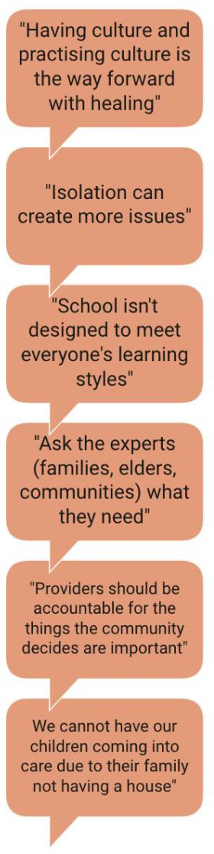
What we heard
Giving our kids the best start in life is proactive, not reactive. It means creating environments where kids and their families have access to the services and facilities, they need to be successful.
The most common services talked about were:
  - Housing: and this is not just having more housing available but rethinking how existing housing is allocated to provide stability and support renters in the long term.
  - Health: particularly increasing services for pre- and post-natal care, but also mental health, fitness, and healthy food habits, and incorporating traditional practices into health services.
  - Education: recognising that not everyone learns the same way, and that the
current school system isn’t always culturally safe or appropriate. We need to address racism and bullying and get rid of suspensions and expulsions in favour of providing supportive rather than punitive behavioural approaches.
Most tables identified that services are particularly challenging in rural and remote areas, and that “red tape” currently prevents a lot of good work happening. The idea of integrated services is popular, a one-stop-shop for Aboriginal and Torres Strait Islanders; or a single case plan approach so that whoever is the first agency becomes the lead agency for any individual or family.
Healing was another strong theme, with the need to embed an understanding of intergenerational trauma across government departments.

Possible actions
Nine of twenty-one tables (43%) selected actions related to give our kids the best start in life among their top three priorities. Below we have collated and categorised the possible actions for ease of reading. The raw data from each of the tables is listed at the end of the section.

HOUSING

Goal | Possible actions
More affordable housing available for Aboriginal and Torres Strait Islander families | Review the criteria for access to affordable housing so most at need have priority.
 | Review criteria to expand eligibility for social housing.
 | Invest in more public housing: identify where investment in affordable housing is most needed and prioritise that.
 | Revise policy so families don't lose public housing if children are removed (so reunification can occur).
 | Explore ways to offer longer term housing options to provide stability and build confidence.
 | Develop housing options for young people exiting care.

 | Explore ways to embed place-based responses to housing needs.
Increased access to crisis accommodation | Review the criteria to access crisis accommodation so most at need have priority.
 | Invest in more crisis accommodation: identify where investment is most needed and prioritise that.
Appropriate and suitable houses | Redefine overcrowding to include an understanding of cultural ways of living.
 | Invest in larger houses, and different design options to improve opportunities for families to stay connected.
Home ownership | Explore opportunities for Aboriginal and Torres Strait Islanders to own their own homes (e.g. rent to buy).

EDUCATION

Goal | Possible actions
Eliminate suspensions and expulsions | Develop a trial program for schools looking at comprehensive assessment, diagnosis, and early intervention – rather than punitive behavioural approaches (suspension and expulsion).
Culturally safe learning environments | Funding models based on meeting well-being needs of Aboriginal and Torres Strait Islander Children and not just academic levels.
 | Appropriate resources in place to support Aboriginal and Torres Strait Islander Children with developmental challenges.
 | Higher levels of accountability and increased scrutiny on decisions made for student non- attendance.
 | Explore education styles to suit different learning needs.
 | Develop therapeutic response to support children at school.
 | Change the curriculum to include cultural awareness, including involving aunties and uncles in the curriculum.
 | All education staff across schools have several cultural capability indicators they are required to demonstrate and report on to a joint governance committee (comprising of government and community leaders).
More kids in school | Address young people in the Torres Strait and Cape York disconnected from school after COVID.
 | Involve parents and engagement in the service.
 | Make it easy for kids to get to school: buses, books and uniforms, laptops/ipads.
 | More programs and support for Aboriginal and Torres Strait Islander parents to understand the importance of education.

HEALTH

Goal | Possible actions
Build cultural capability in the health sector | Embed cultural capability indicators into position descriptions and performance reviews, to report on and demonstrate their achievements.
 | Increase the number of Aboriginal and Torres Strait Islanders employed in the health industry (education, pathways, opportunities).
 | Incorporate traditional practices into health provision.
 | Local and place-based health solutions.
 | Invest in more Indigenous specific health services.
Increased access to | Invest in more health services: identify where investment is most needed and prioritise.

health services | Focus on mental health, so those presenting with mental health conditions are getting the right care and are plugged into the right services.
 | Long term funding to support localised services.
Improved pre and post natal health care | Zero birth removals: change policy and procedure to prevent removal of unborn children.
Increase support for parents and pregnant mums before they enter the child protection system.
Communicate and provide easy access to health services pre, during and post-antenatal care and other services such as parenting programs.
 | Introduce dedicated services for Aboriginal and Torres Strait Islander mothers and babies who suffer from mental health issues including post-natal depression.
Provide parenting support | Invest in programs for new parents.  Review the current situation to identify priority locations and needs (where are the gaps and how can we encourage take up).
 | Positive parenting practices promotion all government agencies - healthy families, not just on NITV.
 | Ask the experts (families, elders, communities) what they need and design accordingly.
 | Engage dads early with support for expectant fathers.
 | Mentoring programs for parents, particularly for men.
Improved access to drug and alcohol services | Invest in more drug and alcohol services: identify where investment is most needed and prioritise.
 | Investment in preventative and support services not just rehabilitation.
 | Focus on parents and families, not just young people.

Address cultural racism and bias in the service system

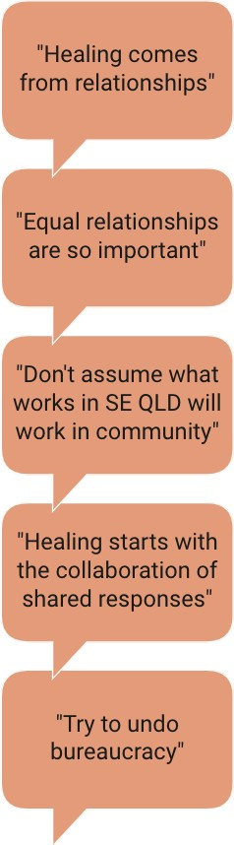
What we heard
This is a huge topic and in a half hour discussion it’s likely most tables only scratched the surface. Key themes that emerged were around truth telling, trauma informed responses and healing.
Truth telling takes many different forms, with tables identifying many ways to build awareness including embedding in the school curriculum. There is a need for commitment both from government at a systems level, valuing equal relationships and having zero tolerance for racism; but also, from individuals being open to looking inward and addressing their own belief systems.
Fundamental to this is acknowledging bias and developing ways to address bias. Suggestions included an examination of the tools used to make decisions; e.g. school expulsions are an example of cultural bias built into the system.
Trauma informed responses are a critical next step. These need to be built on understanding—why kids might be acting out, for example—and then providing alternative options and ensuring responders have the capability to apply trauma informed practice.
These things will help with healing, but the whole family being on country is also important for healing.

Possible actions
Nine of twenty-one tables (43%) selected actions related to address cultural racism and bias in the service system among their top three priorities. Below we have collated and categorised the possible actions for ease of reading. The raw data from each of the tables is listed at the end of the section.

TRUTH TELLING AND HEALING

Goal | Possible actions
Established ways for truth telling and healing to occur | Government and organisations to build action plans on how they will ensure a shared understanding, acceptance, and responsibility for truth telling and healing.
 | Invest in programs on country for Aboriginal and Torres Islander peoples.
 | Establish healing centres.

ADDRESSING RACISM AND BIAS

Goal | Possible actions
Culturally safe practices | Review tools mandated by government to ensure they are culturally appropriate.
 | Develop culturally responsive complaints management processes and systems.
 | Establish an independent body to investigate and drive systemic change of racism in the systems / practice.
 | Co-design local responses with CCOs to improve cultural capability and work on deficiencies in a positive way.

 | Invest in developing Aboriginal and Torres Strait Islander leadership.
Improved cultural awareness and competency | Implement the Family Matters Reflective Practice Tool across all services funded to support Aboriginal and Torres Strait Islander children and families as a strategy to improve the cultural competency of government and mainstream organisations.
 | Run a public campaign.
 | Mandatory training: unconscious bias and cultural awareness across all employees.

Governments and services held accountable to Aboriginal and Torres Strait Islander peoples

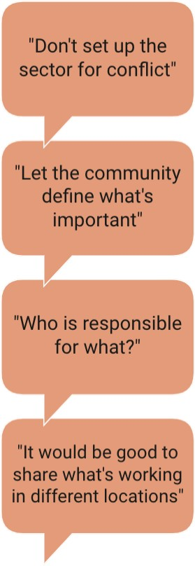
What we heard
This is not about providing yet more reports that document government actions, but about understanding the impact those actions are having on Aboriginal and Torres Strait Islander families and children and learning from them.
Most tables talked about data, and the need for transparency and shared regional data. It’s not about competing against each other for the best results, but about working together to understand what’s working and develop appropriate place-based responses.
There were a number of suggestions about a culturally responsive complaints management process, that could work to provide ongoing feedback loops as well as deal with issues that arise.
In terms of measurement, there was a strong sense that community should define what’s important and therefore what’s measured, and that might look quite different to today. Also, that measurement should be a continual review of what’s working, not a moment in time tick box.
Other tables talked about accountability measures, and the possibility of setting up dedicated independent bodies to oversee and ensure true partnership.

Possible actions
Four of twenty-one tables (19%) selected actions related to Government and services held accountable among their top three priorities. Below we have collated and categorised the possible actions for ease of reading. The raw data from each of the tables is listed at the end of the section.

ACCOUNTABILITY AND GOVERNANCE

Goal | Possible actions
Established structures and bodies. | Fund an Aboriginal and Torres Strait Islander Legal Peak, Aboriginal Torres Strait Islander education peak, a Voice for Aboriginal Torres Strait Islander children in early education to truly have a representative voice.
 | Develop a mechanism to bring together Queensland Government partner agencies and First Nations Boards / Coalitions / Councils / Committees to discuss progress against Closing the Gap targets.
Strategies to support change management Processes | Co-design a reform plan; a high-level strategic understanding of how to achieve the reform planned.
 | Develop a change management strategy to ensure we do not revert to doing business as usual; this requires investment in our leadership.
 | Embed a rights-based approach to implementation of the Aboriginal and Torres Strait Islander Child Placement Principle (ATSICPP) and raise awareness to support families to exercise their rights and all gov & providers to enact responsibilities under the Human Rights Act.
Improved accountability | QATSICPP and QFCC to be able to monitor and provide feedback on funding and data measures at least yearly with a report (FMQ).
 | Accountability back to community for government spending.

Media to be held accountable for what and how they report about Aboriginal and Torres Strait Islander peoples and communities
Establish an Aboriginal and Torres Strait Islander division within treasury to keep agencies accountable for funding.
Establish an independent audit committee (or some other body) that can hold actions to account and make sure they realise their intent – something of the nature of a productivity commission who can report to the public.
Allow young people and those with lived experience into positions of power – give them information and opportunity.
Co-create performance indicators for government agencies to demonstrate how they are transforming their organisations and the way they work with Aboriginal and Torres Strait Islander peoples, communities, and organisations – and hold them to account if they fail to meet them.

DATA

Goal | Possible actions
Data relevant locally and to communities | Local districts / areas develop their own local governance and data arrangements.
 | Data provided from department on district level to governance on outcomes for kids.
 | Let the community and the people who are being served define what's measured and what is important. Dual accountability to the service agreement and the community.
Improved data sharing and transparency | Share relevant data to inform resourcing and decision making and to identify opportunities to partnership to meet needs.
 | Bring together departments and CCO to share what's working in community.
Different data | Acceptance of qualitative data and stories to build evidence.

APPENDICES
Appendix 1: Raw data from table groups Appendix 2: Attendees at the forum
Appendix 3: Post-forum participant survey responses Appendix 4: Links to relevant strategies and initiatives

Appendix 1: Raw data from table groups

Listen to the voice of the child
The priority actions and suggested measures relevant to this topic are transcribed below.

Table | Priority | Measurement
1 | Shift resourcing to preventing kids from entering care | Better resourcing and funding.  Preventative strategies, investing in the work early before child protection intervention.
7 | Embed the voice of children everywhere | Lower # of placement breakdowns. Less use of IP.  Establishment of Aboriginal and Torres Strait Islander young people advisory group to policy makers / to inform changes. Dedicated Aboriginal and Torres Strait Islander Family and Child Commissioner.  Establishment of an Aboriginal and Torres Strait Islander Ombudsman – somewhere young people can go to.
9 | Fund prevention and early intervention with a healing focus | # of Hope and Healing Frameworks (or similar) implemented across QLD CCOs.  $$$ to Family Wellbeing Services (annual increase targets).
10 | Shift resourcing to preventing kids from entering care | Throughput measures (# kids in care, # kids entering care). Lead indicators (connection to health, education, culture,  employment) and identifty lag indicators for kids and families who receive services or support then don't come into care.
11 | Embedding the voice of the child | Opportunities for kids to say what they want.  Children point and tell, children younger than 1 to show how they feel.  Natural mentoring in next step program. Participation rate and experience.  Consumer (child and family) let inclusion.  Performance indicator in the Family Led Decision Making process / review / case planning / reunification / placement.  Performance indicator for child safety in review / case planning / reunification / placement.  Support and enable children to participate and tell us what they think.  Need to see how we can include and pay attention to changing from just focussing on the child and pay just as much attention to their parents, family and community.  Children and family participation.  Decrease the over-representation of children in care. Increase on kids with kin.  Increase in school attainment.
12 | Listen to the voice and rights of the child | Measure audit application of the QATSICPP by DCYJMA.  Capture child voice in data and programs (e.g. not just support for carers in Family Kinship Care).  Not just statewide images and examples for communication, localised for individual communities and regions. Reference country and traditional names.
13 | Embed the voice of children everywhere | Does agency policy require the input of children and young people?  Annual reports by government agencies for Our Way. Consider separate independent person for children and young people in decision making processes.

14 | Increase supports for parents and families, based on what they need. Parenting programs which mentor / model parenting. | (blank)
18 | Shift resources to preventing kids from entering care | Reduction in children entering care. Reduction in notifications.  Reduction in number of orders.  Increase in service users for early intervention / family support. Increased investment in early intervention / family support.  Decreased investment in placement services (as need decreases).

Partner with us: invest in our responses
The priority actions and suggested measures relevant to this topic are transcribed below.

Table | Action | Measure
5 | Reform Strategy for DCYJMA to lead out significant investment reform including scaling of Delegated Authority and investment shift from Non-Government Organisation (NGO) sector to CCO – need sequencing of reform- workforce strategy  - Investing more in locally based initiatives  - Has to address 2 sided process – one is letting go of power the other is building their capability to take on more decisions making  - Must focus on cultural change required  - Have a good communication plan  - Data enablers – such as data sovereignty and data sharing built in  - Should include a change management process  - Builds on momentum | Has identified accountability mechanisms – such as a signed partnership agreement that list out the responsibilities and measures – it is foundationally built on strong principles (we learn together, we are happy to fail if it means we are driving change, we are accountable to children and families – communities understand the power of the partnership agreement – we provide opportunities for young people to lead).  It has sector specific actions – government actions – all within the agreement – promotes shared accountability.  A strong CCO sector is invested in.  Change in the investment and procurement processes.  Independent body that audits programmatic investment in boriginal and Torres Strait Islander children services – it should have real power
5 | Set up new targets for transition of funds –  dates numbers etc.  Set up targets for early intervention funding increased – should be ambitious and should accelerate change  Scale up Delegated Authority – set targets for every region | Clear targets lead to clear measures – good intent and good ideas not enough need to ensure we are tracking our progress.  Set up new targets for transition of funds – dates numbers etc. Set up targets for early intervention funding increased – should be ambitious and should accelerate change.
2 | Shifting investment to ATSICCO / entities to prevent kids and families entering child protection including greater flexibility to ??? | Visibility of total investment and proportion of funds to community. Outcome reporting determined by community.
7 | Increasing investment to scale up infrastructure and workforce | More skilled Aboriginal and Torres Strait Islander workers employed in rural and remote communities for better pay equity.  Proportionate funding is evident; funding restructured to support services / ACCOs, and funding matching service delivery and location Relationships: always having a Aboriginal and Torres Strait Islander present.
8 | Have more counsellors (family counsellors) who are Indigenous (Murri kids more likely to speak up) | # of Aboriginal and Torres Strait Islander counsellors. # of clients receiving that service.  Counsellors can share their ??? of what kids are telling them about so we can see where the need is most.
9 | Workforce development, community- controlled sector (also department / whole- of-government cultural capability) | # staff in CCOs with specialist skills (counselling, trauma, psychology).

# staff enrolled in specialist studies.
# secondments between CCOs and government agencies.
12 | Partner with us, invest in our responses | Incentivised feedback regionally, not just formal complaints. A suggestion box. Have your say barcode for feedback electronically. Annual funding breakdown ACCO and Mainstream, should equate to X% of Aboriginal and Torres Strait Islander children in the system. Measure and monitor regionally new ATSICCOs and allocate funding for start-ups in the relevant sector.
13 | Refine procurement and contract management processes to reduce competition to increase collaboration and continuity of care | Annual survey of service provider about their experience with procurement and contract management processes.  ????? can't read second point.
16 | Increase investment to scale up infrastructure and workforce | Evidence of increase in investment and strategies. Decrease in loss of staffing within organisations due to ??? remunerations in other fields only.  Kids, families, communities are experiencing better outcomes due to improved resourcing of services, that meet the distinct needs identified by community.
17 | Partner with us, invest in our services | Not about transferring, it's about transformation.  Investing to do the work differently, not delegating to do it the same.  Accountability on investment of gov held to same level as NGO / ATSICCO investment.
19 | Increase investment to scale up infrastructure and workforce | Investment in real time to services to match demand.  Proportion of investment in longer term contracts, no trials / pilots. Investment now for the future system, build the infrastructure for the systems we will need in 5-10 years.
20 | Resourcing for Family Wellbeing Services and Family Participation Program and workforce development and building capability | Reduction in waitlists. Increase in funding. Better family outcomes.
15 | RESOURCING  •Existing and future programs support Aboriginal and Torres Strait Islander peoples are properly and adequately funded  •Empower and enable community to do  things  •Build into existing and future procurements flexible and adaptable funding models | A client-centred framework that includes:  •Outcomes focused on impacts on family well-being, health, and overall livelihood.  •Many community-led initiatives funded to support community ways of being and doing.  •Funding models are adjusted to meet needs, adaptable to community contexts and support cultural, family and community healing.
2 | Investment to scale up infrastructure and workforce | Increase in proportion of workforce from ??? to prevention Increase of investment ??? to prevention.

Let us make decisions and lead for change
The priority actions and suggested measures relevant to this topic are transcribed below.

Table | Action | Measure
2 | Governance framework for self- determination | Implementation of local decision-making bodies / advisory. Cabinet sub-committee (Premier, Closing the Gap Ministers,  Aboriginal and Torres Strait Islander community, Our Way Boards). Elevating Queensland Family and Child Commission and ARC - First Nations Commissioner.
3 | Community led decision making and the scaling up of DA | # of new sites.  # of delegated decisions (and expansion of types of delegations). # children under delegated orders.

 |  | # children reunified or connected to family / culture. # of revocations.
7 | Blue card access | Less # of appeals.  Decrease in filings at Queensland Civil and Administrative Tribunal. Increase in kin carers.  Reduced # of Aboriginal and Torres Strait Islander kids in care. Legislative changes to improve / increase uptake.  Presence of Aboriginal and Torres Strait Islander worker within approvals team.
9 | Community Organisations delegated assessment function - assess children and young people across all needs and develop holistic support plans (health, housing, child protection and youth justice) | % of CCOs coordinating or conducting comprehensive assessments for children in child protection system.  % of children on child protection or youth justice orders with a completed comprehensive assessment that includes their views and wishes.  #/% with a resulting associated support plan.
10 | Scale delegated authority | # entity with delegated authority  # CYP involved with delegated authority (placed with kin, reunited with parent, shift in type of order)
11 | Government to let go of power | Increase # of children with delegated authority. Collective sharing of data.  Sector wide conference / knowledge sharing of best practice. Transitioning of investment.  Government readily sharing data.  Increase investment, and better way to contract with CCO or change investment modelling.  Transition of funding from tertiary to primary and secondary.
13 | Revise the Blue Card process to enable kids to stay with kin | Number of Aboriginal and Torres Strait Islander peoples with blue cards.
16 | Family led decision making (number and embedding) also covers intent of DA and who is making decisions, self-determination of children, families, communities, organisations | More resourcing for Family Participation Program, more responses. Decreasing numbers of children coming into care.  More children placed with kin.  Expansion of delegated authority to more locations (number of, quality).  Family Participation Program responses funded for longer terms.
18 | Revise the Blue Card process to enable kids to stay with kin | Increased number of kin carers. Increased kin carer applications.  Timely decisions of kin carer applications.  Increased number of young people staying with kin post 18 years.
20 | Kinship care is subject to a different instrument / tool than Blue Card | Less red tape for kinship care. More kinship carers.  More children placed with kin.
19 | Reconceptualise the whole journey for the family with sector leading the service response | Current state processes well understood and from various perspectives (e.g. young people, families).  Where it's already working differently, reporting outcomes compared to standard service system.
5 | Reform Strategy for DCYJMA to lead out significant investment reform including scaling of Delegated Authority and investment shift from NGO sector to CCO – sequencing of reform- workforce strategy  - Investing more in locally based initiatives  - Has to address 2 sided process – one is letting go of power the other is building their capability to take on more decisions making  - Must focus on cultural change required | Has identified accountability mechanisms – such as a signed partnership agreement that list out the responsibilities and measures – it is foundationally built on strong principles ( we learn together, we are happy to fail if it means we are driving change, we are accountable to children and families – communities understand the power of the partnership agreement – we provide opportunities for young people to lead)  It has sector specific actions – government actions – all within the agreement – promotes shared accountability

 | - Have a good communication plan  - Data enablers – such as data sovereignty and data sharing built in  - Should include a change management process  - Builds on momentum | A strong CCO sector is invested in  Change in the investment and procurement processes  Independent body that audits programmatic investment in Aboriginal and Torres Strait Islander children services – it should have real power
5 | Set up new targets for transition of funds –  dates numbers etc.  Set up targets for early intervention funding increased – should be ambitious and should accelerate change  Scale up delegated Authority –set targets for every region | Clear targets lead to clear measures – good intent and good ideas not enough need to ensure we are tracking our progress.  Set up new targets for transition of funds –dates numbers etc.  Set up targets for early intervention funding increased – should be ambitious and should accelerate change.

Give our kids the best start in life with housing, education and culturally safe support
The priority actions and suggested measures relevant to this topic are transcribed below.

Table | Action | Measures
3 | Support for parents & pregnant mums not entering the child protection system | Decrease in # babies and children entering the child protection system.  Increase in # services (ACCOs and Family Wellbeing). Increase in # of parents accessing services.  Increase in # pregnant women accessing services. Increase in # fathers accessing services.  Increase in # services available (ACCos and Family Wellbeing). Increase in unification rates.
6 | Local workforce strategy: early pathways to High School, Employment through school / Local pathways | Data set developed and implemented. Course enrolment and completion.  Career progression pathway.
6 | Universal services that meet local need are available e.g. housing, health, education | Proportion of funding to community-controlled organisations. Feedback mechanism.  Stories.
8 | Introduce specific Department of Housing, Education and Child Safety teams plus community services, have an interface focused on keeping kids out of care | Child reporting, they feel comfortable within the education system  Improving grades.
17 | Give our kids the best start in life with housing, education, and culturally safe support | Children living with their families in safe, affordable, and appropriate housing.  Increase in co-located and integrated services and programs, a one-stop-shop.  Children and young people utilising multifunctional facilities to meet their needs.
18 | Housing | Reduction in overcrowding. Reduction in homelessness. Increase in stock.  Reduction in homelessness being reason for child safety intervention.  Stable housing (not using other services). Positive stories.

19 | Government funding - integrated and co- ordinated and accountable back to the community | Ensuring housing policies and plans support Aboriginal and Torres Strait Islander families and communities in child protection and youth justice. Eg. kin care, bedroom entitlement, transition to adulthood.
15 | EDUCATION  •Improve how cultural capability is applied in the  recruitment process, school curriculums and  embedded into all staff’s position descriptions  •Increased level of accountability to the  community, families, and children | A client-centred framework that includes:  •Funding models are based on meeting the well-being needs of Aboriginal and Torres Strait Islander children and not just academic levels;  •Appropriate resources are secured and in place to support; Aboriginal and Torres Strait Islander children with developmental challenges;  •Higher levels of accountability and increased scrutiny on decisions made for student non-attendance; and  •All education staff across schools have several cultural capability indicators they are required to demonstrate and report on to a joint governance committee (comprising of government and community leaders).
15 | HEALTH EQUITY  •Strengthen the cultural capability across all  health services and programs  •Ensure a profound level of accountability is  applied across the health sector  •Increase awareness and access to antenatal care, mental health and other health services | A client-centred framework that includes:  •Zero birth removals;  •People presenting with mental health conditions are being; treated for mental health, are getting the right care, and are plugged into the right services;  •Increase numbers of women and mums accessing pre, during and post-antenatal care and offered other services, such as parenting programs; and  •Health staff has embedded into their position descriptions and performance reviews several cultural capability indicators to report on and demonstrate their achievements.

Address cultural racism and bias in the service system
The priority actions and suggested measures relevant to this topic are transcribed below.

Table | Action | Measures
1 | Addressing racism and bias, what would it look like for our children and families. Opportunity for the QFCC | Survey to determine cultural knowledge.  Individual level workshop, feedback from ACCOs, community, young people.  External audit, independently funded, voice of those who are impacted by the decision.  Leadership, how they implement but truly, feedback from ACCOs.  System level, cultural support for our Aboriginal and Torres Strait Islander state.  Reconciliation Action Plan, measurable and definable reporting.
3 | Develop culturally responsive complaints management processes and systems | # of Aboriginal and Torres Strait Islander peoples accessing a complaints process  # of complaints resolved to satisfaction of complainant Measure regarding cultural responsiveness?
6 | Address the disconnect between Directors-General on the ground | Family stories.  Families increase in use of culturally responsive feedback system.  Reduction in over representation across system.  OPR like report (external focus). Change management plan implemented and resourced.

10 | Commitment to cultural competency (non- Indigenous organisation and Aboriginal and Torres Strait Islander ) | Measure people's response to being culturally safe. (Aboriginal and Torres Strait Islander staff, service providers, clients or service users (Aboriginal and Torres Strait Islander families).
11 | Truth telling and healing | Building truth telling into curriculum. Cultural competency training.  How truth telling impacts program design, investment reform.  Link between ongoing funding and continuity of staff.  Path to treaty - truth telling and healing enquiry, how is that rolled out and reported back.  Positively inform decision making. Increase engagement with services.
14 | Addressing cultural bias / racism: equity atlas, develop whole of government reporting to the public on key measures. Report to elders and community. | Community are using knowledge to identify / demand what they need (place based).  Changes in investment decision. Increased localised decision making.
16 | Truth telling and healing | Evaluation of relationship and partnerships across government and community-controlled sector. Identify benchmarks to track improvement.  Surveys of community-controlled orgs.  Number of or delivery of processes to identify internal performance (department).  Qualitative processes, community feedback, action research methodologies.
17 | Address cultural racism and bias in the service system | Matrix for identifying, measuring, and monitoring institutional racism, a form of racism structured into political and social institutions. (Tool used in health equity framework).  Reconciliation barometer at a societal level to measure attitudes and behaviours. Ongoing application to determine shifts and progress.  Outcome to reduce number of Aboriginal and Torres Strait Islander children known to the child protection system.
20 | Investigate the establishment of an independent body to investigate and drive systemic change of racism in the systems / practice | Scope TBD.  Manages complaints of racism / discrimination. Address bias, behaviours, belief systems.  Reason: there are issues in schools / QPS, where do you complain?  Do we need to review the function of the Human Rights Commissioner?

Governments and services held accountable to Aboriginal and Torres Strait Islander peoples
The priority actions and suggested measures relevant to this topic are transcribed below.

Table | Action | Measure
1 | Data | Changing definitions.  What data is defined to mean for each audience.  We have the depth of information needed for our services. Being future focussed.  Accountability for departments as well as NGOs and ACCOs. Yearly or 6-month audit report is made public.

6 | Bi-annual cross-agency and advisory / peak / board accountability meetings | Established Attendance Participant feedback
12 | Government and services held accountable to Aboriginal and Torres Strait Islander peoples | QATSICPP and QFCC to be able to monitor and provide feedback on funding and data measures at least yearly with a report (FMQ)
14 | Embed a rights-based approach to implementation of the ATSICPP and raise awareness to support families to exercise their rights and all gov & providers to enact responsibilities under the Human Rights Act | Rights based metrics identified by those impacted / intended beneficiaries.  Complaint’s data Human Rights commission. Feedback and discussion with children and families. Increase level of legal representation of families.  Other long- term indicators (e.g. suspensions, expulsions, kinship).  Include in all government commitments/charter letters and report against.

Appendix 2: Attendees at the forum

Name | Surname | Organisation / Workgroup
Kadie | Aaskov | Central Queensland Indigenous Development (CQID)
Karen | Abrahams | Department of Children, Youth Justice and Multicultural Affairs (DCYJMA)
Peter | Alexandra | JPL Media
Alexandra | Almond | Meld Studios
Anita | Andrew | Mudth-Niyleta Aboriginal and Torres Strait Islander Corporation
Lauren | Appo | Department of Children, Youth Justice and Multicultural Affairs (DCYJMA)
Brian | Arley | Murawin
Rosie | Armstrong | Gallang Place Aboriginal and Torres Strait Islander Corporation
Rachel | Atkinson | Palm Island Community Company
David | Baird | Yarrabah Aboriginal Shire Council
Marissa | Balch | Queensland Family and Child Commission (QFCC)
Johanna | Beezley | North Coast Aboriginal Corporation for Community Health
Debra | Bennet | Relationships Australia Queensland
Shane | Bevis | Department of Children, Youth Justice and Multicultural Affairs (DCYJMA)
Jacob | Bishop | QATSICPP (support worker)
Victoria | Blundell | Young Consultant, QATSICPP
Sarah | Bodel | Department of Children, Youth Justice and Multicultural Affairs (DCYJMA)
Lina | Bolivar | JPL Media
Phillip | Brooks | Department of Children, Youth Justice and Multicultural Affairs (DCYJMA)
Arna | Brosnan | Department of Children, Youth Justice and Multicultural Affairs (DCYJMA)
Rachel | Bruce | Mura Kosker Sorority
Elizabeth | Bryant | Queensland Corrective Services
Jennifer | Buss | Department of Children, Youth Justice and Multicultural Affairs (DCYJMA)
Candice | Butler | QATSICPP Staff
Tim | Butterfield | JPL Media
Bethany | Cain
Darcy | Cavanagh | Refocus
Adam | Chapman | Department of Children, Youth Justice and Multicultural Affairs (DCYJMA)
David | Collins | Yulu Burri Ba Aboriginal Corporation for Community Health
Kate | Connors | Department of Children, Youth Justice and Multicultural Affairs (DCYJMA)
Julieann | Cork | Department of Children, Youth Justice and Multicultural Affairs (DCYJMA)
Meegan | Crawford | Department of Children, Youth Justice and Multicultural Affairs (DCYJMA)
Letitia | Creevy | Department of Children, Youth Justice and Multicultural Affairs (DCYJMA)
Andrew | Cummins | Murri Watch Aboriginal and Torres Strait Islander Corporation
Angela | Cunningham | Queensland Foster and Kinship Care (QFKC)
Jodie | Currie | Aboriginal and Torres Strait Islander Community Health Service Brisbane Ltd (ATSICH)
Michael | Currie | Benevolent Society
Lenny | Dahlen | QATSICPP Staff
Helen | Dodd | Goondir Health Services
Stacey | Douglas | Kurbingui Youth Development Association Inc
Nicola | Doumany | Department of Justice and Attorney-General (DJAG)
Erin | Earle | Department of Children, Youth Justice and Multicultural Affairs (DCYJMA)
Anne | Edwards | Department of Justice and Attorney-General (DJAG)

Julie | Etchells | Department of Children, Youth Justice and Multicultural Affairs (DCYJMA)
Nyoka | Fetoa'i | Kambu Health
Jason | Field | Central Queensland Indigenous Development (CQID)
Lola | Fletcher | Central Queensland Indigenous Development (CQID)
Dimitra | Fotinos | Department of Children, Youth Justice and Multicultural Affairs (DCYJMA)
Trevor | Fourmile | Kambu Aboriginal and Torres Strait Islander Corporation for Health
Fiona | Fraser | Department of Justice and Attorney-General (DJAG)
Reno | French | QATSICPP Staff (YP support)
John | Fritz | Gallang Place Aboriginal and Torres Strait Islander Corporation
Rieko | Fukushima Byrom | Murawin
Kimberley | Galea | Department of Children, Youth Justice and Multicultural Affairs (DCYJMA)
Stacey | Giles | Department of Communities, Housing and Digital Economy (DCHDE)
Matthew | Gillett | Community Services Industry Alliance (CSIA)
Narelle | Gleeson-Henaway | Palm Island Community Company
Leah | Goldsworthy | Department of Children, Youth Justice and Multicultural Affairs (DCYJMA)
Simon | Gorman-Clark | JPL Media
Megan | Graham | Department of Children, Youth Justice and Multicultural Affairs (DCYJMA)
Kym | Green | Department of Children, Youth Justice and Multicultural Affairs (DCYJMA)
Kate | Greenwood | Aboriginal and Torres Strait Islander Legal Service (ATSILS)
Karen | Hall | Indigenous Community
Samuel | Hampton | Mudth-Niyleta Aboriginal and Torres Strait Islander Corporation
Sophie | Hancock | Delegated Authority (DCYJMA)
Bernadette | Harvey | Department of Children, Youth Justice and Multicultural Affairs (DCYJMA)
Neil | Harwood | Uniting Care Community
Gail | Haslem | Department of Children, Youth Justice and Multicultural Affairs (DCYJMA)
Davina | Hickling | Warringu Aboriginal and Torres Strait Islander Corporation
Lisa | Hillan | QATSICPP Staff
Sheree | Hilt | QATSICPP Staff (YP support)
Priscilla | Holborn | Department of Education (DOE)
Lorraine | Holley | Goondir Health Services
Wing | Hsieh | Deloitte
Lela | Idagi | Girudala Community Cooperative Society
Rhona | James-French | Department of Children, Youth Justice and Multicultural Affairs (DCYJMA)
Cecilia | Jaume | Key Assets
Craig | Jenkins | Department of Children, Youth Justice and Multicultural Affairs (DCYJMA)
Kathryn | Johnson | Department of Children, Youth Justice and Multicultural Affairs (DCYJMA)
Glenda | Jones-terare | Kurbingui
Karen | Kairupan | North Coast Aboriginal Corporation for Community Health
Sebastian | Keim | Department of the Premier and Cabinet (DPC)
Alecia | Kelly | Department of Children, Youth Justice and Multicultural Affairs (DCYJMA)
Sharon | Kenyon | Department of Communities, Housing and Digital Economy (DCHDE)
Eliza | Kerle | Yulu Burri Ba Aboriginal Corporation for Community Health
Marcella | Ketchell | Cape York / Gulf Remote Area Aboriginal and Torres Strait Islander Child Care Advisory Association Inc
Jacinta | Keyes-Lively | Young Consultant, QATSICPP
Kristal | Kinsela | Kristal Kinsela Consultant
Kalumba | Kiyingi | Queensland Indigenous Family Violence Legal Service (QIFVLS)
Emma | Kloda | Department of Children, Youth Justice and Multicultural Affairs (DCYJMA)

Kym | Langill | Mercy Community
Natalie | Lewis | Queensland Family and Child Commission (QFCC)
Tammy | Lloyd | Anglicare Southern Queensland
Meg | Martin | Queensland Council of Social Services (QCOSS)
Jayden | Mason | Young Consultant, QATSICPP
Charmaine | Matebau | Department of Children, Youth Justice and Multicultural Affairs (DCYJMA)
Kevin | Maund | Kurbingui Youth and Family Development
Simeon | Mays | Young Consultant, QATSICPP
Carissa | McAllister | Queensland Aboriginal and Islander Health Council (QAISHC)
Claire | Mcferran | Department of Children, Youth Justice and Multicultural Affairs (DCYJMA)
Gullara | McInnes | Young Consultant, QATSICPP
Michelle | McLinden | Department of Children, Youth Justice and Multicultural Affairs (DCYJMA)
Lelani | Media | JPL Media
Helen | Missen | Department of Children, Youth Justice and Multicultural Affairs (DCYJMA)
Michelle | Mollomini | Gallang Place Aboriginal and Torres Strait Islander Corporation
Lucas | Moore | QATSICPP Staff (YP support)
Ariana | Morgan | Department of Education (DOE)
Garth | Morgan | QATSICPP Staff
Deidre | Mulkerin | Department of Children, Youth Justice and Multicultural Affairs (DCYJMA)
Caitlin | Mullins | QATSICPP Staff
James | Mundy | Central Queensland Indigenous Development
Shelley | Murray | Department of Children, Youth Justice and Multicultural Affairs (DCYJMA)
Tenniel | Murray | Queensland Family and Child Commission (QFCC)
Emma | Ogilvie | Department of the Premier and Cabinet (DPC)
Ronella | Onyeajum | Kambu Aboriginal and Torres Strait Islander Corporation for Health
Donna | Pacher | Warringu Aboriginal and Torres Strait Islander Corporation
Bruce | Pettigrew | Department of Children, Youth Justice and Multicultural Affairs (DCYJMA)
Kylie | Phipps | QATSICPP Staff
Lisa | Pollard | Department of Children, Youth Justice and Multicultural Affairs (DCYJMA)
Justin | Power | QATSICPP Staff
Dakoda | Rake | Young Consultant, QATSICPP
Claire | Ready | Queensland Police Service (QPS)
Justine | Reid | QATSICPP Staff (YP support)
Devante | Richardson | Young Consultant, QATSICPP
Jacqueline | Rowe | Department of Children, Youth Justice and Multicultural Affairs (DCYJMA)
Eva | Ruggiero | QATSICPP Staff
Tracey | Ryan | Department of Children, Youth Justice and Multicultural Affairs (DCYJMA)
Liz | Ryan
Maurice | Sailor | Young Consultant, QATSICPP
Angela | Schifilliti | Department of Children, Youth Justice and Multicultural Affairs (DCYJMA)
Christopher | Seely | Department of Children, Youth Justice and Multicultural Affairs (DCYJMA)
Rob | Seiler | Department of Children, Youth Justice and Multicultural Affairs (DCYJMA)
Pree | Sharma | Aboriginal and Torres Strait Islander Legal Service (ATSILS)
Deb | Shere
Wendy | Shields | Department of Children, Youth Justice and Multicultural Affairs (DCYJMA)
Arnold | Simpson | QATSICPP
Sharon | Smith | Department of Children, Youth Justice and Multicultural Affairs (DCYJMA)

Esther | Tambo | Queensland Indigenous Family Violence Legal Service (QIFVLS)
Elaine | Tanaka | Key Assets
Dion | Tatow | QFCFB
Jesse | Thompson | Gallang Place Aboriginal and Torres Strait Islander Corporation
Trudy | Tronc | Townsville Aboriginal and Islander Health Service
Aletia | Twist | Mura Kosker Sorority
Tiresa | Va'ai | QATSICPP Staff
Carol | Vale | Murawin
Howard | Vandyke | Anglicare Southern Queensland
Carla | Vasoli | Queensland Aboriginal and Islander Health Council (QAISHC)
Bruce | Visser | Department of Seniors, Disability Services and Aboriginal and Torres Strait Islander Partnerships (DSDSATSIP)
Rhea | Waia | Young Consultant, QATSICPP
Mena | Waller | Save the Children Australia
Karyn | Walsh | Micah Projects (Family Inclusion Network)
Ron | Weatherall | Department of Children, Youth Justice and Multicultural Affairs (DCYJMA)
Lindsay | Wegener | PeakCare Queensland
Graham | White | Aboriginal and Torres Strait Islander Legal Service (ATSILS)
Chris | White | Department of Justice and Attorney-General (DJAG)
Natalie | Wilson | Department of Children, Youth Justice and Multicultural Affairs (DCYJMA)
Sydney | Wilson | Department of Children, Youth Justice and Multicultural Affairs (DCYJMA)
Tim | Wilson | Department of Children, Youth Justice and Multicultural Affairs (DCYJMA)
Sara | Woodforth | Department of Justice and Attorney-General (DJAG)
Deborah | Woodward | Department of Children, Youth Justice and Multicultural Affairs (DCYJMA)
Helena | Wright | Department of Children, Youth Justice and Multicultural Affairs (DCYJMA)
Kristin | Wuruki | QATSICPP Staff
Walanbarra | Yanner | Young Consultant, QATSICPP
Vicky | Yarrow | Department of Children, Youth Justice and Multicultural Affairs (DCYJMA)

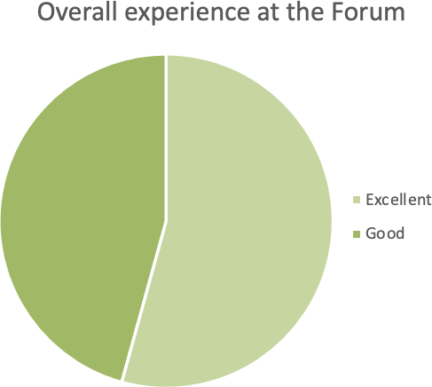

Appendix 3: Post-forum participant survey responses
What worked well?
- Having a facilitator on each table
- Round table talks
- Work at the tables was fabulous and so useful to have a good mix of participants. Opening address by Department useful
- Mix of people on tables was diverse
- Coordination of the whole event. Facilitators delivery of the event and the co-facilitators leading the exercises on the tables. Seating of guests, hand painting, trauma support, food delivery and staff supporting tables and guests.
- communication leading up to and during forum was amazing! The ladies thought of everything. Fantastic Work.
- it went well. Being able to mix with other people and organisations to share experiences was very valuable.
- group discussion and the exchanging of thoughts and ideas
- The yarn and talk section Walking through the community
- Group work
- Having young people and key stakeholders together
- extremely well organised and excellent participants
- meeting new people at the tables we were sat at. The time to discuss the topics presented for us to work on. Having the Youth Representatives at the forum interacting with everyone and participating in discussions.
- The voices of young people present, the flow of the day and focus on action planning that is forward thinking rather than re-hashing same issues.
- the round table discussions and having the scribes on the tables
- small group discussions
- The diversity of the table groups. the continued discussion that was able to be thread through from morning until afternoon within the tables. The commitment and the trust in the room
- The table discussions
- Young People panel was excellent and grounded everyone in what was really important. Good to hear from people on the ground, people with lived experience, people with cultural expertise as well as strategic minds
- The space to walk and yarn
- Incredible amount of (and diverse range of) stakeholders in the room and it looked like a lot of thought was put into each and every part of the day, down to the mix of people on each individual table, the wonderful role play/presentation, hearing directly from youth, the exceptional facilitator, how directed the stakeholder collaboration tasks were. It was very inspiring to be in that room and participate in the forum - I felt very lucky to be there. Also thank you for the free gifts on the table.

- Having young people's voices throughout the day gave it good focus and energy. Having such a range of people (Department, community controlled orgs, young people) was also excellent. That the discussion was future focused.
- small table conversations allowed for range of voices and views to be heard
- organised well planned kept to the timeframe of the agenda
- Was well organised and set up. Inclusion of young people's voices was great. Facilitator had a strong confident style.
- Group work at the tables
- Table facilitators leading each small group discussion
- Mixed tables. The DGs introduction. Facilitation was good. Young people's meaningful input.
- Goof table conversation
- Large number of participants and commitment
- Young people at the tables, the interaction and involvement of young people. Facilitation at the tables, the working tasks
- Workshopping/Brain Storming and having seating pre-set to ensure people are talking to different groups I felt this brought more in-depth conversations to the discussions and some very good ideas on how to do things differently
- Mixture of orgs on tables, involvement of young people, having table facilitators, Working through the 6 action areas
- Having very active work occurring at tables to progress the identification of ideas and actions.
- The mix of people at the forum, as well as the mix on each table was so well done. It really provided a great opportunity for discussion.

What should we do different next time?
- It would have been good to have more plenary sessions to hear what other groups were doing.
- spread it over todays
- I noted there was an absence of non Indigenous service providers who currently hold much of the service to be transitioned and I think it would be important that they are part of the discussion to help facilitate the reform
- More scope to hear / read suggested actions from other tables / potentially use of virtual white boards
- Nothing
- Nothing comes to mind as it was all handled brilliantly by the ladies. Every little detail was covered. No drama at all, just smooth check ins and check outs, gorgeous rooms and venue/location was awesome.
- I can't think of anything.
- have the forum in a regional centre
- Try and have early days we finished @7pm or 7.30pm
- Bigger room
- Include department of education and education Aboriginal and Torres Strait Islander organisations
- it was really good, but maybe more feeding back from each session to the whole group throughout the day
- two half days a week a part would be better as a day out is a lot for everyone to attend. encourage Education, Health, Housing and Treasury decision makers to attend and participate for the duration of the event.
- Better food and hold it over two days. We had no energy for the measurements at the end of the day and we would have liked to hear from the whole room in some way.
- the venue was good but not big enough. It had a lot of noise from the air cons and from other tables.
- Mix up the presentations with an "expert" talking about the behaviors they need to successfully partner with First Nations - eg humility, respect, listening - what does this actually look like?

- Very little. There was a good mix of working through the strategies and content and hearing the voices of children and young people.
- Perhaps larger group discussions with delegates selecting a session they want to be involved in and reporting the high level points from each session back to the whole forum at the end of the day.
- Maybe split over two days - lots of deep thinking, sensitive topics and great opportunity to catch up with old friends/make new connections.
- Shorter days
- I'd love to have the opportunity to mingle more with the stakeholders and/or have the opportunity to obtain contact details from others (we got the ones from our table). As when working together to achieve change, I feel that networking is vital so that you know who to call.
- Need more frontline workers participating to help ground solutions and actions in reality. Need to give people the space to talk about the issues before you go straight into the actions needed. It would have been good to group the tables so those working in the universal space in terms of addressing the issues were all at the table and those in the secondary/tertiary space were all aligned because the issue can be quite different and so the solutions will be as well.
- given the themes overlapped many of the actions identified could have sat under numerous themes. Didn't need 30 mins on each topic.
- Wasn't any real time for large group discussion - know it would be difficult with the number of people but did have a feeling of being quite staged and managed and not sure how the group would visibility about how the issues and themes were accurately captured.
- Maybe have break out spaces, was a little hard to hear over all of the conversations within the room
- The MC could have contributed a lot more
- the last session was too long, people's energy was draining, maybe a short re-energising exercise or break it up some how.
- Make sure more men at each table & that they are encouraged. Not just women's voices.
- I really enjoyed the focused discussion at tables more time for that would have been great.
- It was a long day with a lot of information I would suggest spreading this over 2 days if the expectation is to gather more ideas to make change
- A space for participants to write up things they wanted to add/say, Welcome to Country, Ensure Ed, Health, police attend (noting they were invited ●)
- Some additional interactive discussion as larger group would be good but acknowledge it is difficult to manage.
- Can't think of anything.

What is your main takeaway from the day?
- great changes to come
- Collective commitment to change Very strong acknowledgement to deep listening and letting go of frameworks that dont work
- A lot of effort needed to divest authority and funding to communities. Effort needs to be persistent, supportive and sustained.
- Participation and inclusiveness.
- Supporting the whole family not just the child in question and also getting back to grass roots, involving connection to culture
- It takes the whole community and government to achieve change.
- hope
- This training if possible needs to be an aboriginal community
- There’s good intentions across the sector, but real action is needed
- Now is the time for actions to make significant change.
- its a great start but there is a lot of work to do. the department of child safety is doing a lot of good work, but Health, Police and Housing need to lean in too.

- I took away hope for further collaboration within the community service sector and the government departments/agencies.
- We all collectively want to address systems issues instead of continually focusing on the service level and short-term actions.
- That there has been progress and we are learning from that what has happened and working towards making things better
- We can successfully co-design with First Nations partners and should listen to the voices of young people
- That we have regained trust in each other as a collective to work towards solutions. And that all are hopeful if we are committed we can get there
- How much is involved from government and NGOs to make a difference.
- Young People want their parents supported to be good parents. Government needs to be more flexible in the way it works with others, designs and delivers. Give up the power and control of resources and let First Nations families take care of themselves. Support needs to be holistic and encompass a good understanding of Aboriginal definitions of family. Parents should have the final say in their children's placement (in relation to kin/carers).
- Loved interaction with the community
- I felt very inspired that change has been occurring and further change is inevitable with the amount of incredible people and organisations in that room working towards the same goal.
- To reduce over-representation we need to work really hard together to do whatever it takes (flexible approaches) to keep children with family and culture
- so many opportunities to do differently and so much good will to do so.
- Keeping our Aboriginal and Torres Strait Islander Children and families out of care, if they are entering how best can we support them around Cultural, families and connection.
- Shared sense of commitment
- Words now need to be turned into actions
- The young people who shared their views
- genuine commitment and willingness from staff and services to make a difference
- Government to address structural Racism & systemic racism . GOVERNMENT LEADERSHIP , DG " WE CANNOT UNKNOW THE FACTS !"
- this requires real and courageous leadership at every level
- The young people’s perspective and that there is such commitment of doing things differently and more
- Hopeful of change and felt heard
- Focus on parent support and cross govt responsibilities
- Great commitment to delivering stronger outcomes from all stakeholders across the sector and intersecting service sectors.
- This approach is so valuable. Hearing all the voices and collaborating on ideas, solutions and the way forward - gold. So many stories were told at our table, which really helped put things into perspective and challenged some assumptions that I had made about service delivery in regional Queensland.

Is there anything else you want to share for the Breaking Cycles action plan?
- Looking forward to the write up and very committed to continuing the discussion to move to action!
- Keep going.
- Looking forward to the achievable actions being reached in the near future.
- This was such an amazing forum and I am so thankful that i got to be apart of it. To be in the room with so many Beautiful Amazing Educated Mob all working together to reach the same goal, was truly Inspiring. Thank You for allowing me to be included in this Deadly Event. Hoping to be able to attend future forums.
- Keep the good work up.

- positive experience with hopefully positive outcomes that will happen sooner rather that later or not at all......
- Real improvements in reducing numbers of Aboriginal and Torres Strait Islander kids in care requires a proper cross government response with communities
- well done everyone - lets get to it!
- It needs to be based on HOW you achieve systems change. Closing The Gap also includes transforming governments and we could have used some up front education on this in theory by the facilitators so we could make informed actions and measures. More engagement of the lead facilitator, who seemed like an MC rather than facilitating.
- A big thank you to all the staff. everyone was so lovely and accommodating. the ladies who also organised the travel and accommodation were DEADLY too! really enjoyed the dinner, the company and conversations the night before the forum.
- Great day - very inspiring and well thought out. thanks for the opportunity
- No thank you we gave rich information on the day. be good to stay across the progress of such important work
- No thanks
- We need to think about individual responsibility for how we work to improve lives for OUR children. As well as community responsibility and organisational responsibility. If you change the way workers all across the system understand and appreciate culture, it will flow through to their work behaviours and decision-making
- Not at this stage, I think it was extremely well thought through. Thank you for giving me the opportunity to attend on behalf of the Aboriginal and Torres Strait Islander Legal Service.
- There needs to be lots more Intensive Family Support Services for First Nations people, and there should be joint Education/Housing/Child Safety teams working to help families stay together by addressing structural inequality
- Clear measurable steps to get us to the goal
- for Government to adequately support Community Control Organisation (CCO) to meet the needs of the families and children. (not to set them up to fail ) eg number of case management referrals an organizational should be meeting. Government to provide Resourcing and upskilling CCO staff. CCO being able to match government pay system for CCO we need to empower our CCO worker to feel they are capable to achieving similar outcome as to non-indigenous organisation.
- more focus on a few transformative actions, must get buy from over government. more services on the ground. we are heading in the right direction, the proof will be numbers coming down. we need good measurements.
- ADDRESS STRUCTURAL & SYSTEMIC RACISM - UNIQUE FORM OF POLICE RACISM DIRECTED AT ABORIGINAL PEOPLE , MEN WOMEN, YOUTH & CHILDREN. RETHI K THE CULTURAL CAPABITY & WORKFORCE STRATEGY FOR QPS. POLICE & CHILD PROTECTION. OFFICERS LACK ESSENTIAL MOST LACK CULTURAL KNOWLEDGE & A TRAUMA INFORMED APPROACH , LACK SOPHISTICATED SKILLS SETS &KNOWLEDGE OF CULTURALLY INFORMED & SENSITIVE APPROACH TO ENGAGE WITH TRAUMATISED FIRST NATIONS ABORIGINAL & TORRES STRAIT ISLANDER FAMIMIES . NEED THOROUGH INVESTIGATION. POLICE CHILD PROTECTION & HOSPITALS - ESP EMERGENCY WARDS STAFF & AMBULANCE , SOCIAL HOUSING DPT STAFF & REAL ESTATE AGENTS ALL NEED CULTURAL COMPETENCE TRAINING SO MANY at BLIND & DESTRUCTIVE END OF CULTURAL COMPETENCY CONTINUUM.
- Need to have action now.. but such energy and commitment and excellent opportunity to do this work together
- Hoping for outcomes and change or to be advised of where to next.
- Congratulations on a great forum
- Congratulations on a job well done!

Appendix 4: Links to relevant strategies and initiatives

Queensland Government legislation, policy and strategies which complement Our Way

Domain | Relevant legislation / policy / strategies
Healing and rights | Tracks to Treaty Statement of Commitment, A Reframed Relationship between Aboriginal and Torres Strait Islander Queenslanders and the Queensland Government
 | Local Thriving Communities
 | Queensland Government Reconciliation Action Plan 2018-2021 (extended to 31 December 2022)
 | Every Life, The Queensland Suicide Prevention Plan 2019-2029
 | Human Rights Act 2019
Health and wellbeing | Hospital and Health Boards (Health Equity Strategies) Amendment Regulation 2021
Making Tracks Together – Queensland’s Aboriginal and Torres Strait Islander Health
Equity Framework
 | Aboriginal and Torres Strait Islander Health and Wellbeing Services Plan 2018-2023
Deadly Kids Deadly Futures, Queensland’s Aboriginal and Torres Strait Islander Child
Ear and Hearing Health Framework 2016-2026
 | Growing Deadly Families: Aboriginal and Torres Strait Islander Maternity Services Strategy 2019-2025
 | Shifting Minds: Queensland Mental Health, Alcohol and other Drugs Strategic Plan 2018-2023
 | Activate! Queensland 2019-2029 (Queensland Sport and Recreation Strategy)
Housing | Working Together for a Better Housing Future, Aboriginal and Torres Strait Islander Housing Action Plan 2019-2023
Safety | The Framework for Action – Reshaping our Approach to Aboriginal and Torres Strait Islander Domestic and Family Violence
 | National Strategy to Prevent and Respond to Child Sexual Abuse 2021-2030
Education | Advancing Aboriginal and Torres Strait Islander education: An action plan for Queensland
 | Every Aboriginal and Torres Strait Islander student succeeding strategy

Federal Government strategies and initiatives
At a national level, Our Way is aligned with the following initiatives and strategies:
- Family Matters Campaign at both national and state level
- National Agreement on Closing the Gap between the Australian governments and the Coalition of Aboriginal and Torres Strait Islander Peak Organisations
- Council of Australian Governments Closing the Gap in Indigenous Disadvantage
- National Framework for Protecting Australia’s Children Third Three Year Action Plan, 2015–18, Driving Change: Intervening Early
- National Plan to Reduce Violence Against Women and their Children 2010–2022
- National Aboriginal and Torres Strait Islander Education Strategy
- Belonging, Being and Becoming: The Early Years Learning Framework.

